Simulating Predator-Prey Models with Artificial Intelligence (for video games)

BSc Computer Science (Game Eng)

02/05/2019

Justin Carter (160383867)

Project Supervisor: Dr Gary Ushaw

Abstract

This dissertation aims to improve the artificial intelligence that simulates animals in the game industry by using predator-prey models and flocking to achieve a set of scripts that will increase the overall realism of video games where an accurate representation of animal behaviour is necessary.

The finished system will provide a graphical representation of a general predator-prey model and will simulate to a certain degree how a predator-prey relation affects both species (predator and prey) in the real world.

The parties benefitting from this project are mainly game developers, who will be able extrapolate and adapt the systems scripts to suit their needs. However, the system could be used by a variety of people, including Biologists who wish to simulate the actions of real animals, or Mathematicians who want a graphical representation of predator-prey models.

Declaration

“I declare that this dissertation represents my own work except where otherwise stated.”

Acknowledgements

I’d like to thank both my supervisor, Dr Gary Ushaw, and the games engineering staff, Dr Graham Morgan, Dr Rich Davison and Dr Neil Speirs for all their help.

I’d also like to thank my parents for their support throughout my degree.

Table of Contents

1 Table of Figures 8

2 Glossary 11

3 Introduction 12

3.1 Problem 12

3.2 Purpose 12

3.3 Novel Approach 12

3.4 Personal motivation 12

3.5 Aim and Objectives 12

3.6 Timeline 14

3.7 Dissertation Structure 14

4 Background Research 16

4.1 Strategy 16

4.2 Unity 16

4.2.1 Assets 16

4.2.2 GameObjects 16

4.2.3 Prefabs 17

4.2.4 Scripting 17

4.2.5 Summary 18

4.3 Flocking 18

4.3.1 History 18

4.3.2 Behaviours 20

4.3.3 Implementation 22

4.3.4 Flocking Summary 23

4.4 Predator-Prey Models 24

4.4.1 General 25

4.4.2 Lotka-Volterra 25

4.4.3 Predator-Prey Model Summary 27

4.5 Predators and Prey in The Games Industry 28

4.5.1 The Hunter: Call of The Wild 28

4.5.2 DayZ 30

4.5.3 Farcry: Primal 31

4.5.4 Red Dead Redemption 2 34

4.5.5 Predators and Prey in The Games Industry Summary 35

5 Methodology 37

5.1 Tools 37

5.1.1 Unity 37

5.1.2 C# 37

5.1.3 Flocking 37

5.1.4 Dynamic Line Chart 37

5.2 Planning 38

5.3 Requirements 39

5.3.1 Functional 39

5.3.2 Non-Functional 39

5.4 Design 39

5.4.1 AI Rules 39

5.4.2 Pass Criteria 39

5.5 Implementation 40

5.5.1 Version 0.1 40

5.5.2 Version 0.2 40

5.5.3 Version 0.3 41

5.5.4 Version 0.4 42

5.5.5 Version 0.5 43

5.5.6 Version 0.6 43

5.5.7 Version 1.0 44

5.6 Structure 46

5.7 Testing 46

5.7.1 Performance Testing 46

5.7.2 General Simulation Testing 50

6 Evaluation 54

6.1 Variable Experimentation 54

6.1.1 Prey 57

6.1.2 Predators 64

6.1.3 Manager 74

6.1.4 Experimentation Summary 77

6.2 Background Research Comparison 78

6.2.1 Predator-Prey Models 78

6.2.2 Flocking 79

7 Conclusion 82

7.1 Objectives Achievement 82

7.2 What Has Been Learned 83

7.3 Personal Development 83

7.4 Future Work 84

8 Form / References 85

9 Appendix 88

9.1 Scripts 88

9.1.1 PreyController.cs 88

9.1.2 PredatorController.cs 95

9.1.3 SimulationManager.cs 101

9.1.4 SeasonManager.cs 103

9.1.5 RestartSimulation.cs 105

9.2 Graph Screenshots 107

# Table of Figures

Figure 1: Project Timeline8 14

Figure 2: GameObject Example41 17

Figure 3: Public Variable Example43 18

Figure 4: Early Flocking Example4 18

Figure 5: Use of flocking in The Lion King12 19

Figure 6: Use of flocking in The Lord of the Rings12 19

Figure 7: Use of flocking in Titanic12 19

Figure 8: Cohesion Visualisation4 20

Figure 9: Cohesion code example 20

Figure 10: Separation Visualisation4 20

Figure 11: Separation code example 21

Figure 12: Alignment Visualisation4 21

Figure 13: Alignment code example 21

Figure 14: Combined behaviours code example6 22

Figure 15: Flocking tutorial video6 23

Figure 16: Linear Predator-Prey model graph2 x axis: Time, y axis: population 24

Figure 17: Lotka-Volterra Predator-Prey model graph2 26

Figure 18: The Hunter: Call of the Wild in-game screenshot15 28

Figure 19: Question asked to The Hunter: Call of the Wild’s community17 29

Figure 20: DayZ in-game screenshot3 30

Figure 21: Question asked to DayZ’s community34 31

Figure 22: Farcry: Primal in-game screenshot20 32

Figure 23: Question asked to Farcry; Primal’s community 1/233 33

Figure 24: Question asked to Farcry: Primal’s community 2/233 33

Figure 25: Red Dead Redemption 2 wolf contesting Bear in-game screenshot39 35

Figure 26: Red Dead Redemption 2 in-game screenshot30 35

Figure 27: World War Z zombie swarm37 36

Figure 28: Days Gone zombie horde38 36

Figure 29: Dynamic Line Chart example26 38

Figure 30: Functional requirements 39

Figure 31: Non-functional requirements 39

Figure 32: Version 0.1 screenshot 40

Figure 33: Prey 3D model 40

Figure 34: Version 0.2 screenshot 41

Figure 35: Version 0.3 screenshot 41

Figure 36: Predator 3D model 42

Figure 37: Predator sight visualisation 42

Figure 38: Hibernation spot 3D model 43

Figure 39: Alpha 3D model 44

Figure 40: Scripts structure29 46

Figure 41: Laptop specifications 47

Figure 42: Performance: Not Running 47

Figure 43: Performance: Idle 47

Figure 44: Performance: Only Prey 47

Figure 45: Performance: Only Predators 48

Figure 46: Performance: Both Prey and Predators 48

Figure 47: Performance: High Predator Popualtion 48

Figure 48: Performance: Hibernation 48

Figure 49: Performance: High Prey Population 48

Figure 50: Performance summary: Not Running Fully 49

Figure 51: Performance summary: Running Fully 50

Figure 52: Variable Testing: Prey 51

Figure 53: Variable Testing: Predators 52

Figure 54: Variable Testing: Manager 53

Figure 55: Variable Experimentation: Original: graph 1 55

Figure 56: Variable Experimentation: Original: graph 2 55

Figure 57: Variable Experimentation: Original: graph 3 56

Figure 58: Variable Experimentation: Original: graph 4 56

Figure 59: Prey Speed changes 57

Figure 60: Variable Experimentation: Prey Speed: graph 1 57

Figure 61: Variable Experimentation: Prey Speed: graph 2 57

Figure 62: Variable Experimentation: Prey Speed: graph 3 58

Figure 63: Variable Experimentation: Prey Speed: graph 4 58

Figure 64: Prey Breed Rate changes 59

Figure 65: Variable Experimentation: Prey Breed Rate: graph 1 59

Figure 66: Variable Experimentation: Prey Breed Rate: graph 2 59

Figure 67: Variable Experimentation: Prey Breed Rate: graph 3 60

Figure 68: Variable Experimentation: Prey Breed Rate: graph 4 60

Figure 69: Prey Predator avoidance intensity changes 61

Figure 70: Variable Experimentation: Predator Avoidance Intensity: graph 1 61

Figure 71: Variable Experimentation: Predator Avoidance Intensity: graph 2 61

Figure 72: Variable Experimentation: Predator Avoidance Intensity: graph 3 62

Figure 73: Variable Experimentation: Predator Avoidance Intensity: graph 4 62

Figure 74: Prey Predator Avoidance Radius changes 63

Figure 75: Variable Experimentation: Predator Avoidance Radius: graph 1 63

Figure 76: Variable Experimentation: Predator Avoidance Radius: graph 2 63

Figure 77: Variable Experimentation: Predator Avoidance Radius: graph 3 64

Figure 78: Predator Chase Speed changes 64

Figure 79: Variable Experimentation: Predator Chase Speed: graph 1 65

Figure 80: Variable Experimentation: Predator Chase Speed: graph 2 65

Figure 81: Variable Experimentation: Predator Chase Speed: graph 3 66

Figure 82: Predator Sight Range changes 66

Figure 83: Variable Experimentation: Predator Sight Range: graph 1 67

Figure 84: Variable Experimentation: Predator Sight Range: graph 2 67

Figure 85: Variable Experimentation: Predator Sight Range: graph 3 68

Figure 86: Variable Experimentation: Predator Sight Range: graph 4 68

Figure 87: Predator Eat Cooldown changes 69

Figure 88: Variable Experimentation: Predator Eat Cooldown: graph 1 69

Figure 89: Variable Experimentation: Predator Eat Cooldown: graph 2 69

Figure 90: Variable Experimentation: Predator Eat Cooldown: graph 3 70

Figure 91: Predator Death Time changes 70

Figure 92: Variable Experimentation: Predator Death Time: graph 1 71

Figure 93: Variable Experimentation: Predator Death Time: graph 2 71

Figure 94: Variable Experimentation: Predator Death Time: graph 3 72

Figure 95: Variable Experimentation: Predator Death Time: graph 4 72

Figure 96: Predator Max Number of Alphas changes 73

Figure 97: Variable Experimentation: Predator Max Number of Alphas: graph 1 73

Figure 98: Variable Experimentation: Predator Max Number of Alphas: graph 2 73

Figure 99: Variable Experimentation: Predator Max Number of Alphas: graph 3 74

Figure 100: Variable Experimentation: Predator Max Number of Alphas: graph 4 74

Figure 101: Manager Starting Prey Population changes 75

Figure 102: Variable Experimentation: Starting Prey Population: graph 1 75

Figure 103: Variable Experimentation: Starting Prey Population: graph 2 75

Figure 104: Variable Experimentation: Starting Prey Population: graph 3 76

Figure 105: Manager Starting Predator Population changes 76

Figure 106: Variable Experimentation: Starting Predator Population: graph 1 76

Figure 107: Variable Experimentation: Starting Predator Population: graph 2 77

Figure 108: Variable Experimentation: Starting Predator Population: graph 3 77

Figure 109: Background research comparison: Predator-prey models 78

Figure 110: Trend 3 failure example 79

Figure 111: Flocking implementation 80

Figure 112: Separation fails when fleeing 81

# Glossary

Method/function – A group of code

Boid – The name given to refer to object used in flocking

Flocking – A set of behaviours that replicate real world animal movement (bird flocks)

Vector3 – A data type to store an objects position on x, y, and z axis

Transform – position, rotation and scale of an object in Unity

Translate() – Function that can be used to move a Unity GameObject

GameObject – Objects that are in a Unity game

RigidBody – A Unity component that allows manipulation of physics

# Introduction

## Problem

A video game will often implement animals using simple AI (Artificial Intelligence), allowing them to move around and have various interactions with the player, but rarely will any two animals exhibit an accurate predator-prey relationship. Although the choice to exclude realistic relationships like this might be ideal for some games, whose focus is not on the accuracy of their animal behaviour, there are many games out there that should provide more attention to the realism of their systems. Such a game includes DayZ3, a survival game implementing various animals which players can hunt, kill and eat. However, the animal behaviour includes no interaction between different species, which could possibly impact on the user’s gameplay experience by ruining immersion. An example of such an occasion is when a rabbit and a fox come across each other and nothing happens, whereas in a realistic situation (and what my project aims to achieve), the rabbit would flee, the fox would give chase, then attempt to catch an eat the rabbit.

## Purpose

Taking from the problem explained above, the purpose for this project is to raise the standard of realism that the games industry currently has where an environment of multiple species is being used. My project hopes to do so by providing artificial intelligence capable of reproducing the relationship that predators and prey experience in the wild as accurately as possible.

## Novel Approach

Existing projects that also attempt to recreate the relationship between predator and prey mostly attempt to simply see if a predator can hunt the prey, with the prey trying to avoid the predators. My project differs from these because I am reproducing Predator-Prey models2 to attempt to create some sort of balance between their (the two species) populations. By this I mean that I will attempt to recreate the graphs that predator-prey models2 create, in which the predator population rises when prey population is high, and falls when prey population is low, and where the prey population rises when predator population is low and falls when predator population is high. My plan is for this process to be repeated exponentially.

## Personal motivation

From a young age, I have always been interested in Video Games, especially that of the survival genre in which the player is required to secure food, shelter, weaponry etc in order to keep their character alive. I have also always been fascinated by the way different species living in the same habitat interact with each other. During school I completed a project on the impact of artificially reducing the Wolf population in Yellow Stone National Park. Doing so led to a steep rise in Elk population (due to lack of predation), which led to a decrease in population of willow & aspen trees (due to elk feeding), which led to a reduction in Beaver population (due to lack of material for use in building dams). Eventually due to the many problems that removing the wolf population had caused to the natural balance of the habitat, wolves were reintroduced to stabilise it. Food chains such as this and the equilibrium they manage to maintain fascinates me. I’ve combined these interests into a dissertation project that I’m highly motivated to complete.

## Aim and Objectives

The aim of the project is:

*“To investigate to what extent that the theory and mathematics behind Predator-Prey models can be replicated using Artificial Intelligence (AI)”*

The project aim is split into five objectives which must be achieved before the project can be completed

* *“Use published articles and case studies documenting Predator-Prey models & Flocking to research and identify a technique for implementing the AI”*
* *“Establish a set of at least 5 rules that the AI must follow to keep the conditions controlled (e.g. Predators can only attack every 3 seconds)”*
* *“Define a set of 3 pass criteria that the system must achieve in which it can be said that the results of research were accurately reproduced”*
* *“Implement AI to simulate the actions of both predator and prey in their natural environment as accurately as possible”*
* *“Evaluate if, and to what extent the results from research can be reproduced using the predator and prey AI (using pass criteria mentioned previously)”*

Most of the objectives build upon the previous ones, except for the second and third, either one can be completed before the other, but both must be completed after the first objective and before the fourth. This is because creating a set of rules for the AI to follow wouldn’t be possible before enough research is completed as I wouldn’t have enough context on how flocking and predator-prey relationships work.

Firstly, adequate research into both Predator-Prey models and flocking must be initially completed to provide me with an adequate understanding on both subjects.

Once the brunt of the research is done, the second and third objectives can be completed at roughly the same time. As explained briefly above, the purpose of the second objective, establishing a set of rules for the AI to follow, is to keep the conditions of the simulation somewhat controlled. For example, if the predator could continually move from prey to prey at high speeds, the prey population would be diminished almost instantly. Not only is that not the wanted outcome, but it is also unrealistic, as most predators do not begin another hunt straight after finishing one. The purpose of the third objective is rather self-explanatory; there needs to be a way to determine if the aim was achieved or not and depending on the amount of pass criteria that the end system meets, this question can be answered.

The fourth objective is the implementation of the system, in which the population of both predator and prey will hopefully be able to reproduce a basic Predator-Prey Model graph.

The final objective evaluates whether the aim of the project was met, which will be dependent on the number of pass criteria the system meets.

## Timeline

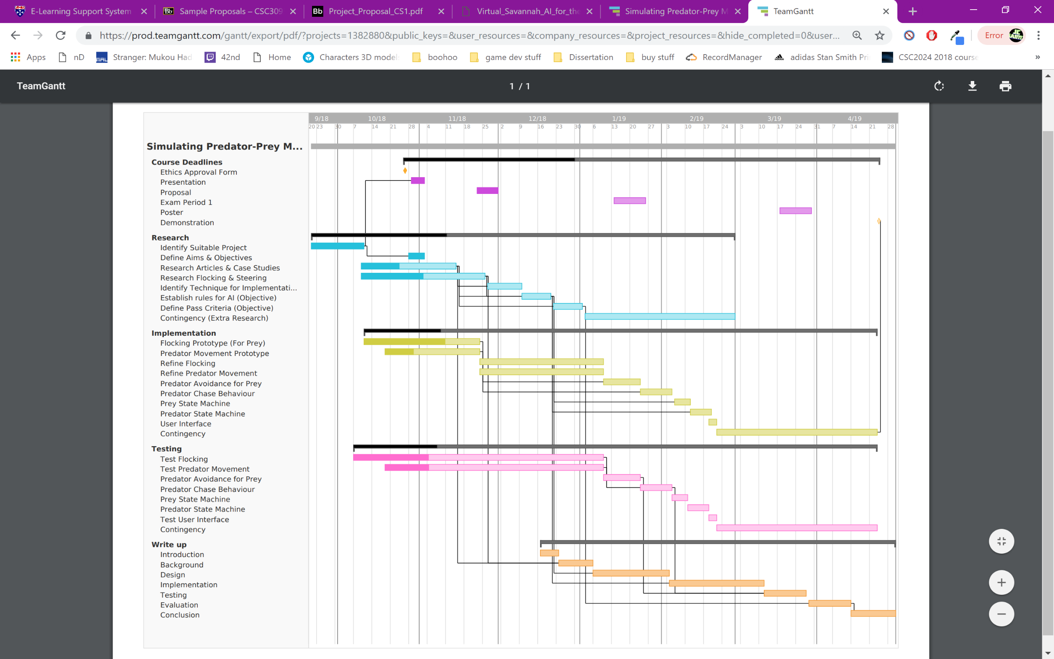

Figure : Project Timeline8

## Dissertation Structure

**Introduction**

The introduction provides context for the project so that the reader can acquire an adequate understanding of what the project entails before continuing. The subsections are below:

* Problem
* Purpose
* Novel Approach
* Personal motivation
* Aim and Objectives
* Timeline
* Dissertation Structure
* Summary

**Background Research**

This chapter aims to provide information on the technologies and techniques that will be used to produce the finished system.

**Implementation**

The implementation is where all the scripts that make up the system will be written. The rules and pass criteria for the second and third objectives will also be provided at the start of this section.

**Testing**

The system is not designed to be in a form that can be employed by users without any modification whatsoever, so there is minimal testing that can be done. The testing that was done consists of mainly altering certain variables to make sure that the expected outcome matches the observed outcome and some performance testing.

**Evaluation**

This section will carry out a series of experiments to see how the simulation reacts when various values are altered. I will also compare my implementation with the results found from background research.

**Conclusion**

The final chapter will provide details on whether the system met the original objectives, the pass criteria, outline what has been learnt and identify any future work.

# Background Research

## Strategy

The basic strategy used when conducting research was to browse online articles and video tutorials to gather enough information.

## Unity

Unity is one of the world’s leading game development engine’s, “Unity is used to create half of the world’s games22”. Unity provides a clean and user-friendly interface coupled with powerful tools to enhance the game development process. They also offer their platform in the form of three different plans23, which scale based on the size of the development team. The best of these packages23 is ‘Pro’, which is designed for large teams who aim to create polished and successful video games. Plus is aimed at hobbyists who want some extra features and ‘Personal’ is designed for beginners just entering the game development scene.

### Assets

In Unity, an ‘asset’ is any item/file that can be used in a Unity Project, be it a video game, a simulation or some sort of cinematic movie. Assets can take the form of a multitude of different file types including audio, 3D models, animations, 2D sprites, images etc and these items can be imported into your Unity project from external sources. For example, the Unity asset store24 provides a huge amount of different types of asset packages that can be imported directly into unity. Assets can also be created by the user using Unity’s built in tools, and the variables of these assets can be altered at will.40

### GameObjects

A GameObject is every item that is in the game, and all these GameObjects can be seen from a window located in the Unity editor, allowing easy access to everything that is currently in the game. GameObjects are usually used to store ‘components’ which when added can allow the GameObject to fulfil various purposes. For example, a lighting component will allow the GameObject to provide light in the game, or a RigidBody component will allow the developer to manipulate the object with physics.41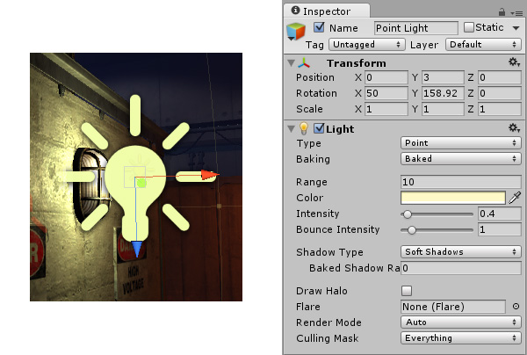

Figure : GameObject Example41

### Prefabs

Unity provides a system which lets the user take GameObjects and save them in their current state (saving all values). This will create a ‘prefabricated object’ which the user can then place into their game as many times as they want. Editing the prefab will also edit all the versions currently in the game, which is hugely helpful when dealing will multiple elements that are the same (editing each object in the game one by one would be immensely time consuming).42 Prefabs will prove useful in my project as all predator objects will be made from the same prefab, as well as the prey objects. Some of the variables will be altered at runtime however, to give each object a bit of individuality.

### Scripting

Amongst object-oriented, procedural and more, scripting is one of the many types of programming languages that are available and the one that is used to develop video games. Once created, a script is treated like an asset, and can also be used as a component when attached to a GameObject. Scripts contain an ‘Update()’ method which is run every frame and allows the programmer to detect and respond to certain events as they occur at runtime. For example, in order to detect when the player wants to jump, the programmer could add a detection in the Update method for when the space key is pressed, and in response to this event, the programmer could either directly manipulate the y position of the character, or manipulate its RigidBody to make the character jump using physics. A useful feature that unity provides when using scripts attached to GameObjects is that when making a variable public, its value can be seen and altered directly from the Unity editor both when running and idle, allowing easy debugging and tweaking.



Figure : Public Variable Example43

### Summary

The purpose of this section is to give the reader a brief introduction to the Unity game engine, and how it works. Unity is one of the world’s leading game development engines and is what I’ll be using to implement this project. Its abundance of documentation and ease of use makes it ideal for me and it is well suited to my project overall, as the prefab feature will make implementation much quicker.

## Flocking

Many animals in the real-world travel around in large groups rather than as individuals. Such behaviour can be reproduced using a simple set of code, providing realistic movement for large groups of animals5. This section will provide a background to flocking, how it has been used in industry, and the code that implements it.

### History

In 1986, Craig Reynolds produced “a computer model of coordinated animal motion such as bird flocks and fish schools4”. Both examples (bird flocks and fish schools) refer to three-dimensional flocking, but for my implementation, I intend to only use two dimensions. The example most like my intended implementation would be herding, which involves land-based animals such as antelopes or bison. The article that Reynolds published focuses mainly on three dimensional flocks of birds or fish but fortunately, the behaviours that fuel flocking can easily be restricted to two dimensions10. He named each individual object in the simulation a ‘boid’.

Reynolds explains that “a significant property of life-like behaviour is unpredictability over moderate time scales”4 meaning that in five or more minutes, the flock could be travelling in the complete opposite direction, but within small timescales such as a few seconds, the flock will most likely be travelling in the same general direction4. This unpredictability provides the flocking simulation with almost random and chaotic looking movements, which accurately depicts the movements of real animals. So why am I using flocking in the first place; in his article, Reynolds explains why birds flock in the first place: to protect from predators, and advantages in searching for food, mating and socialising. Overall, using flocking will add an additional layer of realism to the system10.

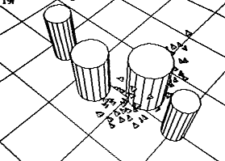Reynolds’ early experiments of flocking included not only the three-dimensional movement of a flock, but also goal seeking and obstacle avoidance behaviours. The obstacle avoiding allowed the flocks to avoid certain objects and the goal seeking allowed them to follow a specific path, rather than wandering aimlessly4. These behaviours have paramount importance to my project, as my intention is two-fold, the first is for the prey flocks to have goals set within the area underneath the camera, preventing any flocks from wandering off where they cannot be seen. And the second, is for the prey flocks to avoid the predators, as they would in their natural environment. This behaviour will also provide a realistic outcome when the predators give chase; the prey will attempt to flee.

Figure : Early Flocking Example4

Since the release of the Reynolds’ article, flocking has been used in industry multiple times, but early on, it was used in the film industry, rather than in video games. The first use was five years later in 1992 when the film Batman Returns11 used modified versions of the original flocking software to simulate swarms of bats and herds of penguins marching through the streets of Gotham City4.

Likely the most well-known use is in the original The Lion King movie, where flocking was used to simulate a stampede of thousands of wildebeest. The directors wanted a dramatic scene, one where only a dozen wildebeest would not suffice, but hand animating thousands of the animals stampeding in a realistic fashion would take far too long, so they turned to flocking. Even with use of flocking however, the roughly two-minute sequence took over two years to complete4.

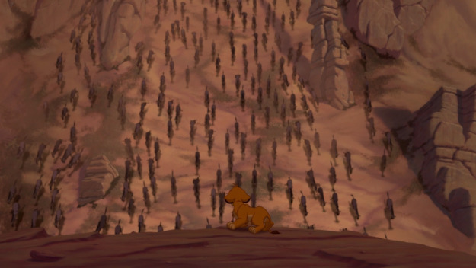

Figure : Use of flocking in The Lion King12

More developed versions of the algorithm have been used in huge blockbuster movies, including Titanic, to generate the huge crowds of passengers moving around the decks of the ship and Lord of the Rings, Star Wars, and The Mummy where huge moving armies are required for certain scenes.

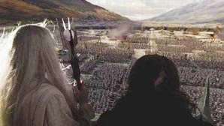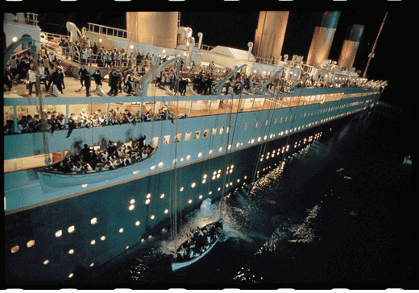

Figure : Use of flocking in The Lord of the Rings12

Figure : Use of flocking in Titanic12

### Behaviours

An implementation of a flocking algorithm uses three main behaviours; separation, alignment, and cohesion. These behaviours are exhibited by real animals, both airborne and grounded, in order to protect, and provide various advantages to survival, as explained further above.

#### cohesion diagramCohesion

Figure : Cohesion Visualisation4

First of the three behaviours that fuel flocking, cohesion is the behaviour that causes each boid to move closer to other nearby boids. More specifically, the behaviour will find all the boids (excluding itself) within a certain radius centred on itself, it will then find the centre position of all these boids and steer toward it.

Adapting this behaviour can produce the goal seeking feature that I explained above. The algorithm will take in a single point underneath the camera, but the intensity of steering toward this position will be amplified greatly for each boid, causing them to steer toward that position slightly more than the centre of the flock.

Below is an example of how cohesion is usually implemented in C#.

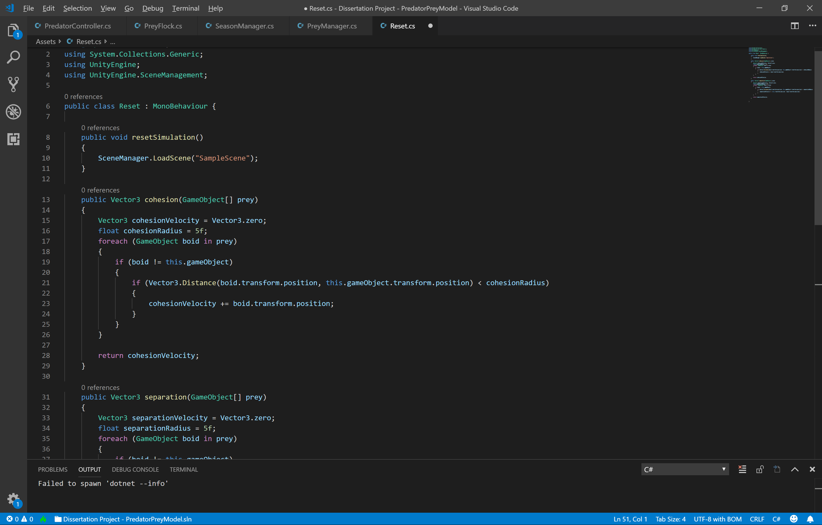

Figure : Cohesion code example

#### Separation

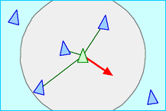The separation behaviour is the opposite of cohesion; when the boids are moving closer to one another, they will eventually become so close that they’ll be overlapping. Separation prevents this by taking in all the boids within a certain radius and steers away from them enough to still be a part of the flock but preventing it from getting too close to other nearby boids.

Figure : Separation Visualisation4

This behaviour can be adapted to provide an obstacle avoiding behaviour that was explained above, which will be used to steer the boids away from nearby predators. This can be done quite simply, instead of taking in all the nearby prey within a certain radius, the algorithm will take in all the nearby predators, and the radius used will likely need to be larger.

Below is an example of how separation is usually implemented.

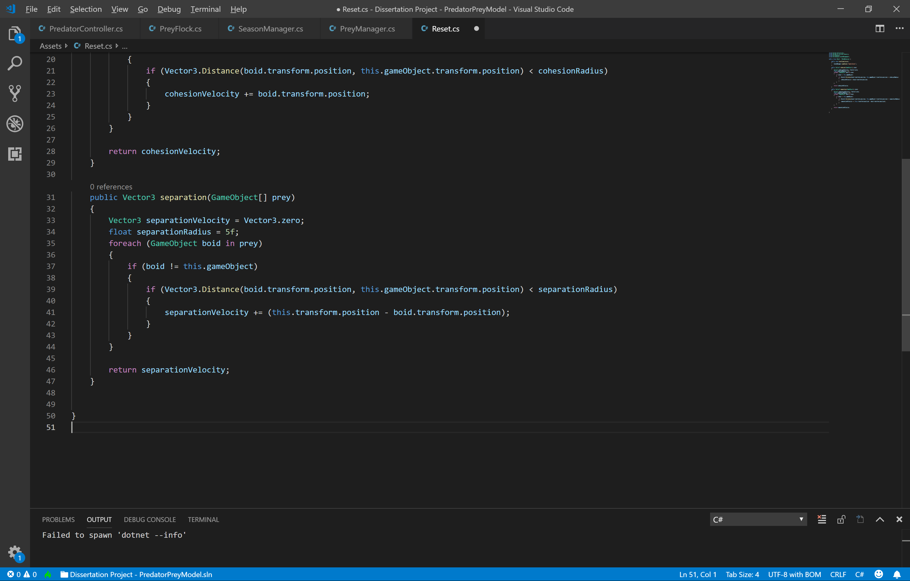

Figure : Separation code example

#### alignment diagramAlignment

Figure : Alignment Visualisation4

The final behaviour necessary for fuelling flocking is alignment. Again, each individual boid will take in all other boids within a certain radius. It will then calculate the average direction of these boids and alter its own direction to match this average. This causes the whole flock to rotate correctly upon changes in direction, providing very realistic movement.

Below is an example of how alignment is usually implemented.

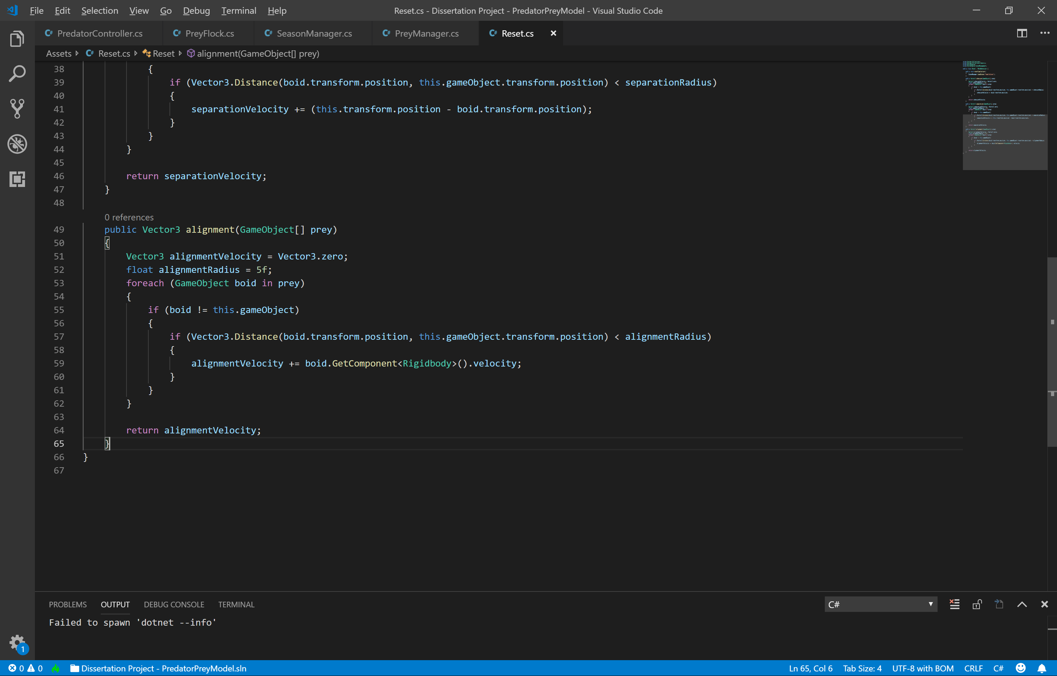

Figure : Alignment code example

What makes these behaviours so useful is that both the radius and intensity of the steering can be easily altered. For example, increasing the radius of cohesion will allow boids that are far away from each other to flock together, which will in-turn, create much larger flocks in population. If the intensity of the separation behaviour was increased, the distance between each boid in the flock would increase, creating much larger flocks in size.

#### Combining the Behaviours

In theory adding all the behaviours together is easy. Simply add together all the behaviours, multiplying each by their intensity value, and then add that to the boids velocity, as can be seen in the code below. 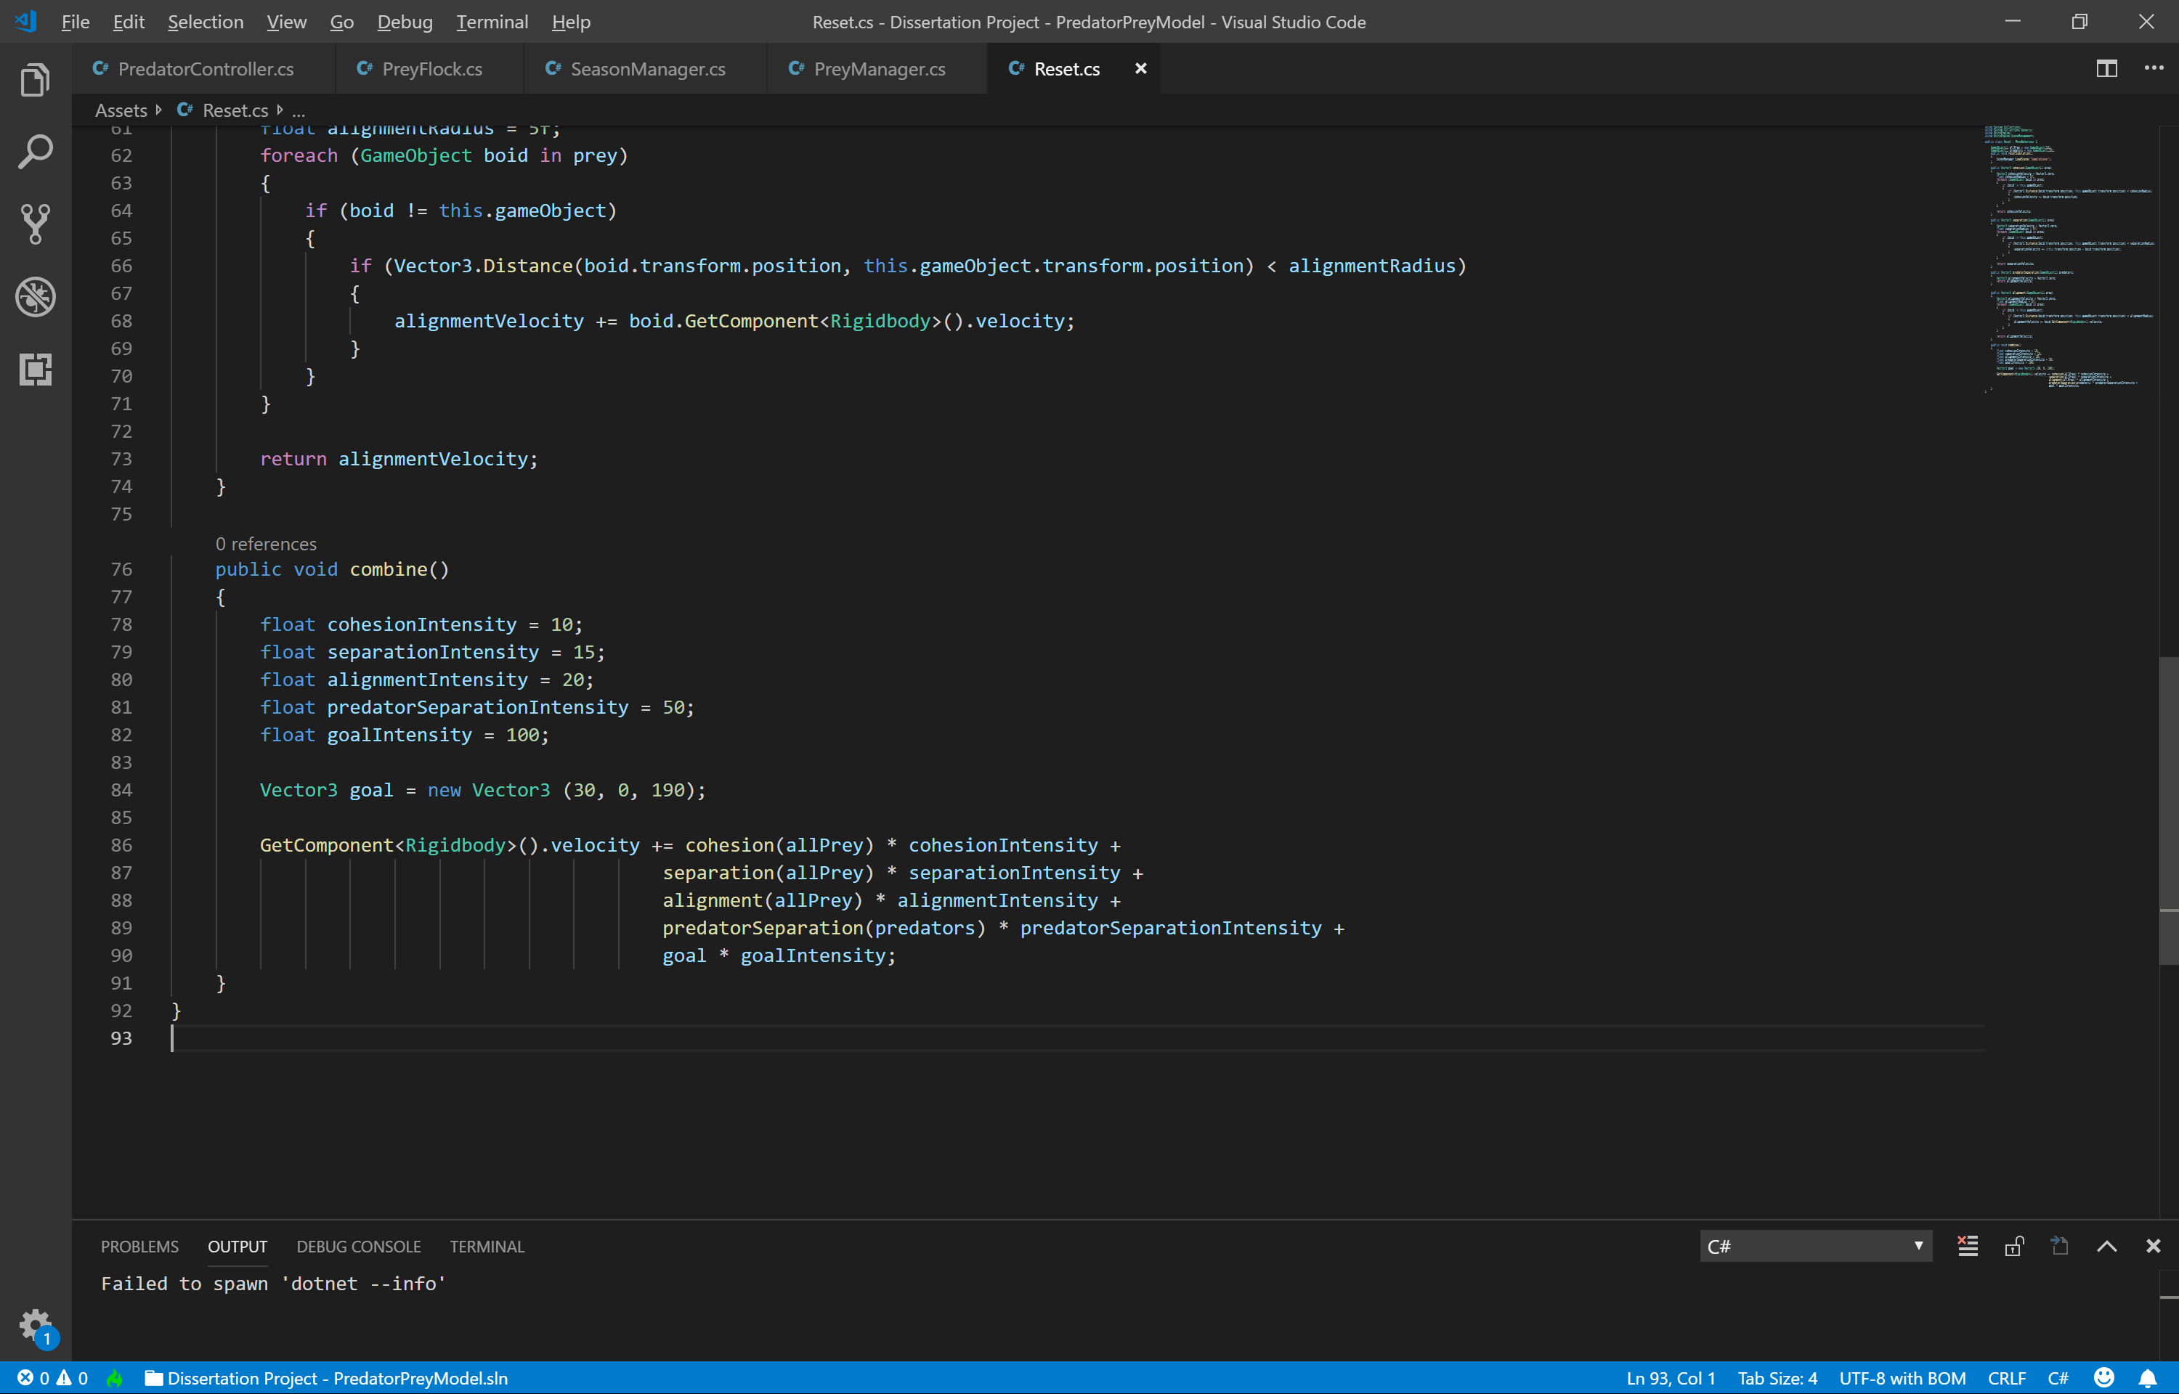

Figure : Combined behaviours code example6

### Implementation

Learning about how the behaviours work was very useful, but the explanations didn’t provide much support implementing the actual behaviour using Unity and C#. Luckily, I found a great video6 which shows and explains how to implement the basic behaviours in unity using C#. The video implements three-dimensional flocking, but it is easy enough to simply lock the boids to travelling on only the x and z axis, which is what I plan to do. The video also implements goal seeking behaviour, but however only uses one goal for one big flock. In order to maximise the realism of my implementation I intend to provide a way for multiple flocks to form, each with their own goal to seek. The solution for this will be explained in the implementation chapter.

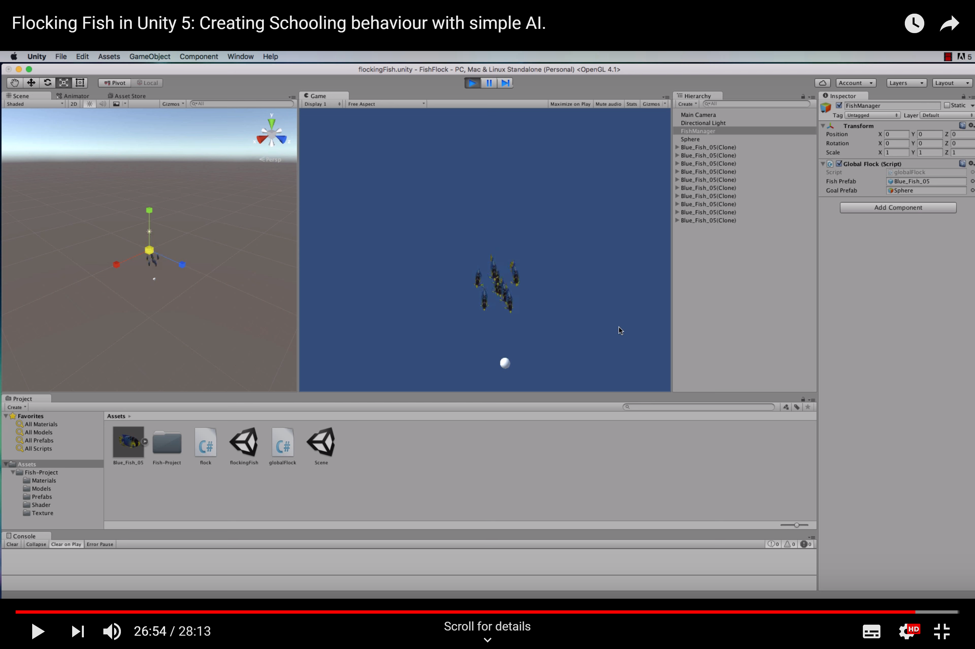

Figure : Flocking tutorial video6

### Flocking Summary

Overall, flocking is the ideal technique to use for prey movement, the unpredictability and chaos it provides for their movement will make the entire simulation more realistic, rather than simply having the prey move around without interacting with each other at all. The adaptability of the behaviours also makes extra features possible such as goal seeking and obstacle avoidance, which will be used in my implementation.

## Predator-Prey Models

Predator-Prey models2 are used to describe the relationship between two entities, in which the population of one entity (the predator) exhausts the population of the other (the prey) in order to survive and reproduce. Such entities can take the form of any predator and prey relationship, including shark/fish, fox/rabbit, Lion/Buffalo, Wolf/Elk but models can even be used to describe the relationship between more complex species, such as parasite/host or virus/immune system.

Predator-Prey models use mathematical equations2 to calculate the population of an entity at a specific time based on the population of the other entity and some other factors such as death rate and rate of growth. For example, when the population of predator is high, the population of prey will fall, as they are being hunted on a large scale. However, as the population of prey begins to fall, the population of predator will also fall, as their food supply is being diminished. The population of prey will then rise due to lack of predation, and the cycle will begin again, as can be seen in the graph below.

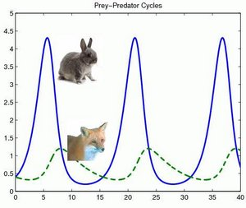

Figure : Linear Predator-Prey model graph2 x axis: Time, y axis: population

There are many different types of predator-prey models, including ones which take into account infections, where the prey is the susceptible species and predator the infecting species(Kermack-McKendrick)2, as well as ones which take into account organisms taking in nutrients, where they have a limited uptake(Jacob-Monod Model)2. However, the model which involves a predator which hunts the prey is called the Lotka-Volterra model, which is what my project will be focussing on.

### General

There most general Predator-Prey model considers two populations, in this case predator and prey, who’s sizes at time t are denoted by x(t) and y(t), where x and y are the population numbers. Changes in the population sizes of each population are denoted by *x*˙≡*dx*/*dt* and *y*˙≡*dy*/*dt,* where the two populations have now interaction with each other at this point. This means that the previous two equations consider only natural death rates rather than due to predation. The following two equations assume that the two populations interact with each other: *x*˙=*xf*(*x*,*y*) and *y*˙=*yg*(*x*,*y*) where f and g represent the per capita growth rate of the two species2.

### Lotka-Volterra

The Lotka-Volterramodel was proposed by both Vito Volterra and Alfred Lotka independently and at roughly the same time (1925/1926). Volterra proposed the model to explain population changes in fish while Lotka developed the model for a completely different area; to describe a chemical reaction where the chemical concentration oscillate. The equations for calculating both predator and prey population growth/fall are shown below2:

Prey: x˙ = (b−py) x

Predator: y˙ = (rx−d) y

Where:

· x˙ - The change in population size with time for the prey (linear per capita growth rate)

· y˙ - The change in population size with time for the predators (linear per capita growth rate)

· x - The population of prey

· y - The population of predator

· b - The growth rate of prey in the absence of predators (The rate at which they breed)

· p - The impact of predation on the prey

· r - The impact of predation on the predators

· d - The death rate of predators from lack of interaction with prey (death due to starvation)

Looking at the two equations above, it can be deduced that as the predator population rises, the linear per capita growth rate (x˙) will diminish and rise as the predator population falls. Similarly, the predator linear per capita growth rate (y˙) will increase as the prey population rises and decrease as it falls. Other variables also have influence in the equations. For example, increasing the death rate of predators (d) will overall reduce the population that they can reach throughout the cycle and give the prey an advantage. Increasing the growth rate of prey (b) will make it much harder for the predator to diminish their population effectively.

The graph below shows the change in populations of both species assuming that the value of all variables (b, p, r, d) are 1. The arrows depict the direction of population change, and their size depicts the speed of change. The cycle reaches equilibrium when both populations are equal to 1, and also when both are equal to 0.

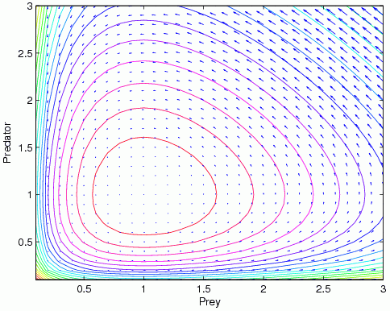

Figure : Lotka-Volterra Predator-Prey model graph2

Nature can be difficult to predict, so in order to simplify the model, it makes a few assumptions, the same of which will be made for my implementation14:

* The prey population will grow faster when the predator population is small
* The predator population will diminish when prey population is small
* There is no limit to the amount of prey a predator can consume
* The environment has no impact on the simulation (there are no obstacles that the predators can avoid but the prey cannot)
* Prey are immune to starvation

*“A good model must be simple enough to be mathematically tractable, but complex enough to represent a system realistically. Realism is often sacrificed for simplicity, and one of the shortcomings of the Lotka-Volterra model is its reliance on unrealistic assumptions.”*14

The quote above is true, but luckily, I am developing a system for use in video games, in which the realism is never expected to be on par with that of the real world, and as such, it will be completely fine to rely on unrealistic assumptions. Such assumptions include the prey being immune to starvation. In real life, the prey would also need to secure their food, and when populations are high enough, there might even be competition for it, as there are for the predators.

### Predator-Prey Model Summary

To summarise, predator-prey models can be used to explain the change in populations of two species that share a predator-prey relationship. I aim for the population changes in my system to match the Lotka-Volterra model as closely as possible, but it will be difficult to provide a perfect implementation as there are many things that I plan to use in my system that the model does not consider. For example, the model doesn’t consider the speed of the two species. This could cause problems as, for example, when the speed of the predators is much higher than that of the prey, the prey population will get diminished very quickly.

## Predators and Prey in The Games Industry

There are many games already published into industry which involve animals that have both predatory and prey natures. However, whether the game simulates realistic predator-prey relationships is a very different matter. Finding the answer to this problem has proven more difficult than simply researching normally, as a games focus is almost always on the player’s interaction with the world, not the worlds interaction with itself, even if the player gets to witness such an event. As such, information about predator-prey relationships in games is scarce. To solve this issue, I posed a question to the communities of some games which feature both prey and predator animals:

*“*I'm currently doing my dissertation on simulating predator-prey relationships using AI and am doing some research on video games that involve the use of animal AI. Does this game involve any interaction between predatory species and prey species? not including the player hunting the animals. For example, will the foxes hunt rabbits and will the player see this process happening? I played the first version of the game quite a while back but the only predator/prey relationship I remember is that of the player hunting the animals. The point of my dissertation is to provide a system which will improve realism in video games where predator/prey type animals are being used. Thanks in advance for any info.”

The question differs slightly for some of the games, for example, I have played both The Hunter and DayZ, but not Far cry Primal, so I removed the line about having played it. A description of these games are as follows, including some answers to the question above from each game’s community.

### The Hunter: Call of The Wild

The Hunter: Call of The Wild is a realistic hunting simulation game featuring a variety of huge maps adding up to a total of 50 square miles of terrain each with a different biome such as wetlands, forests, valleys and farm fields15. The game features a total of 25 different animals with many having different breeds, adding up to a total of 34. Both predatory and non-predatory animals are featured such as foxes, deer, lynx, ducks, bears and even lions16.

The game allows the player to track the many animals in their natural habitats using their footprints, droppings and mating calls, the animals can even be drawn toward the player by using items to make fake mating calls16.

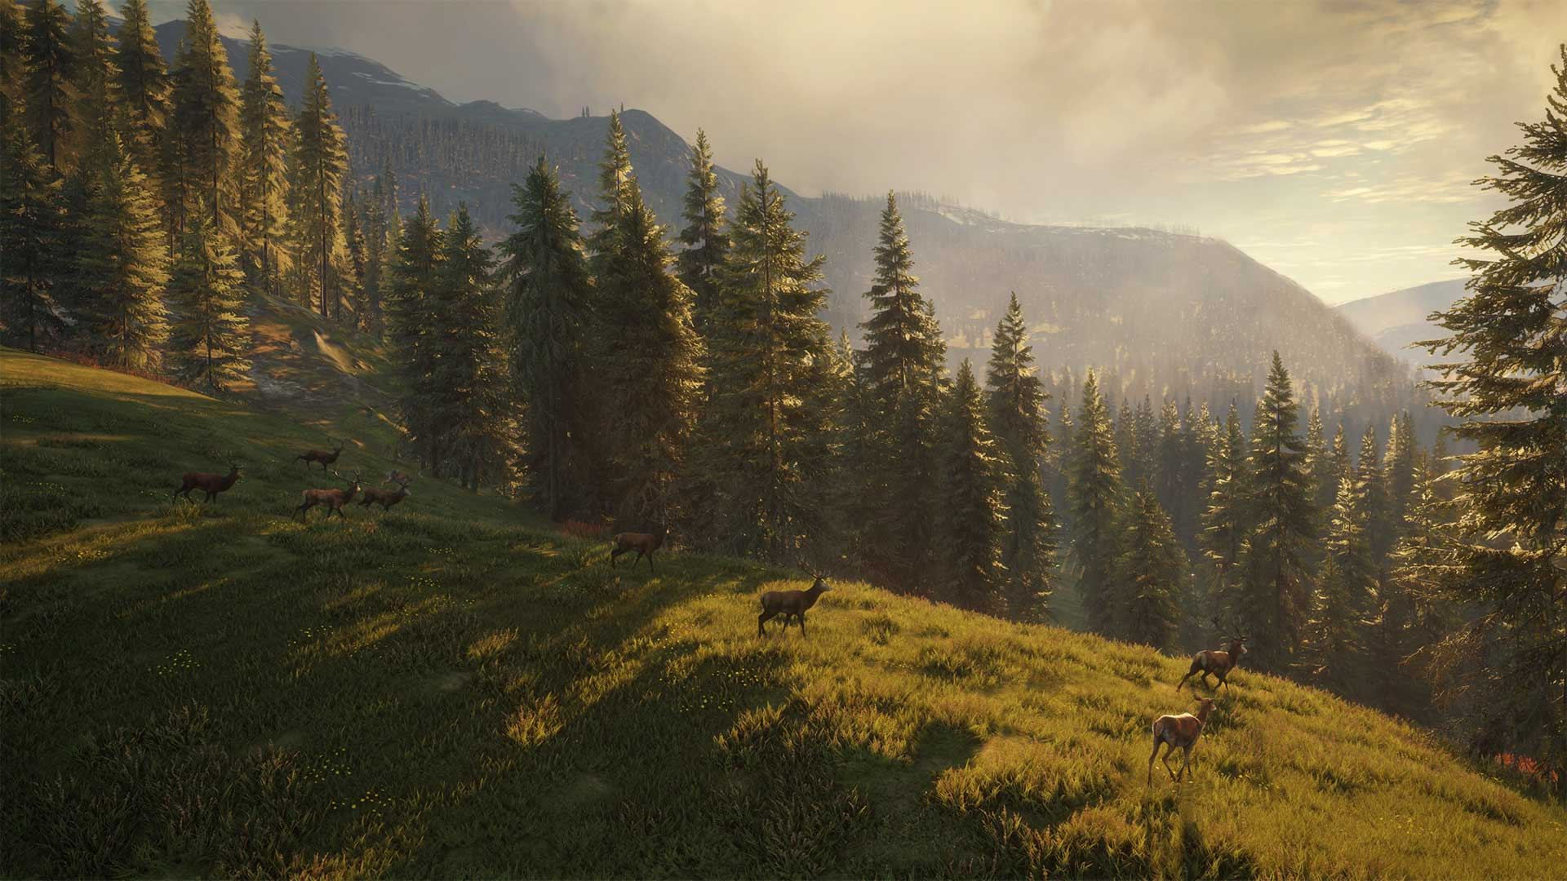

Figure : The Hunter: Call of the Wild in-game screenshot15

After conducting some initial research, the only evidence of a predator hunting prey is when said prey is the player. The only time when one animal will ever interact with another is when a predator gets close to a prey, the prey will get spooked and flee in the same way it will when the player gets too close, however the predator will not give chase. Additionally, it should be noted that if the player gets too close to a predator or spooks it, the predator may attack the player, but in this situation, the player is not a realistic prey.

The answers to the question posed to the game’s community are as follows:

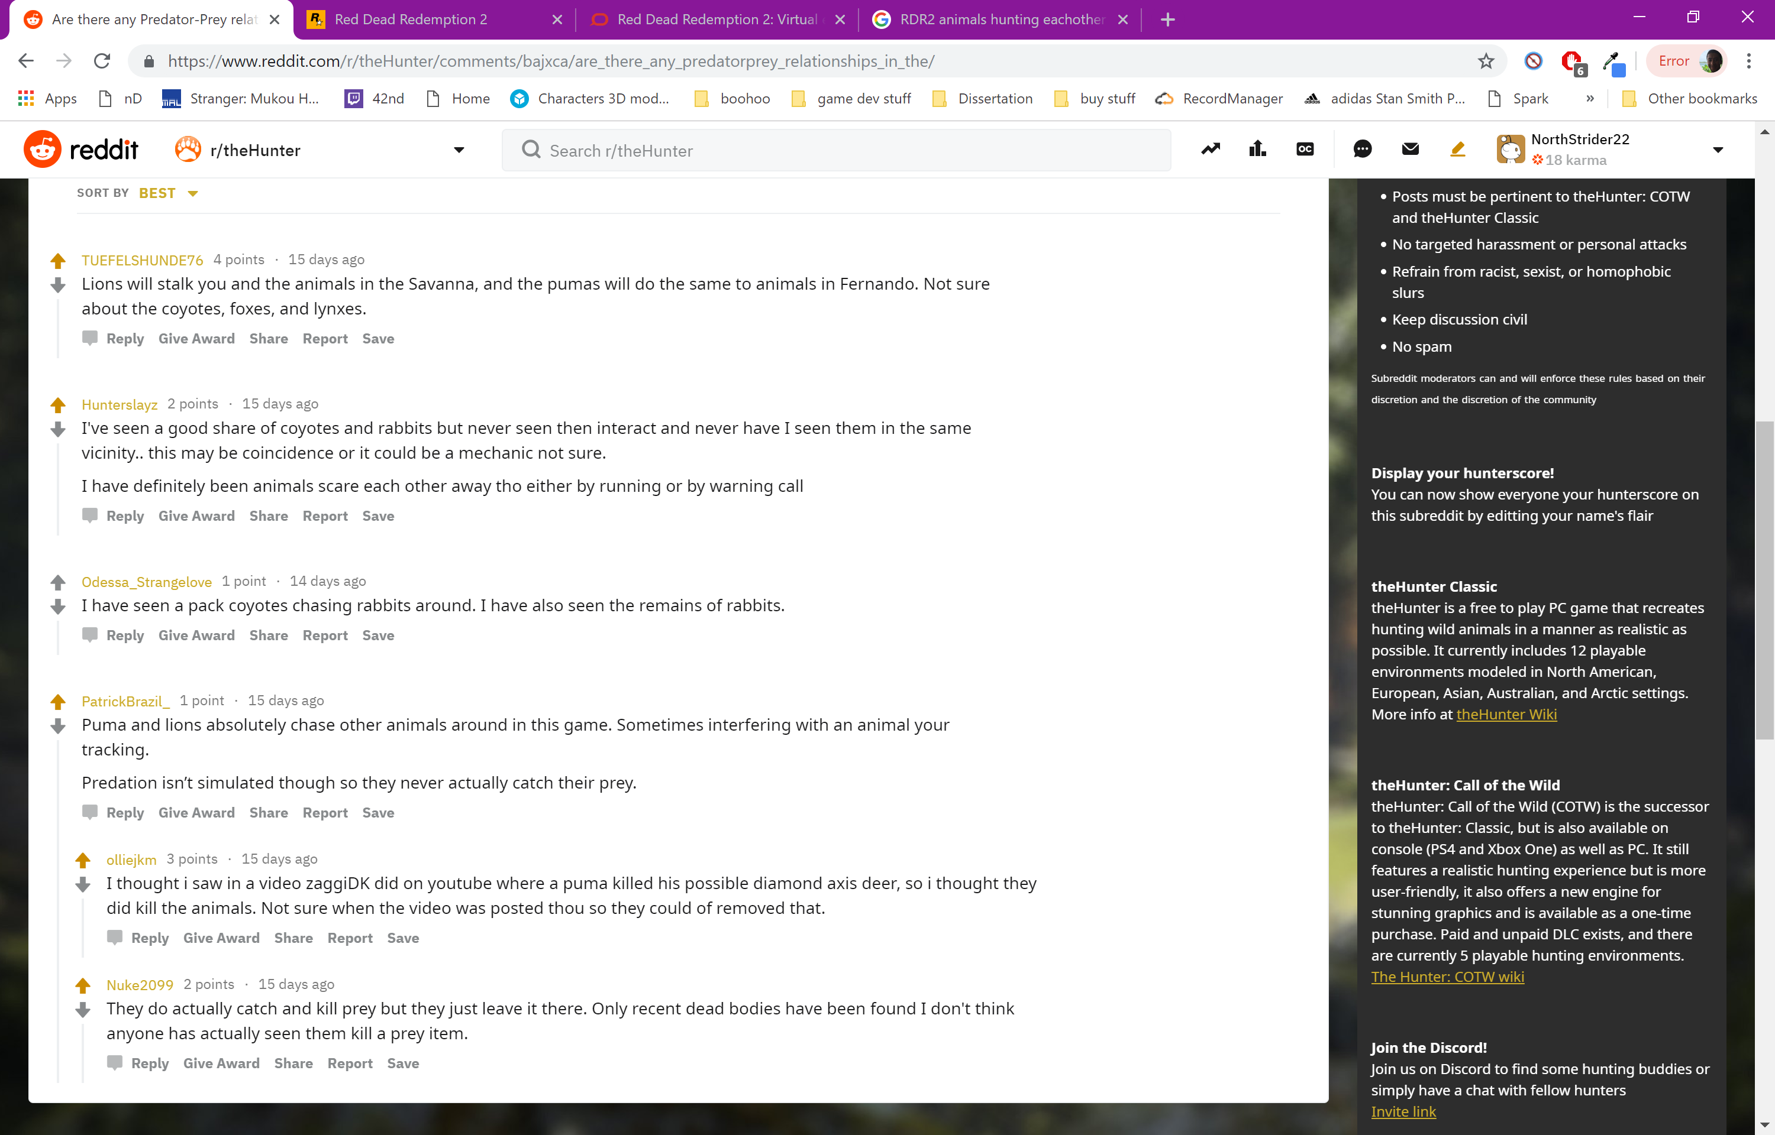

Figure : Question asked to The Hunter: Call of the Wild’s community17

The results seem rather inconclusive, some believe that the predators do hunt and kill their prey, but others believe that they only stalk them. User olliejkm mentions a video18 in which a puma killed the deer that he was hunting, however after watching the video, the puma is never seen.

User Nuke2099 mentions that predators do catch and kill their prey, but never in the sights of the player. This could mean that the game simply spawns the carcasses of animals around the map randomly and when the player finds one, it will tell them that it was killed by another animal. This certainly helps increase realism but allowing the player to witness the event happen would prove much more effective.

The main deduction I can make from these results is that the game does not simulate predator-prey relationships to the extent I was looking for, which is where predators and prey in the game world can affect each other’s populations noticeably.

### DayZ

Dayz3 is an open world multiplayer survival game playable on servers of up to sixty players. The goal of the game is simply to survive for as long as possible. This includes foraging and looting abandoned buildings for food, water, clothing, tools, weapons, ammunition and other items. Players must regularly satisfy their thirst and hunger and find better clothes to keep themselves warm. It includes several different species of animals which roam around the map, including cows, chickens, goats, sheep, rabbits, deer, bears, fox, and wolves19. The player can hunt these animals in order to harvest and cook their meat, satisfying their hunger. The major towns and cities in the game are also inhabited by zombies, which will attack on sight, forcing the player to defend themselves3.

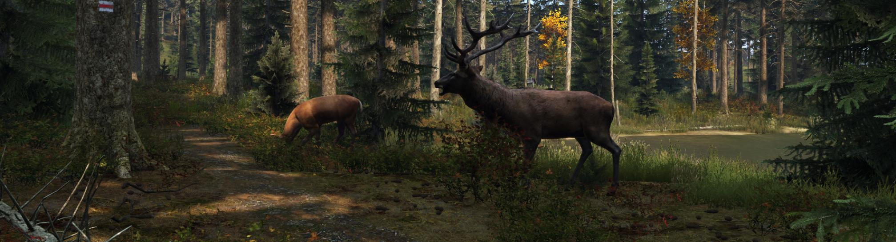

Figure : DayZ in-game screenshot3

From experience playing the game, I know that the wolves gather in packs and hunt the player, they also attack the zombies and the zombies attack back. However, both events are predator-predator relationships, not predator-prey, much the same with The Hunter: Call of The Wild. As expected, due to this being such a niche subject, more information is required.

The answers to the question posed to the game’s community are as follows:

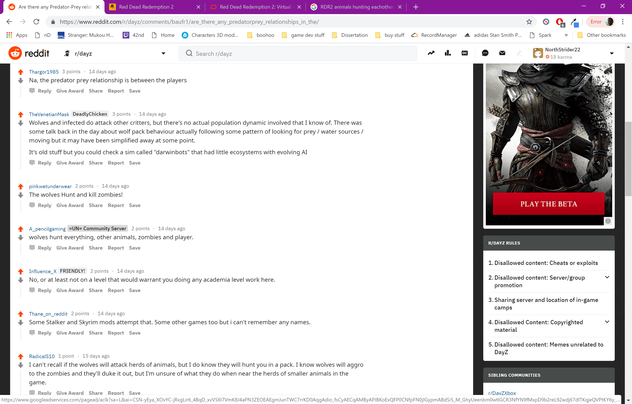

Figure : Question asked to DayZ’s community34

According to the answers above, wolves will hunt and kill other animals, but whether or not the player sees this process is unclear. According to user TheVenetianMask, there is no “population dynamic”, meaning that animals’ species cannot affect each other’s population in the game world, which is the kind of predator-prey relationship I am looking for.

### Farcry: Primal

Farcry: Primal20 is a similar game to DayZ, both being of the survival genre. Primal however, is set in the stone age, and as such modern technologies such as guns are not available. Instead the player must craft crude bows and spears in order to defend themselves against the dangerous beasts lurking the map. Animals include badgers, boars, mammoths, crocodiles, snow leopards, deer, elk and even rhinos21. The main feature of this game that makes it stand out from both The Hunter and DayZ is that not only can the player hunt the animals, but they can tame them and use them as a weapon. After taming an animal, it can be ordered to attack other animals, or humans.

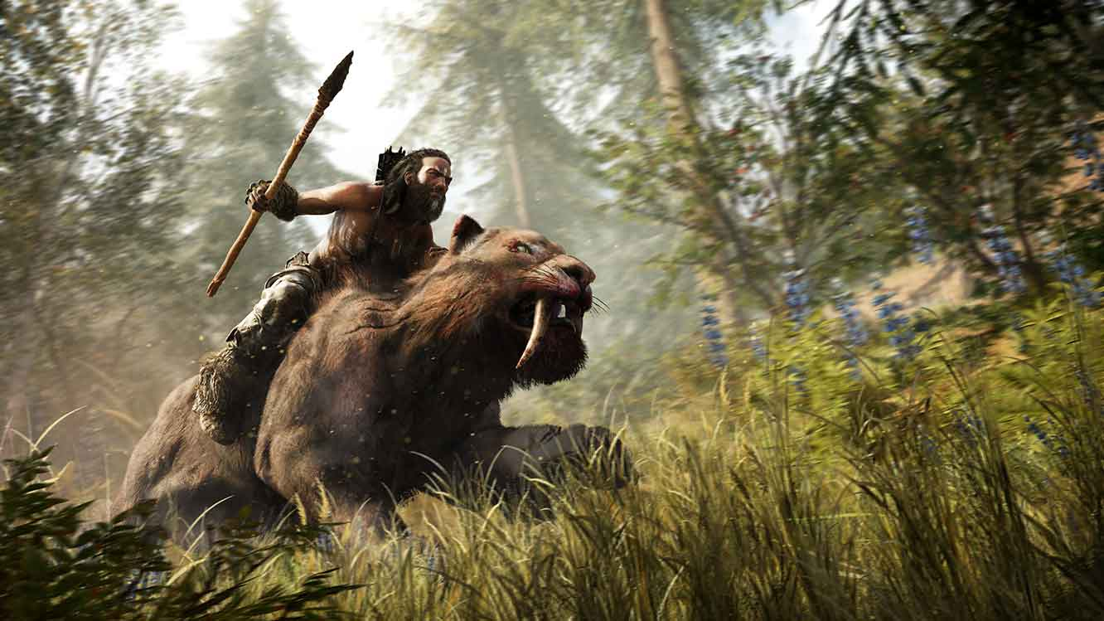

Figure : Farcry: Primal in-game screenshot20

Obviously, this means that predators can indeed hunt prey, but as this is a game mechanic used specifically by the player, it’s not likely to help with improving the overall realism of the game.

The answers to the question posed to the game’s community are as follows:

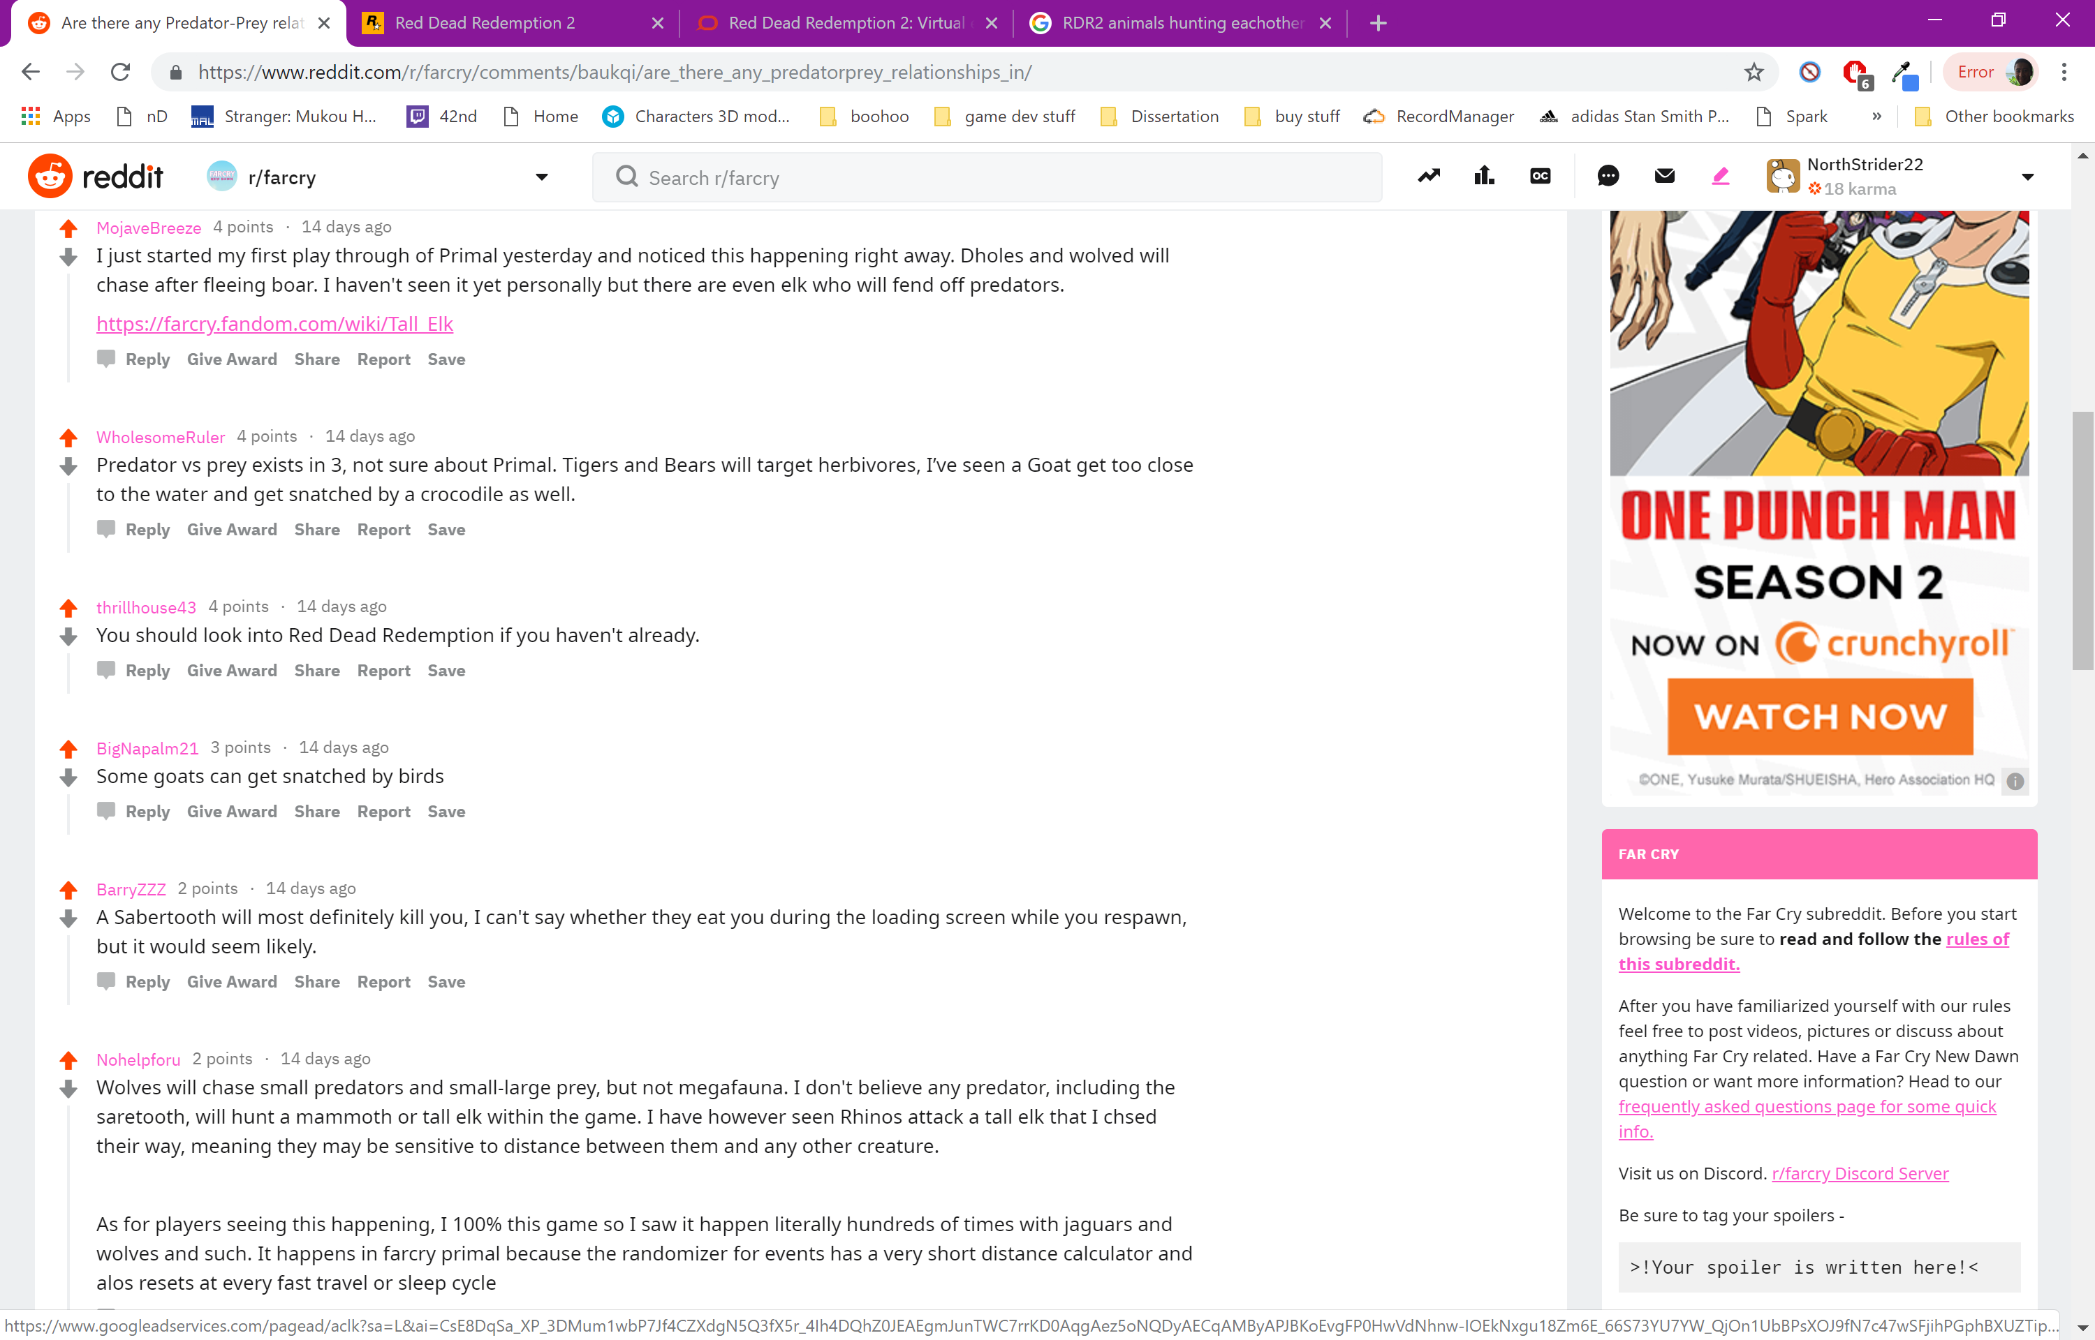

Figure : Question asked to Farcry; Primal’s community 1/233

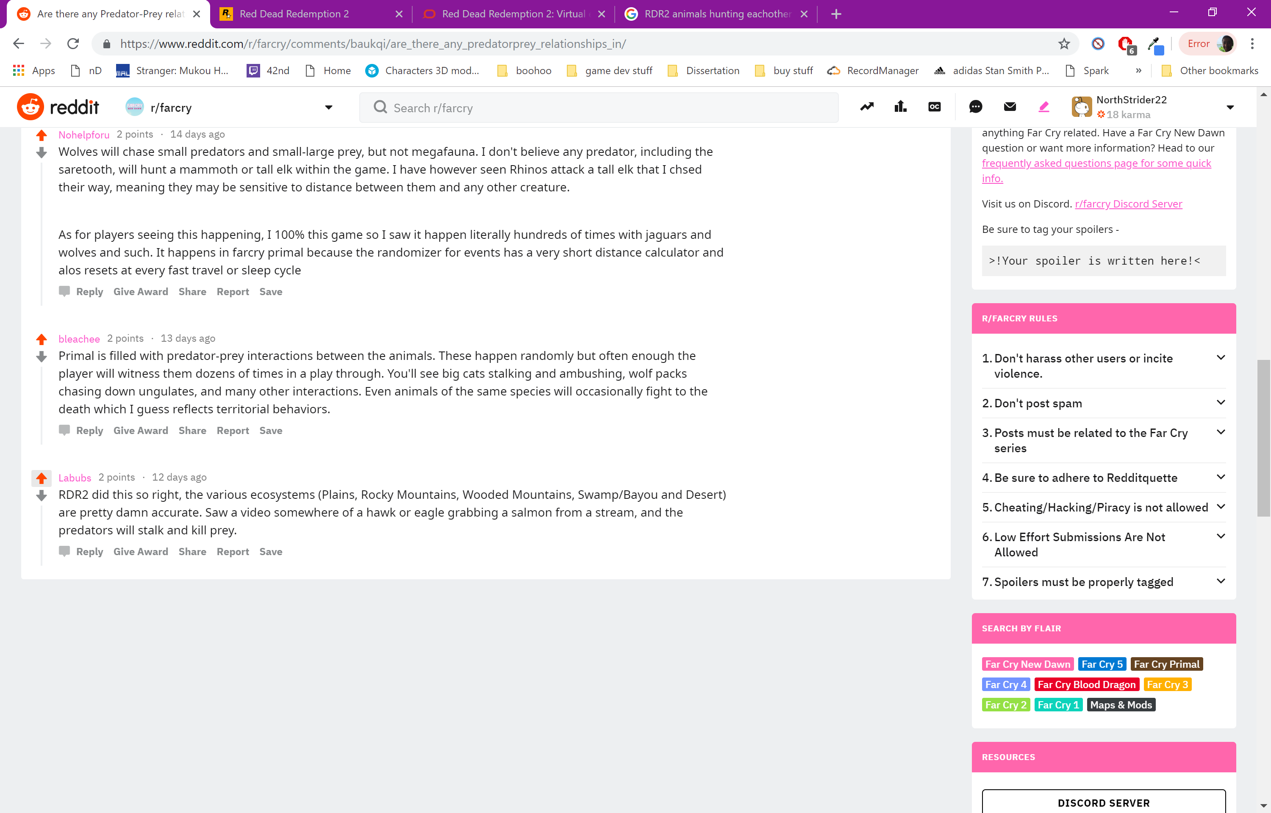

Figure : Question asked to Farcry: Primal’s community 2/233

The consensus is that animals do in-fact hunt and kill other animals, and this process is seen by the player on a regular basis. This behaviour is much closer to what I am looking for, there is however no evidence of species having impacts on the populations of other species. Meaning that throughout the game you would likely not see any difference in the numbers of each type of creature.

Both users thrillhous43 and Labubs mention the recently released game Read Dead Redemption 2, and although I had plans to play the game after finishing the academic year, I had no idea that It has implemented an incredibly impressive wildlife system. More information on RDR2 is provided below.

### Red Dead Redemption 2

Sequel to the immensely successful Read Dead Redemption, developed by Rockstar, Red Dead Redemption 2 provides an open world Wild West experience set in 1899, near the end of the Wild West era. The game features a deep storyline, intriguing characters and enjoyable gameplay, but most relevant of the games many features is its wildlife system. RDR2 map consists of several different biomes spread throughout the map which are populated by over 200 different species of animal.31 Considering that The Hunter has only 25 different species, and its gameplay is focussed entirely on its wildlife system and the players interaction with it whereas RDR2 is more of a story oriented game, this just goes to show just how much effort Rockstar put into the wildlife populating their game. Due to their overwhelming success, investing time into the game’s ecosystem system is obviously important for these types of games.

The animals that populate the various ecosystems of RDR2 also exhibit various behaviours that not only involve interaction with the player, but also interaction with the game world itself. For example, alligators will lie in wait beneath the surface of the water before pouncing on any prey that ventures too close. This prey includes both the player and other animals. Prey species such as Deer or Horses will also flee at the first sign of a nearby predator, such as a Cougar or a Bear.32 This is the type of world on world interaction that I’ve been looking for, rather than only player on world interaction.

Below is a link to a video39 showing a prime example of world on world interaction. A Wolf contests a Bear for its meal and although they do not fight, the fact that the player can stand on the side-lines and watch the interaction take place really enhances realism. Not everything in the world revolves entirely around the player, animals are living their own lives and do not exist entirely for giving the player something to fight. If the wolf was with a pack rather than alone, the situation might have been very different, the wolves may have decided to attack the bear in order to secure the food.

<https://www.youtube.com/watch?v=R1WZrs-T_Rc>

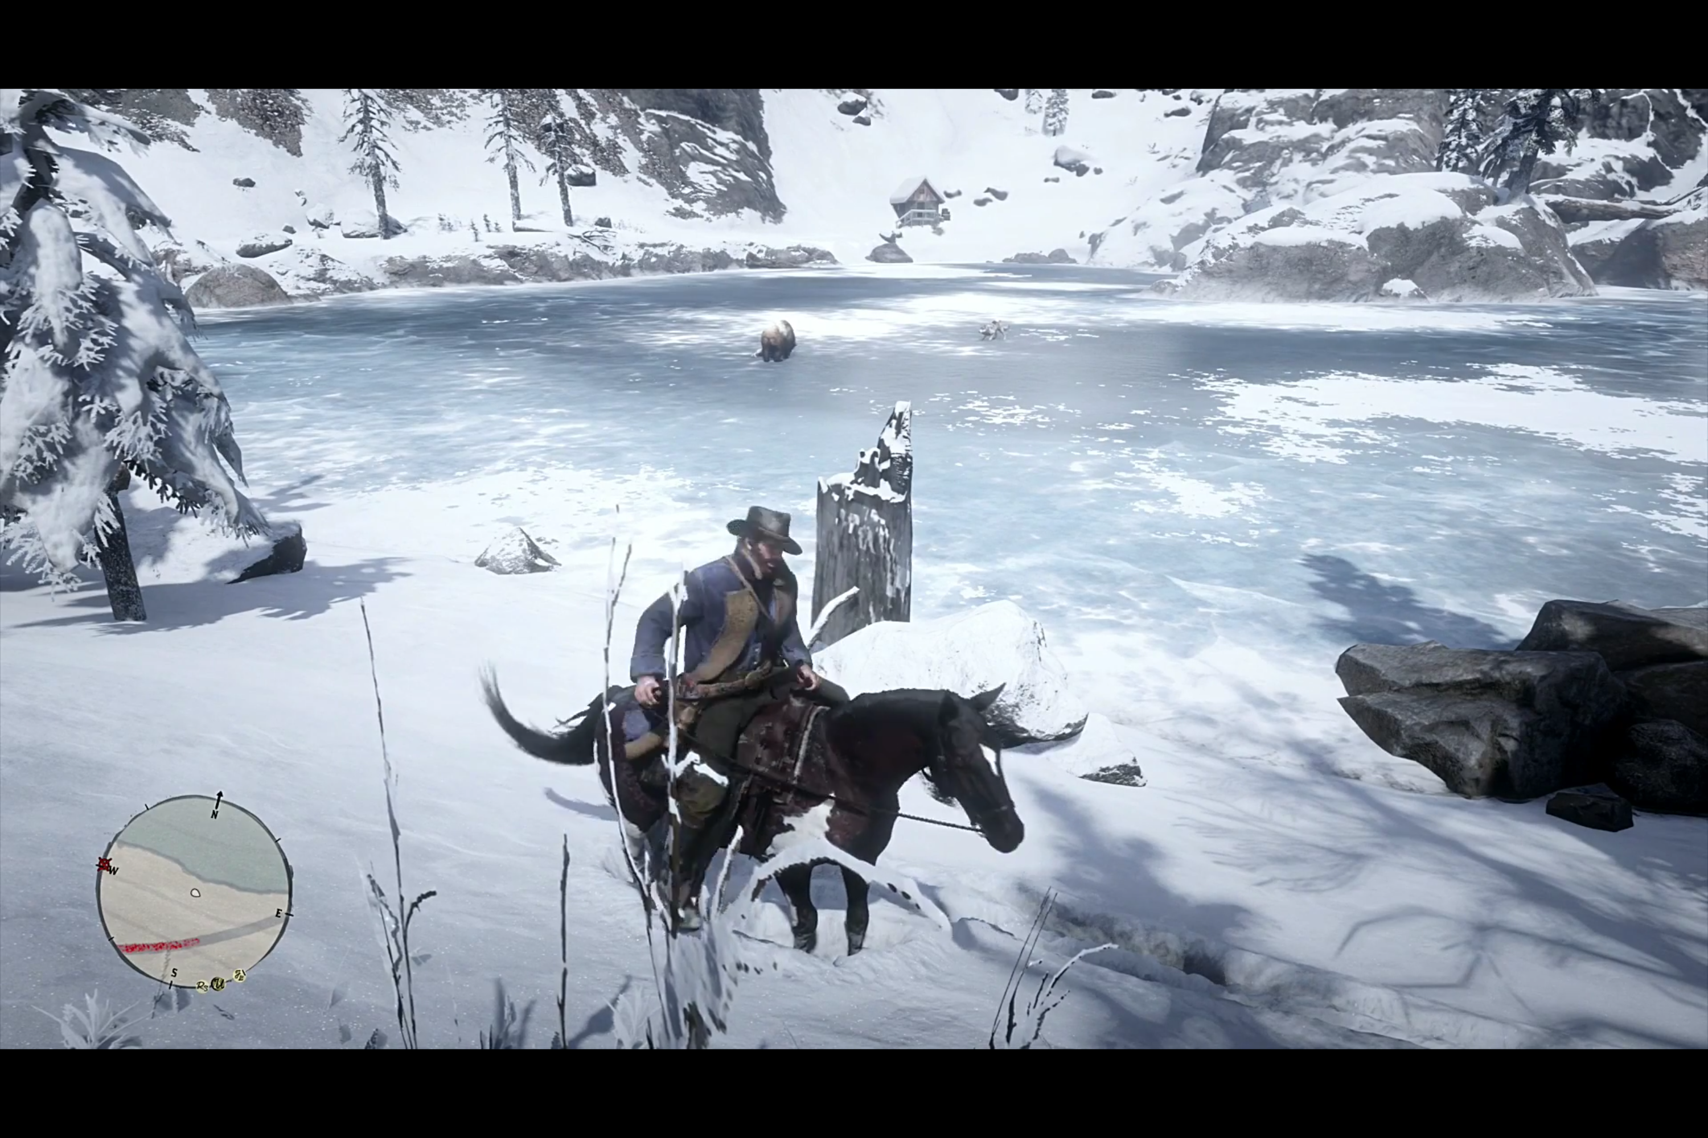

Figure : Red Dead Redemption 2 wolf contesting Bear in-game screenshot39

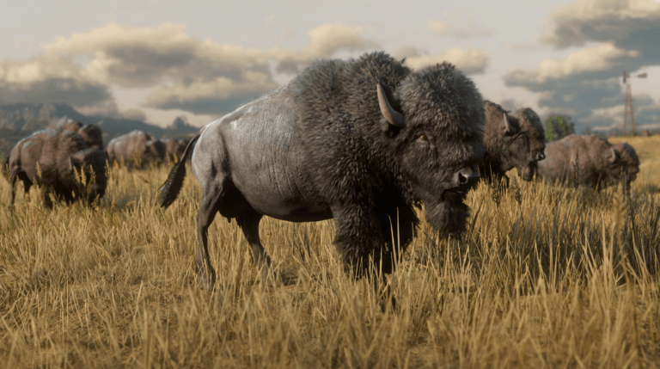

Figure : Red Dead Redemption 2 in-game screenshot30

### Predators and Prey in The Games Industry Summary

To summarise, many video games implement wildlife systems, but most of these systems in the past lack the amount of realism that I’m looking for. By this I mean that they only implement gameplay mechanics between the animals and the player, rather than the animals and other animals. Read Dead Redemption 2 is a prime example of a successful wildlife system in my opinion, and the game’s success speaks for itself. As the sophistication of technology increases in the games industry, the possibilities for wildlife systems only grows, and more powerful hardware allows developers to make these systems much more complex. I imagine in the next few decades we’ll be seeing open world games like RDR2 featuring entire herds of animals thousands deep. Recent games that give us a glimpse of this kind of future are World War Z35 and Days Gone36, both of which feature huge hordes of zombies that literally have to crawl over each other to get to the player.

The screenshot below is from live gameplay footage of World War Z which shows a horde of zombies climbing over each other to get up to the player.37

<https://www.youtube.com/watch?v=EAoDX2hyvB8>

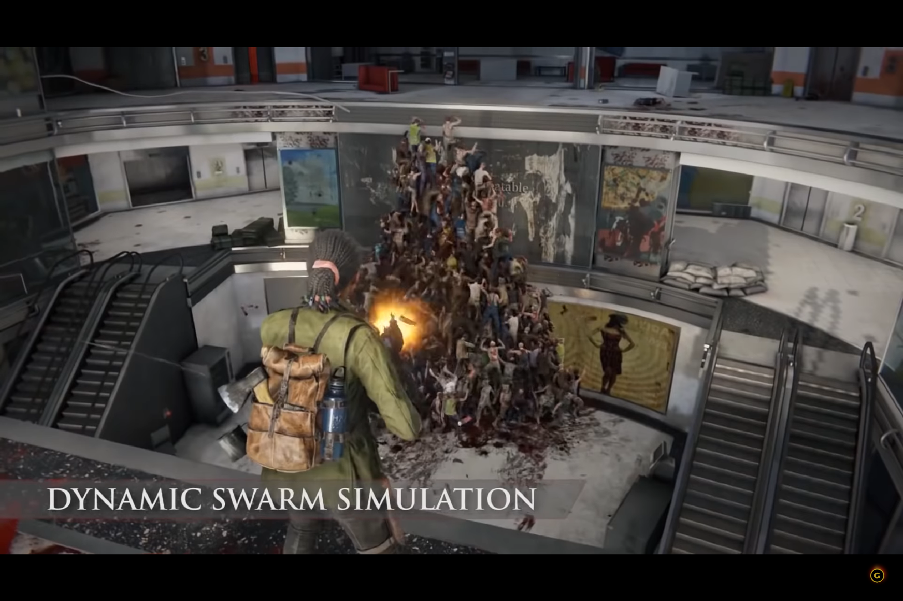

Figure : World War Z zombie swarm37

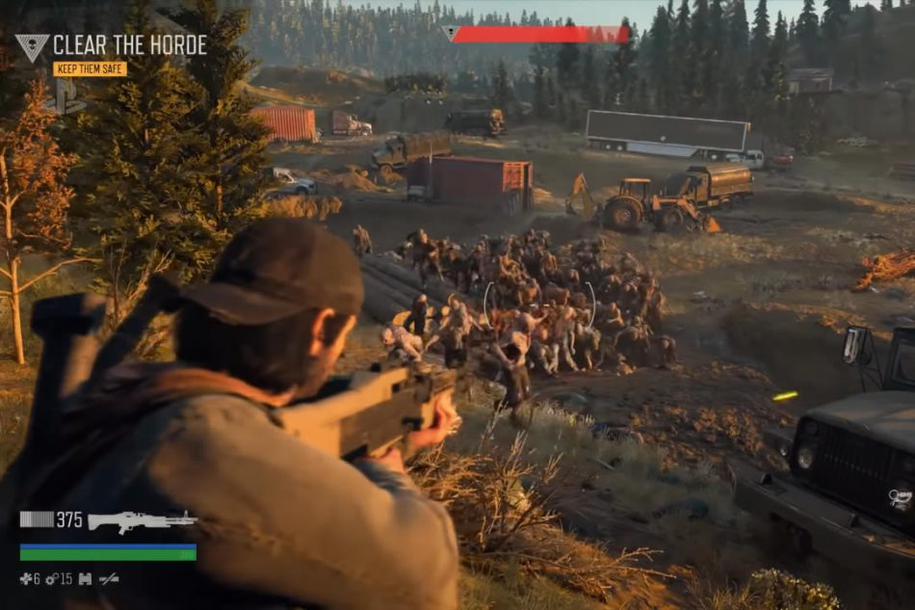

Figure : Days Gone zombie horde38

# Methodology

This chapter will explain what was done throughout the project and why. I will detail the design of the system, as well as the various stages of implementation that the system went through, split into versions. I will also explain the tools I used, and why I chose these tools. Any problems encountered throughout the project will be brought up and explained at appropriate times (in the section of the version they were encountered). A system architecture of the finished system will be provided at the end of the chapter.

## Tools

### Unity

The system I am creating is more of a simulation than a playable game, so it might be strange choosing a game development engine to complete this project. However, my motivation for doing so is that after having developed multiple games in both my personal and academic time, I am very comfortable with Unity and its inner workings. Using Unity would likely save me a huge amount of time overall, time that would have been spent getting to know the platform and making unnecessary mistakes had I chosen something that I was completely unfamiliar with. Another reason for using Unity is the abundance of external assets provided by the community through the Unity Asset Store24. The store provides a huge amount of both free and paid assets ranging from animations and 3D character models to User Interface addons and scripts. Additionally, Unity has a huge amount of documentation available online, covering both their unique tools, and using the language C# in conjunction with these tools, providing an abundance of help.

### C#

Unity supports multiple scripting languages, including UnityScript (JavaScript) and Boo25, I’ve chosen to use C# for this project because, as mentioned above, I have developed multiple games using Unity, in which I used C#. The benefits of sticking with C# are the same as sticking with Unity, but there are a few added benefits of not switching to either UnityScript or Boo. For one, C# is a very popular language, much more so than the alternatives, and as such C# is likely to have much more documentation online, so finding help and solutions to any problems I run into will be much easier25. Secondly, although UnityScript might provide simpler syntax, C# is more likely to catch errors at compile time25. This is likely to save me a lot of time in the long run.

### Flocking

Flocking is more of a technique than a tool, but it is so significant to the system that it should be mentioned here. As explained in the research chapter, flocking allows for realistic animal like behaviour using a simple set of behaviours that can be coded easily.

### Dynamic Line Chart

Dynamic Line Chart26 is an external asset provided on the Unity Asset Store24. It allows for the creation of line charts which dynamically update with data at runtime. The asset will be used to monitor the populations of predator and prey at runtime, and the finished system should be able to produce a graph that looks like the ones produced by actual predator-prey models, as can be seen in the research chapter.

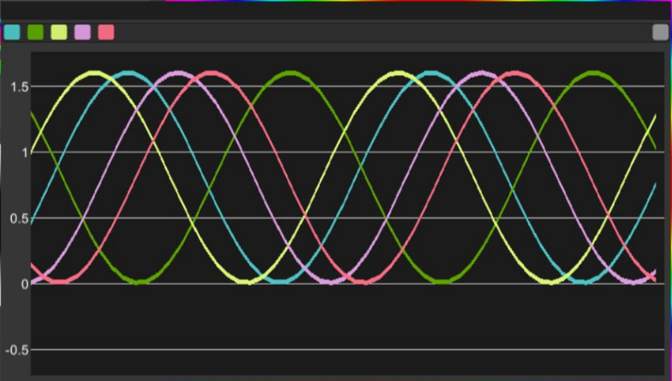

Figure : Dynamic Line Chart example26

## Planning

From the start of the project I decided to use an agile development model, as after a few years of experience using different development models, agile is the one I am most comfortable with. I much prefer doing both research and development at the same time, as if I encounter any issues during development, or want to add any extra features, I can easily do some extra research on the relevant subjects.

The brunt of the background research was done during the start of the first semester with the implementation beginning shortly after that. Multiple versions have been developed since that time, as will be explained further down, with the most recent version being finished during the Easter break. The implementation process consisted of several ‘sprints’ that are common in an agile development cycle, and the direction that the project took was intentionally flexible, as in my experience, not everything can go as planned. This gave me a lot of breathing room to add in new features when required, or even remove features that were detrimental to the project. The implementation is finished but there are still many features that could be added which I didn’t have time to complete. These will be outlined in the conclusion chapter.

## Requirements

### Functional

|  |  |
| --- | --- |
| Name | Description |
| F1 | The system will represent a general (Lotka-Volterra) predator-prey model accurately. |
| F2 | Predators and Prey will realistically represent their real-world counterparts. |
| F3 | A dynamic line chart will be provided to help monitor the populations. |
| F4 | A seasonal system will dictate when hibernation begins. |
| F5 | Code will be documented. |

Figure : Functional requirements

### Non-Functional

|  |  |
| --- | --- |
| Name | Description |
| F1 | Code and documentation will be written well and easy to understand. |
| F2 | Scripts will be easy to extrapolate and use. |
| F3 | Prey will use flocking to represent realistic movement. |

Figure : Non-functional requirements

## Design

As explained in the objectives, there are a few things that I needed to decide on before beginning implementation; define a set of at least 5 rules that the AI must follow to keep the conditions controlled and to define a set of 3 pass criteria that can be used in the conclusion to deduce whether or not I have succeeded in my aim. These are explained below.

### AI Rules

1. Predators have a fixed speed
2. Predators have a maximum sight distance
3. Predators have a cooldown before they can begin chasing again after catching a prey
4. Prey have a min and max breed timer limit
5. Prey have a maximum speed

### Pass Criteria

1. When the population of prey rises, so does population of predators
2. When the population of prey drops, so does the population of predators
3. This process repeats itself continually

## Implementation

### Version 0.1

This is very early stages of the project; the brunt of the research was still being done and this version was to simply test code that moves lots of different agents to specific goals. At start, each agent will travel to the nearest goal, which are the green rectangles around the edges of the map. The red agent is the earliest test of a predator, who simply moves around the map randomly.

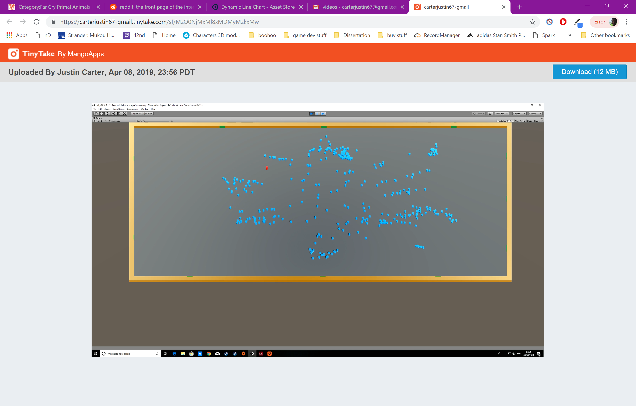

Figure : Version 0.1 screenshot

Link to a video showing this version running is below:

<https://carterjustin67-gmail.tinytake.com/sf/MzQ0NjMxMl8xMDMyMzkxMw>

### Version 0.2

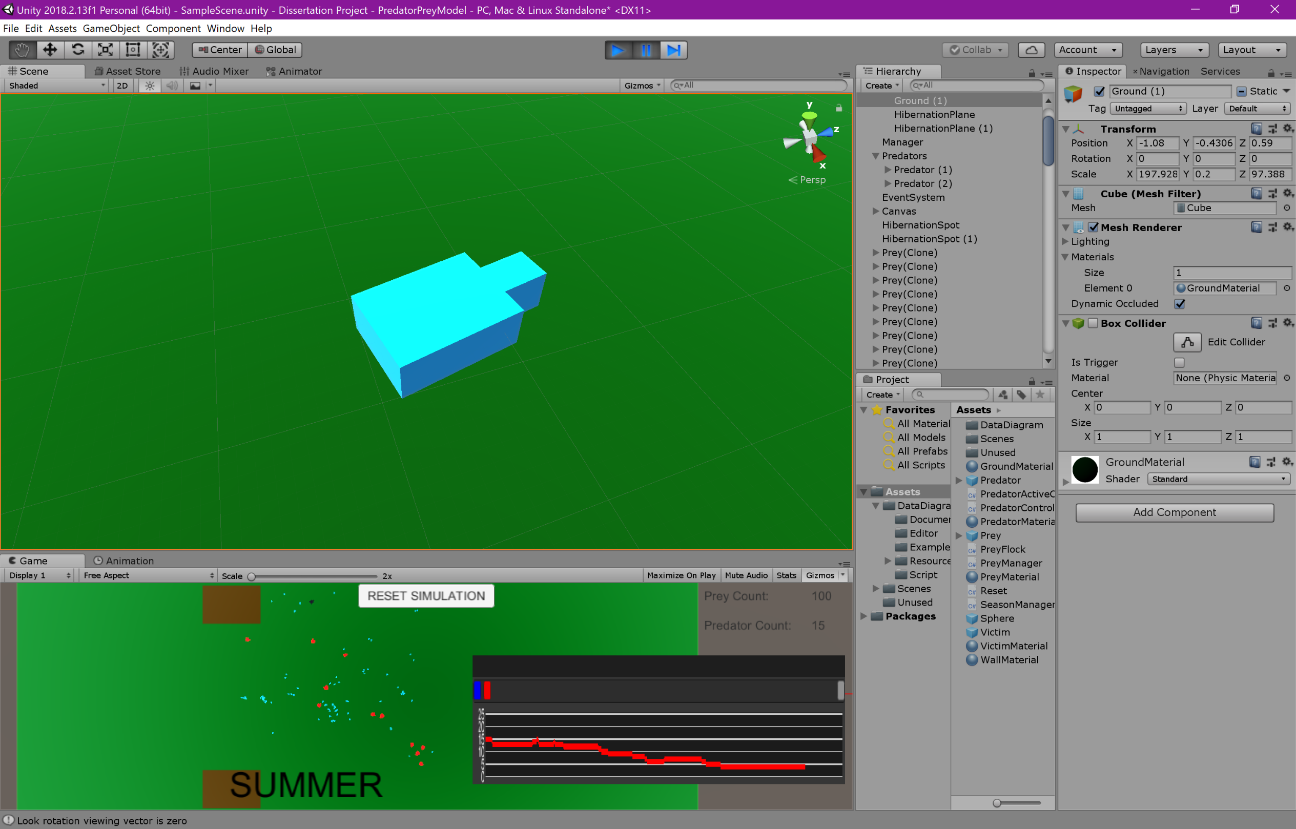This version implements flocking behaviours for the first time. The system is very primitive and only one flock can be formed for all the agents as there is only one goal that they will all travel towards. This goal updates with a new location periodically allowing the flock to move around the map but keeping them within the view of the camera. There is some code which attempts to prevent the prey from leaving the bounds of the sectioned off area, however this method proved ineffective as the prey would manage to force their way through regardless. This feature is removed in later versions as keeping the goals within the view of the camera is sufficient. I also altered the shape of the agents; instead of a blue cylinder I used two rectangles, one to represent the body and one to represent the head. This makes it much easier for the viewer to discern which direction the prey object is facing.

Figure : Prey 3D model

The behaviours are implemented using a single script “PreyFlock.cs” which runs on each prey object.

The main problem with this version is that the prey form one huge flock, which isn’t very realistic. In the natural world, animals that are far away from each other would not know to travel to the same goal.

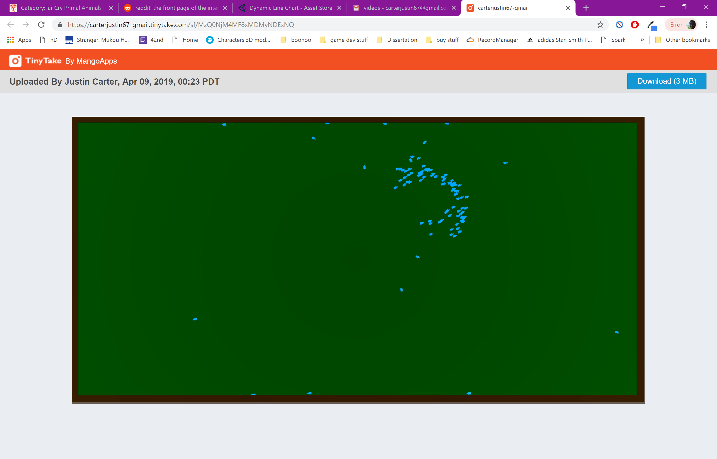

Figure : Version 0.2 screenshot

Link to a video showing this version running is below:

<https://carterjustin67-gmail.tinytake.com/sf/MzQ0NjM4MF8xMDMyNDExNQ>

### Version 0.3

This version allows the prey to form multiple flocks instead of a singular large one. This is done by giving each prey agent a ‘superiority value’. When at least two prey are within range of each other, the one with the highest superiority value will become the leader of the flock. This leader will then choose the positions of the goal, which all prey in the same flock will travel towards. This allows flocks to both combine and split off. At this point, the flocking algorithms were working very well, so I proceeded to begin work on the predators.

The problems with this version are that the code attempting to keep the prey within the bounds is quite ineffective and looks very unrealistic as can be seen in the video.

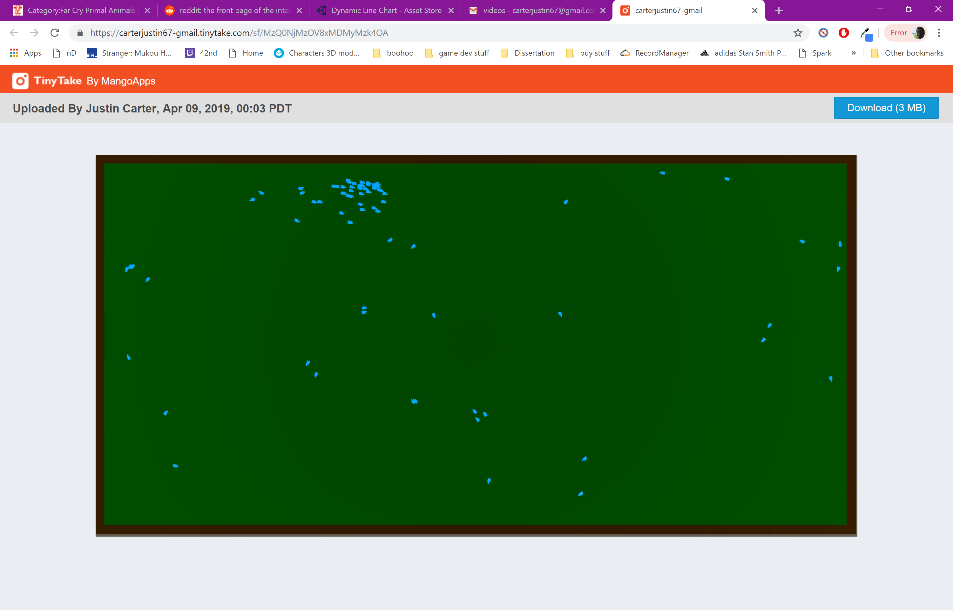

Figure : Version 0.3 screenshot

Link to a video showing this version running is below:

<https://carterjustin67-gmail.tinytake.com/sf/MzQ0NjMzOV8xMDMyMzk4OA>

### Version 0.4

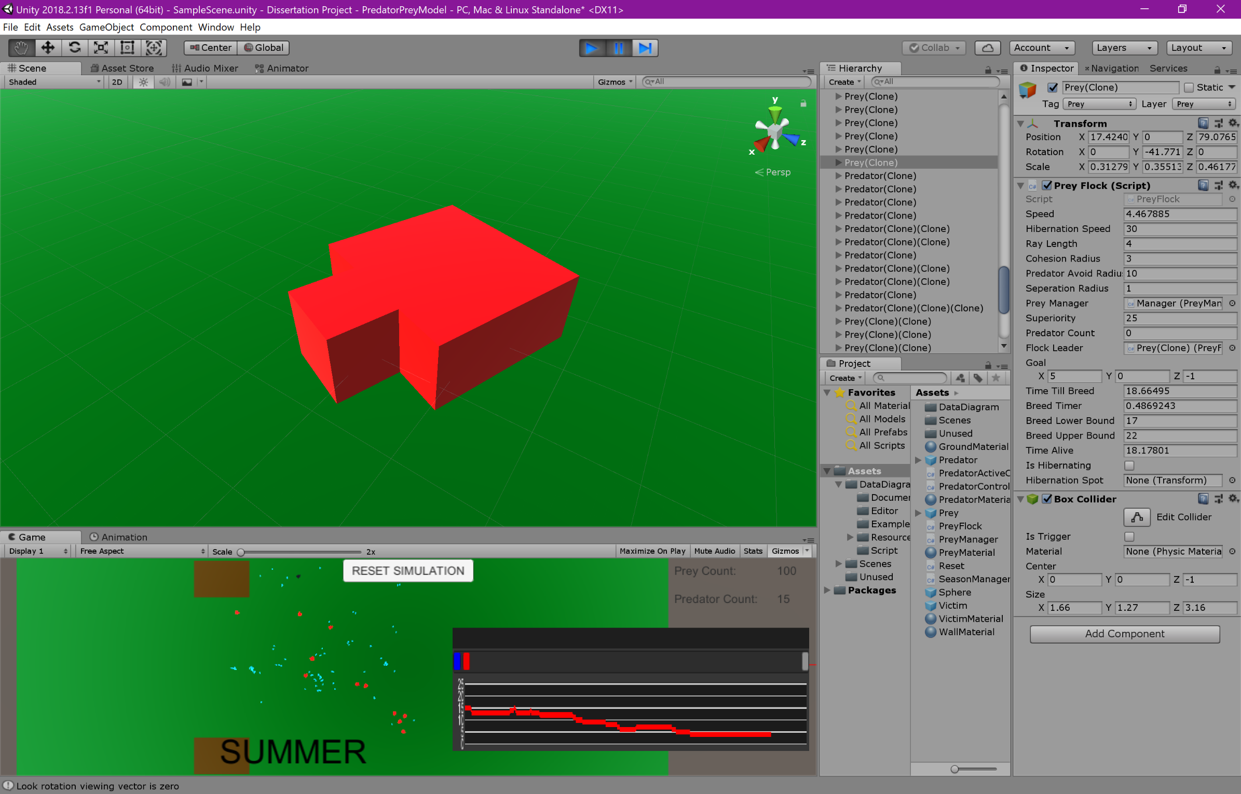This version sees the first implementation of predators, as well as life and death systems for both predator and prey. For the prey, this means that whenever they are caught by a predator, they are killed and eaten (object is destroyed) and they also reproduce periodically (new prey object is instantiated). For predators, this means that whenever they successfully catch and eat a prey object, a new predator is instantiated, and predators will die if they go a certain amount of time without eating.

Figure : Predator 3D model

For the predators to be able to see and chase the prey, I implemented a mechanism akin to the sense of sight that real animals will have. Each predator object shoots three raycasts27 out of the front of its head, one angled to the left, one angled to the right and one shooting straight down the middle. These raycasts are basically lines that are constantly shooting from a starting point, in a certain direction and have a certain distance. When sending out the raycast, it can be checked if the line hit an object on a certain layer27, in this case, that layer would be “Prey”. If the predator sees a prey object using these raycasts, it will lock onto that prey and begin chasing. The white lines in the picture below indicate how the raycasts work. As soon as a prey touches one of the lines, the predator will begin chasing.

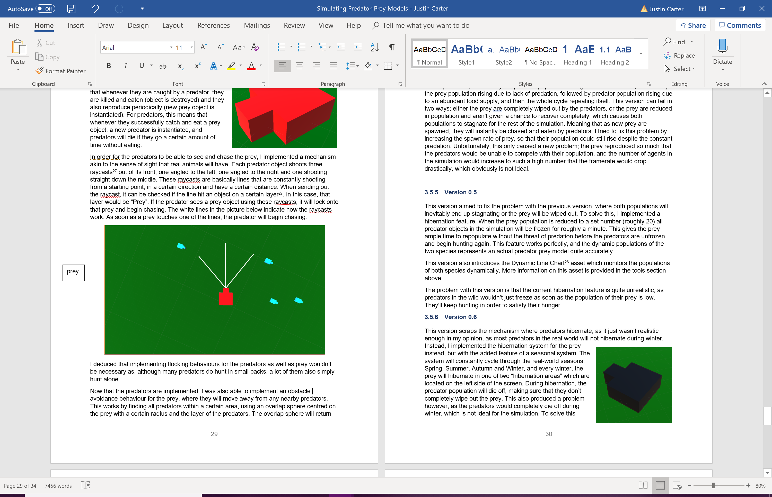

Figure : Predator sight visualisation

I deduced that implementing flocking behaviours for the predators as well as prey wouldn’t be necessary as, although many predators do hunt in small packs, a lot of them also simply hunt alone.

Now that the predators are implemented, I was also able to implement an obstacle avoidance behaviour for the prey, where they will move away from any nearby predators. This works by finding all predators within a certain area, using an overlap sphere28 centred on the prey with a certain radius and the layer of the predators. The overlap sphere will return any predators within and use them in the same way that prey use separation, causing the prey to move away from any nearby predators.

The main problem with this version is with the balance between predator and prey. The finished system is expected to simulate a real predator-prey model, where the prey population falls due to predation, followed by the predator population falling due to lack of food, followed by the prey population rising due to lack of predation, followed by predator population rising due to an abundant food supply, and then the whole cycle repeating itself. This version can fail in two ways; either the prey are completely wiped out by the predators, or the prey are reduced in population and aren’t given a chance to recover completely, which causes both populations to stagnate for the rest of the simulation. Meaning that as new prey are spawned, they will instantly be chased and eaten by predators. I tried to fix this problem by increasing the spawn rate of prey, so that their population could still rise despite the constant predation. Unfortunately, this only caused a new problem; the prey reproduced so much that the predators would be unable to compete with their population, and the number of agents in the simulation would increase to such a high number that the framerate would drop drastically, which obviously is not ideal.

### Version 0.5

This version aimed to fix the problem with the previous version, where both populations will inevitably end up stagnating or the prey will be wiped out. To solve this, I implemented a hibernation feature. When the prey population is reduced to a set number (roughly 20) all predator objects in the simulation will be frozen for roughly a minute. This gives the prey ample time to repopulate without the threat of predation before the predators are unfrozen and begin hunting again. This feature works perfectly, and the dynamic populations of the two species represents an actual predator prey model quite accurately.

This version also introduces the Dynamic Line Chart26 asset which monitors the populations of both species dynamically. More information on this asset is provided in the tools section above.

The problem with this version is that the current hibernation feature is quite unrealistic, as predators in the wild wouldn’t just freeze as soon as the population of their prey is low. They’ll keep hunting in order to satisfy their hunger.

### Version 0.6

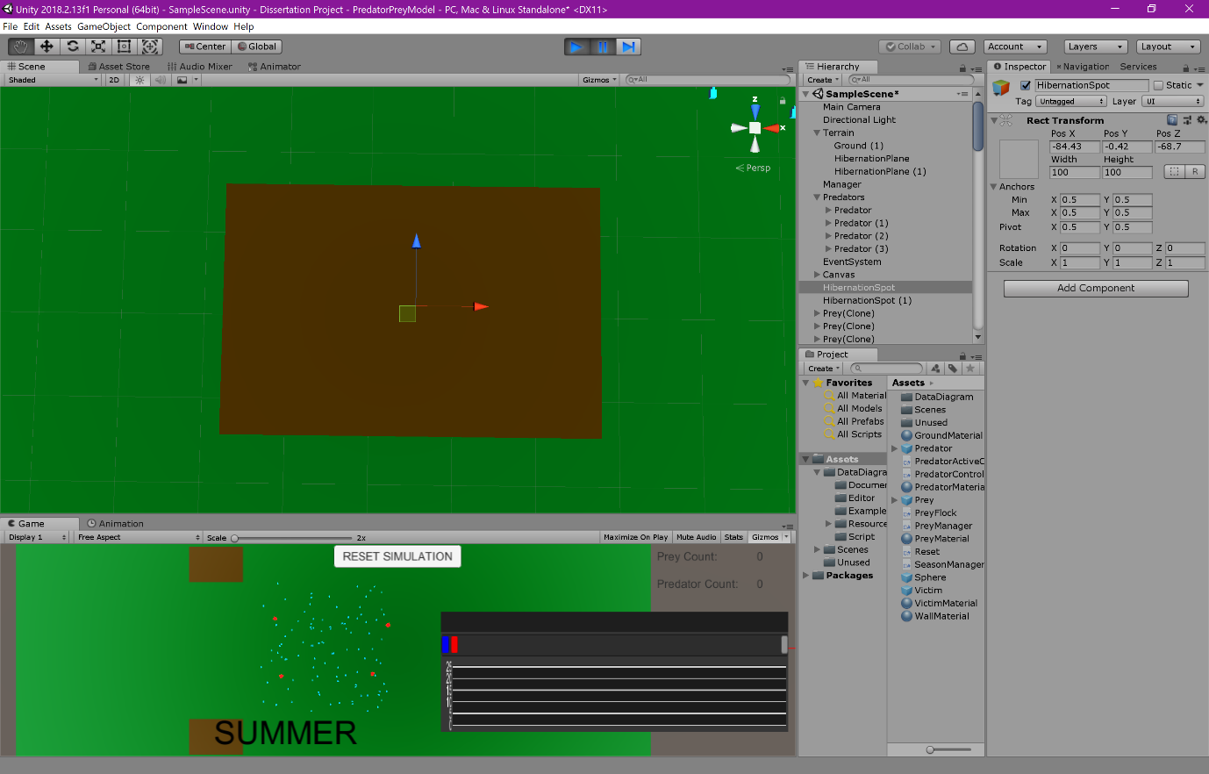This version scraps the mechanism where predators hibernate, as it just wasn’t realistic enough in my opinion, as most predators in the real world will not hibernate during winter. Instead, I implemented the hibernation system for the prey instead, but with the added feature of a seasonal system. The system will constantly cycle through the real-world seasons; Spring, Summer, Autumn and Winter. Every winter, the prey will hibernate in one of two “hibernation areas” which are located on the left side of the screen. During hibernation, the predator population will die off, making sure that they don’t completely wipe out the prey. This also produced a problem however, as the predators would completely die off during winter, which is not ideal for the simulation. To solve this problem, I implemented a system which would allow some predators to become “alphas”. These special predators are completely immune to hunger, and have some slightly enhanced stats, making them slightly stronger than typical predators. In order to decide if a certain predator should become an alpha, I implemented a “superiority” value for each predator, much like prey have. The value ranges from 1 to 100 and predators with a superiority of 95 or over become an alpha. This allows the predator population to survive through winter. Alphas are coloured black, rather 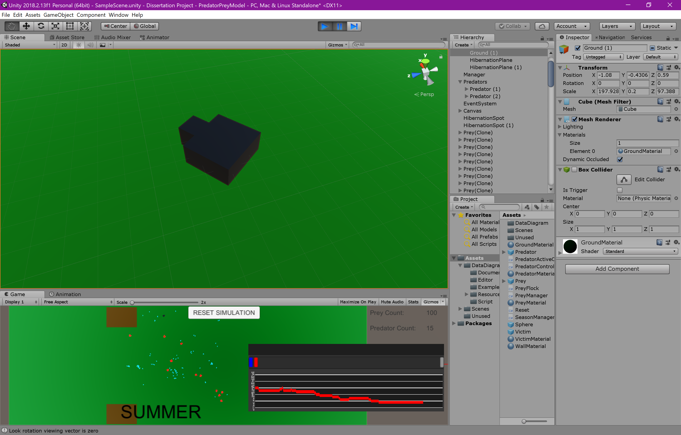than the red of a typical predator and there is a maximum number of alphas to make sure that not too many predators survive through winter, the ideal amount seems to be four.

Figure : Hibernation spot 3D model

Figure : Alpha 3D model

Although these new features solved almost all of my problems, they also created one; during winter, since there are no prey around for them to chase, the alphas would end up wondering too far away from the “habitat” (in the view of the camera). When winter ends and the prey come out of hibernation, the predators are too far away to see them, causing the prey to end up with a huge population, as there is no predation whatsoever. To solve this issue, I implemented another “sense” for the predators. I called this sense smell, as it allows the predators to move in the general direction of the closest prey. To implement this, I used an overlap sphere28 with a huge radius, and taking in the prey layer. The closest prey object is then found and its Vector3 position at that point in time is saved and the predator changes direction to move to that position. Giving the predator the ability to know where the closest prey is at all times is unrealistic, so I also implemented a cooldown on this ability, which can be altered to make the predators stronger or weaker when necessary.

Below is a link to a video if this version running.

<https://tinytake.s3.amazonaws.com/pulse/carterjustin67-gmail/attachments/10355999/TinyTake12-04-2019-05-13-11.mp4>

### Version 1.0

Even though there were no problems with version 0.6, the flocking code was quite messy and unbeknownst to me until now, I had not implemented the alignment behaviour for flocking at all. I decided to do a full re-work of the code to give it better structure, remove any unnecessary lines and make sure there were no errors.

The redesigned flocking script calls the function “flocking()” every frame. This function calls the functions “cohesion()”, “separation()” and “alignment()” and stores the Vector3 values that these functions return. The “getGoal()” function is then called which updates the current flock leader (prey with highest superiority in the flock) and if the flock leader is itself, it will either set a new goal if it doesn’t already have one or have a chance to choose a brand new one. The “flocking()” function then adds the goal to the cohesion vector and then adds together the vectors of all three behaviours, multiplying them by their intensities at the same time.

The final implementations to complete the algorithm was to use the vector to move the prey object and rotate it to face the direction of travel. There were two ways I could do so; either move the object directly by altering its Vector3 position and setting its facing direction to the final vector of the behaviours. Or, constantly move the object forward using transform.Translate() and rotate the object to face the vector produced by the flocking behaviours. After lengthy testing switching between the two options, I finally decided to choose the latter of the two choices. The reasoning for this is that altering the rotation of the object allows me to slow the speed at which it rotates, whereas the former choice snaps to face its new direction instantly, which is much less realistic. The latter choice is also much more stable. Links to videos of the two versions running are below.

Directly altering position:

<https://tinytake.s3.amazonaws.com/pulse/carterjustin67-gmail/attachments/10356364/TinyTake12-04-2019-06-09-02.mp4>

Changing rotation to travel towards vector:

[https://tinytake.s3.amazonaws.com/pulse/carterjustin67-gmail/attachments/10356294/TinyTake12-04-2019-05-53-51.mp4](https://tinytake.s3.amazonaws.com/pulse/carterjustin67-gmail/attachments/10356364/TinyTake12-04-2019-06-09-02.mp4)

One last change to the system involved implementing a maximum population for the prey, as allowing them to reproduce indefinitely would cause performance issues. Keeping their population within an acceptable amount is ideal.

To summarise, this version is working fantastically and is the first that I feel could represent the finished product I was aiming for at the start of the project.

Below is a link to a video of the finished simulation.

<https://tinytake.s3.amazonaws.com/pulse/carterjustin67-gmail/attachments/10434743/TinyTake23-04-2019-12-31-32.mp4>

## Structure

Figure : Scripts structure29

Scripts can be found in the appendix.

## Testing

The simulation is designed to be extrapolated by third parties for use in video games, and not to be directly downloaded by a user, so there are no user interfaces to test. The testing will consist of performance testing and general testing as can be found below.

### Performance Testing

This testing investigates the strain that the simulation puts on the hardware it is running on. I performed three tests on performance, each one with the simulation in a different state;

* Not running
* Idle (both predator and prey are disabled)
* Only prey enabled
* Only predators enabled
* Both predators and prey enabled

I performed tests with only one species active to get an idea of the strain they put on the system on their own.

Each test is run on the same laptop (specs below), with the same programs opened and the strain put on the system is monitored using task manager.



Figure : Laptop specifications

#### Not Running

This is the systems performance when the system is not running at all:

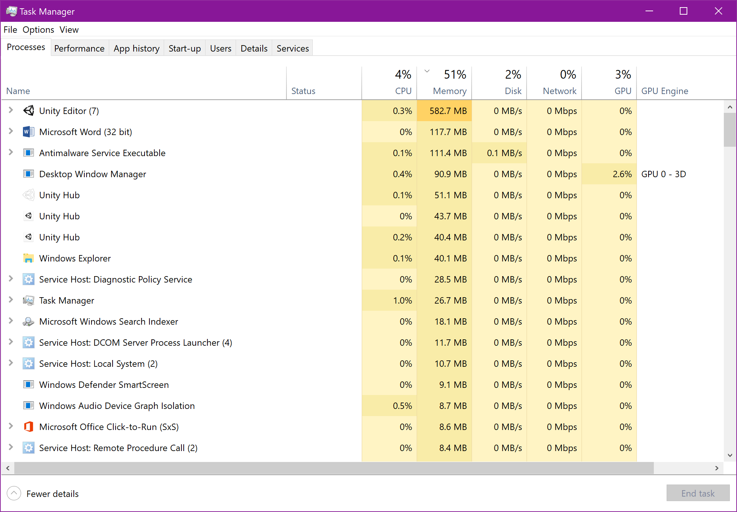

Figure : Performance: Not Running

#### Idle



Figure : Performance: Idle

#### Only Prey



Figure : Performance: Only Prey

#### Only Predators



Figure : Performance: Only Predators

#### Both Prey and Predators

Directly after start



Figure : Performance: Both Prey and Predators

High Predator Population



Figure : Performance: High Predator Popualtion

Hibernation



Figure : Performance: Hibernation

High Prey population



Figure : Performance: High Prey Population

#### Summary

Figure : Performance summary: Not Running Fully

Chart 1 above tests the performance at times when the simulation isn’t fully running. These tests can be used as a base line when comparing to chart 2 below, which tests the full simulation.

As expected, both predator and prey have an impact on both the CPU and GPU, however the memory impact seems to lower when prey or predators are enabled compared to when the not. This is unexpected but it seems that the simulation has little to no effect on memory, as throughout the test’s memory does not change much, even when the simulation isn’t running whatsoever.

The prey seems to have a higher impact on both CPU and GPU. I fully expected this outcome as the prey contain much more complication movement mechanisms (flocking) compared to the predators who simply wander around. Additionally, there are many more prey objects (100) compared to predators (4) at simulation start.

Figure : Performance summary: Running Fully

Both CPU and GPU impacts are higher just after the simulation is started, which is expected as all the prey objects are instantiated, and all their flocking algorithms kick in at the same time. Impact is higher when predator population is high compared to when prey population is higher, which is unexpected as the predator movement mechanics are much simpler compared to that of the prey. The source of this might be the differences in how the two object types breed; when prey population is high, they have reached the maximum population limit, so they will not breed further, however predators have no population limit and will keep breeding until they cannot find any more prey to eat. So, the source is most likely due to how many new objects are being instantiated.

As for hibernation, the lowest GPU impact out of all four scenarios is completely expected as all prey are idle, and the number of predators has fallen to leave only the alphas. The CPU impact is however completely unexpected, as it is higher than both high predator population and high prey population.

### General Simulation Testing

To complete this testing, I modified various variables of the simulation to see if the expected outcome of doing so matched the observed outcome. If in any case the two do not, I explain how the issue was rectified. The evaluation will be conducted by modifying variables to monitor what affect they have on the simulation, so testing that these variables work as expected first is necessary. Since I’m using an agile development model, a lot of testing was completed during the implementation process, so no problems were actually encountered with how the variables operate. The testing tables below were still included as they include some information on how each variable will work when its value is increased or decreased.

**Prey**

Figure : Variable Testing: Prey

|  |  |  |  |
| --- | --- | --- | --- |
| Variable | Expected Outcome | Observed Outcome | Actions Taken |
| Speed | Increase: Moves faster  Decrease: Moves slower | As expected | None |
| Rotation Speed | Increase: Rotates faster  Decrease: Rotates slower | As expected | None |
| Average breed rate | Increase: Faster prey population increase  Decrease: Slower prey population increase | As expected | None |
| Maximum Population | Increase: Maximum population increases  Decrease: Maximum population decreases | As expected | None |
| Alignment Intensity | Increase: Face average flock direction faster  Decrease: Face average flock direction slower | As expected | None |
| Alignment Radius | Increase: Face average direction of more prey  Decrease: Face average direction of less prey | As expected | None |
| Cohesion Intensity | Increase: Move to centre of flock faster  Decrease: Move to centre of flock slower | As expected | None |
| Cohesion Radius | Increase: Move to the centre of more prey  Decrease: Move to the centre of less prey | As expected | None |
| Separation Intensity | Increase: Move away from nearby prey faster  Decrease: Move away from nearby prey slower | As expected | None |
| Separation Radius | Increase: Move further away from nearby prey  Decrease: Move closer to nearby prey | As expected | None |
| Predator Avoidance Intensity | Increase: Move away from predators faster  Decrease: Move away from predators slower | As expected | None |
| Predator Avoidance Radius | Increase: Move away from predators when they’re further away  Decrease: Move away from predators when they’re closer | As expected | None |

**Predators Manager**

Figure : Variable Testing: Predators

|  |  |  |  |
| --- | --- | --- | --- |
| Variable | Expected Outcome | Observed Outcome | Actions Taken |
| Speed | Increase: Moves faster when not chasing  Decrease: Moves slower when not chasing | As expected | None |
| Chase Speed | Increase: Moves faster when chasing  Decrease: Moves slower when chasing | As expected | None |
| Sight Range | Increase: Can see prey from further away  Decrease: Distance in which prey can be seen is reduced | As expected | None |
| Smell Range | Increase: Search for prey to move towards at a higher range  Decrease: Search for prey to move towards at a smaller range | As expected | None |
| Smell Cooldown | Increase: Smell ability can be used less  Decrease: Smell ability can be used more | As expected | None |
| Eat Cooldown | Increase: Can eat prey less often  Decrease: Can eat prey more often | As expected | None |
| Death Time | Increase: More time before dying  Decrease: Less time before dying | As expected | None |
| Max Number of Alphas | Increase: More alphas can exist  Decrease: Less alphas can exist | As expected | None |

Figure : Variable Testing: Manager

|  |  |  |  |
| --- | --- | --- | --- |
| Variable | Expected Outcome | Observed Outcome | Actions Taken |
|  |  |  |  |
| Season Lengths | Increase: Each season lasts longer; seasonal year is longer  Decrease: Each season finishes faster; seasonal year is shorter | As expected | None |
| Starting Prey Population | Increase: Simulation starts with more prey  Decrease: Simulation starts with less prey | As expected | None |
| Starting Predator Population | Increase: Simulation starts with more predators  Decrease: Simulation starts with less predators | As expected | None |
| Number in Which Prey Are Endangered | Increase: Prey enter hibernation when at a higher population  Decrease: Prey enter hibernation when at a lower population | As expected | None |

# Evaluation

The system is evaluated firstly by conducting a series of experiments that investigate how some variables can affect the system. These experiments will only include variables that have a meaningful impact on the system such as prey speed or predator eat cooldown. Variables such as those used in the flocking algorithms won’t be tested, as their impact on the population changes is minimal (time is better spent elsewhere).

I’ll then compare the simulation with my findings from background research to deduce whether I have successfully replicated the shape that a predator-prey model graph looks (Lotka-Volterra). I’ll also carry out a small evaluation on the flocking algorithms I have implemented for prey movement how well they work. This includes the extra behaviours I’m using that have been adapted from the original ones (goal seeking & obstacle avoidance).

I’ll then decide whether the objectives set at the beginning of the project have been met, and finally whether the pass criteria for the project have been met in my opinion.

## Variable Experimentation

As explained above, all the variables tested earlier to make sure they work as intended will be tested again to find out what impact they have on the simulation individually. This means that for each experiment, only the variable tested will be changed, thus keeping conditions controlled. The point of testing all variables individually like this is to gain a better understanding of what impact they have on the whole simulation, allowing me to provide any potential future users insight into how to use each variable to achieve their goal.

Each variable will be tested for two seasonal years, one of which will last roughly 1:21 minutes (with original season durations) so most experiments will last roughly 2:41 minutes. A plot of data on the graph will take roughly 34 seconds to reach the end of the graph, so the populations throughout each experiment will be monitored using roughly five graphs captured directly from the simulation as it runs.

Below is a series of graphs showing how the simulation runs will all its original variables values. These graphs can be compared with those of the experiments to see how each variable affects the two populations. These first few graphs will be annotated just to explain what is happening at the various rises and drops in population and the experiments will have the same trends, they will just happen at different speeds.

It should be noted that the data plotted on the graph starts on the left then moves to the right as more data is plotted. Meaning that the passage of ‘time’ goes from right to left. The blue line shows the prey population and the red shows the predators. For some experiments I didn’t show the full hibernation period as it would take up space unnecessarily.

Predation impact on prey

Simulation starts

Prey breeding

Predation impact on predators

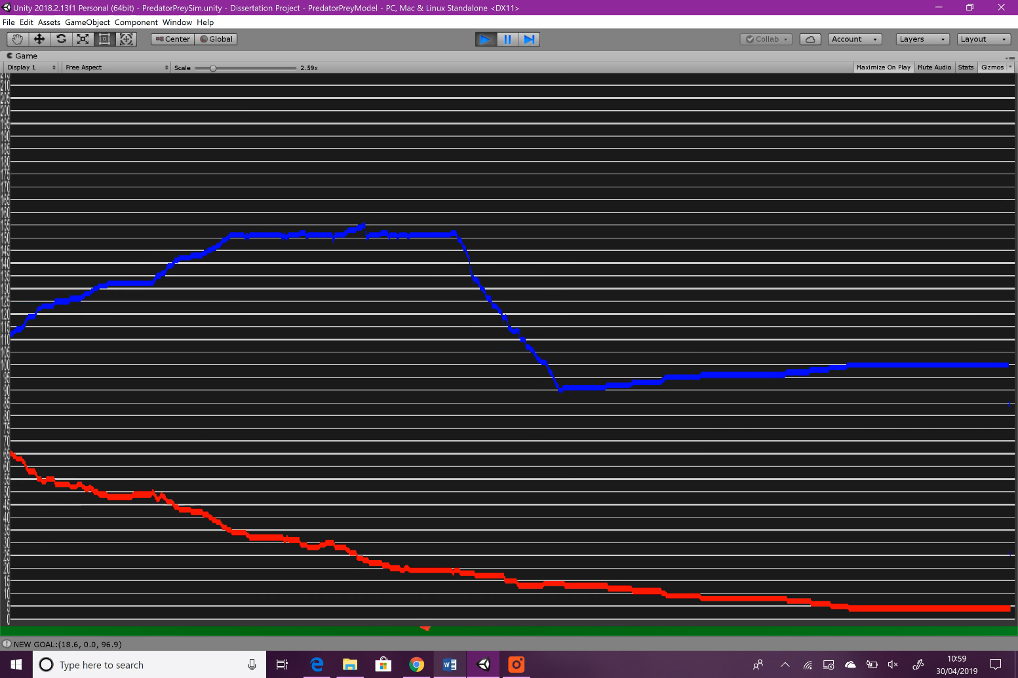

Figure : Variable Experimentation: Original: graph 1

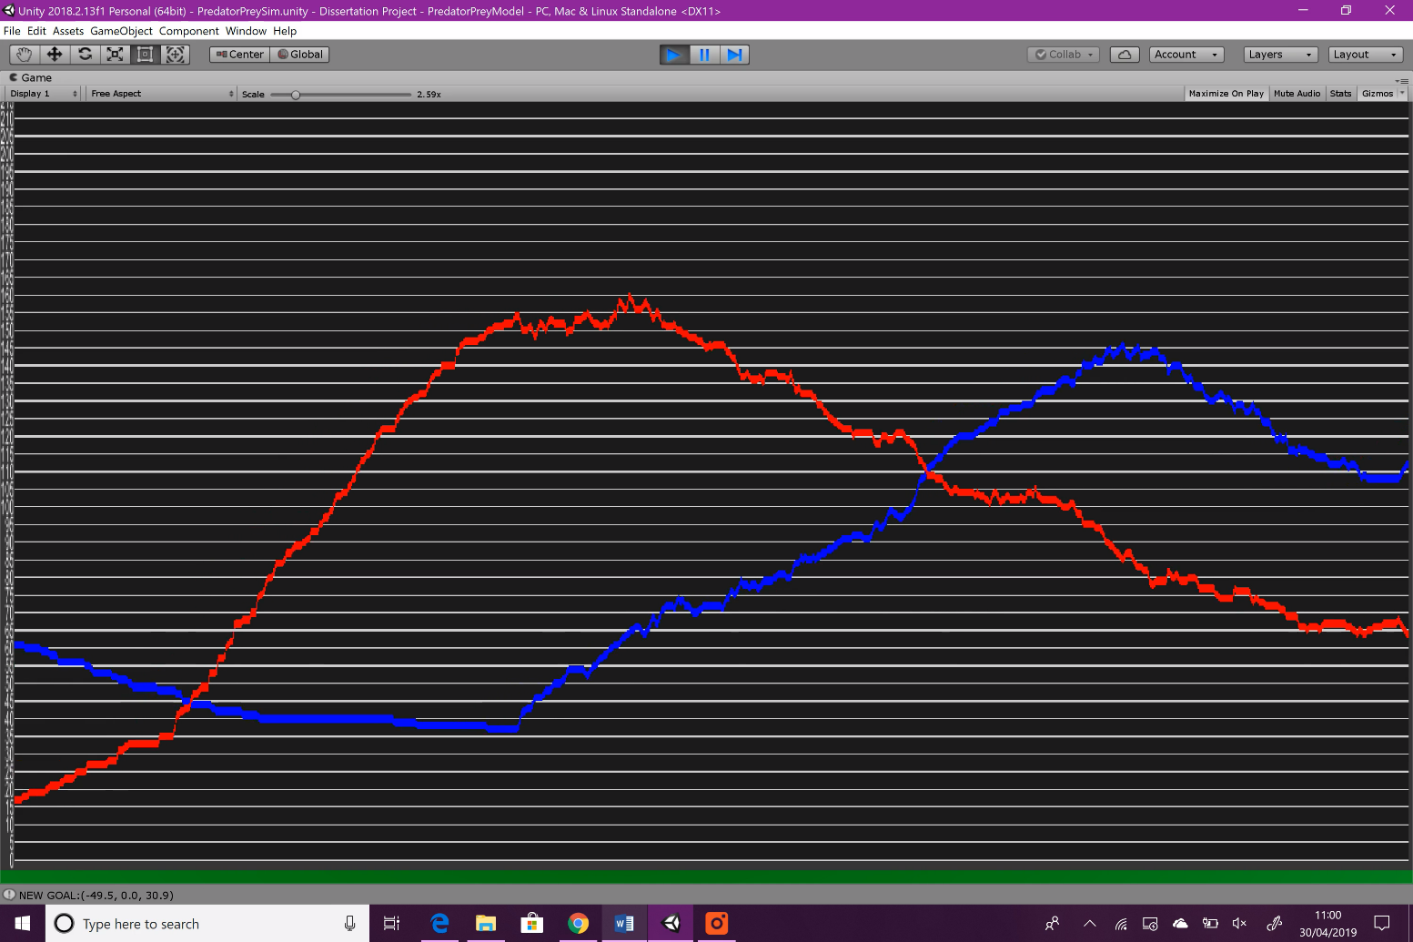

Prey become endangered, hibernation begins

Lack of food

Prey breeding

Figure : Variable Experimentation: Original: graph 2

Note: the passage of ‘time’ goes from right to left

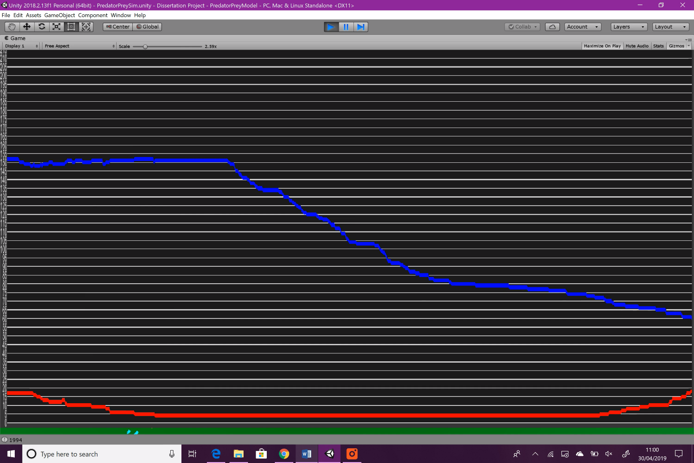

Maximum population reached

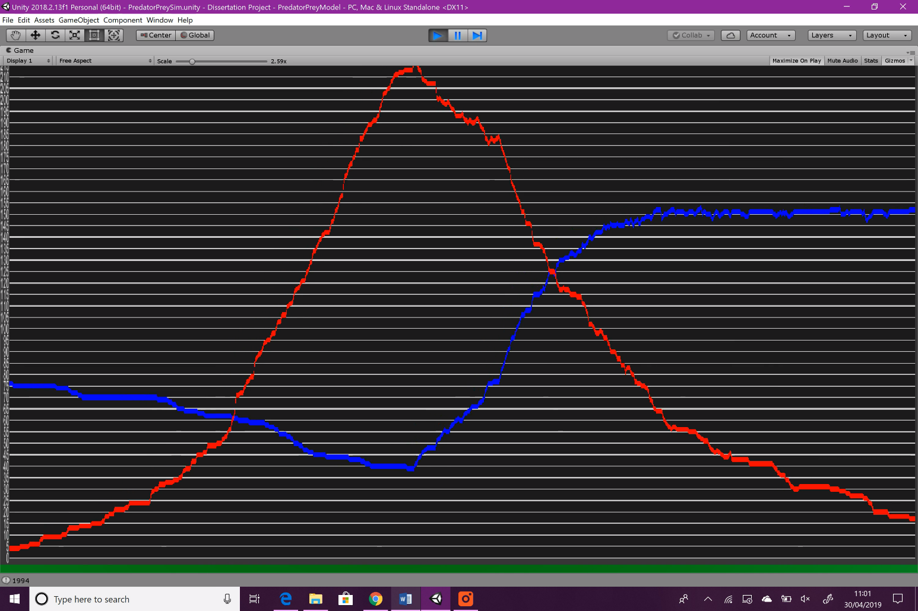

Hibernation ends, predation begins again

Figure : Variable Experimentation: Original: graph 3

Predator population falls due to lack of food

Prey are once again endangered and enter hibernation

Prey repopulate during winter

Predator population rises faster this time due to abundance of food

Increased predation leads to sharper decrease in population

Figure : Variable Experimentation: Original: graph 4

### Prey

#### Speed

The speed for each prey object on instantiation is a random number between 2 and 8. When the prey object joins a flock, it changes its speed to match the average of its neighbours, thus keeping each flock moving at similar speeds. Should the speed rise over a maximum amount, it is reset using the original margin, making sure that flocks don’t become too fast.

The impacts that prey speed might have on the simulation are beneficial for prey population when raised, but detrimental when lowered. Higher speed means that prey will be able to flee from predators longer, and if the speed is high enough, predators may never even catch their prey.

|  |  |
| --- | --- |
| Variable | Value |
| Margin original | between 2 – 8 |
| Margin experimental | between 4 – 10 |
| Limit original | 10 |
| Limit experimental | 12 |

Figure : Prey Speed changes

**Result**

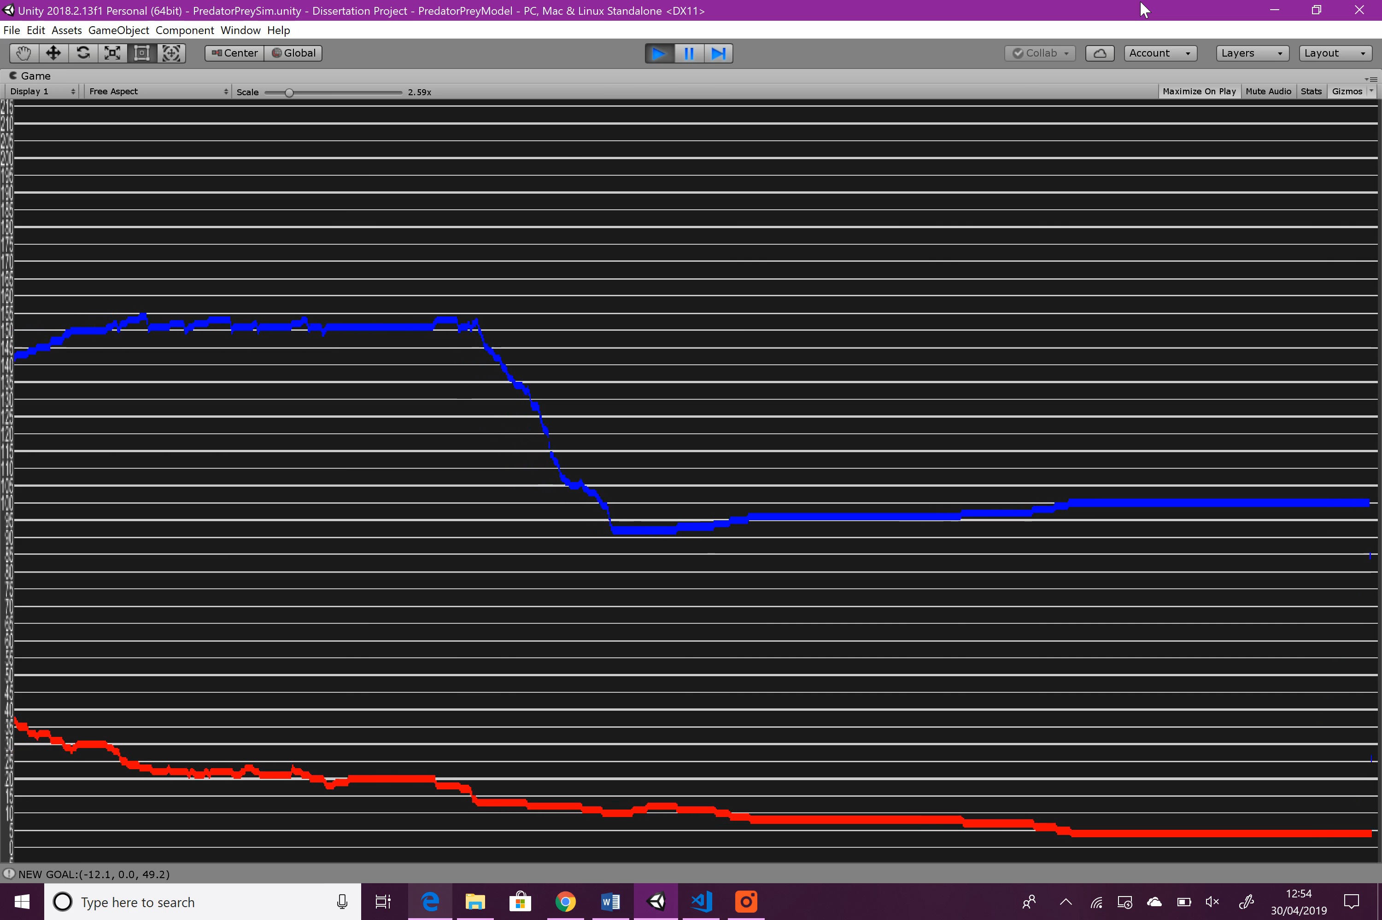

Figure : Variable Experimentation: Prey Speed: graph 1

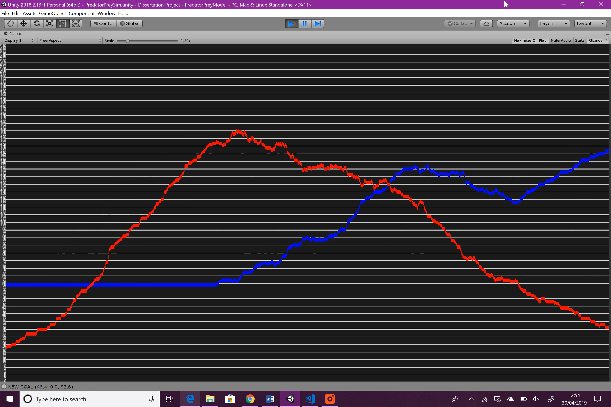

Figure : Variable Experimentation: Prey Speed: graph 2

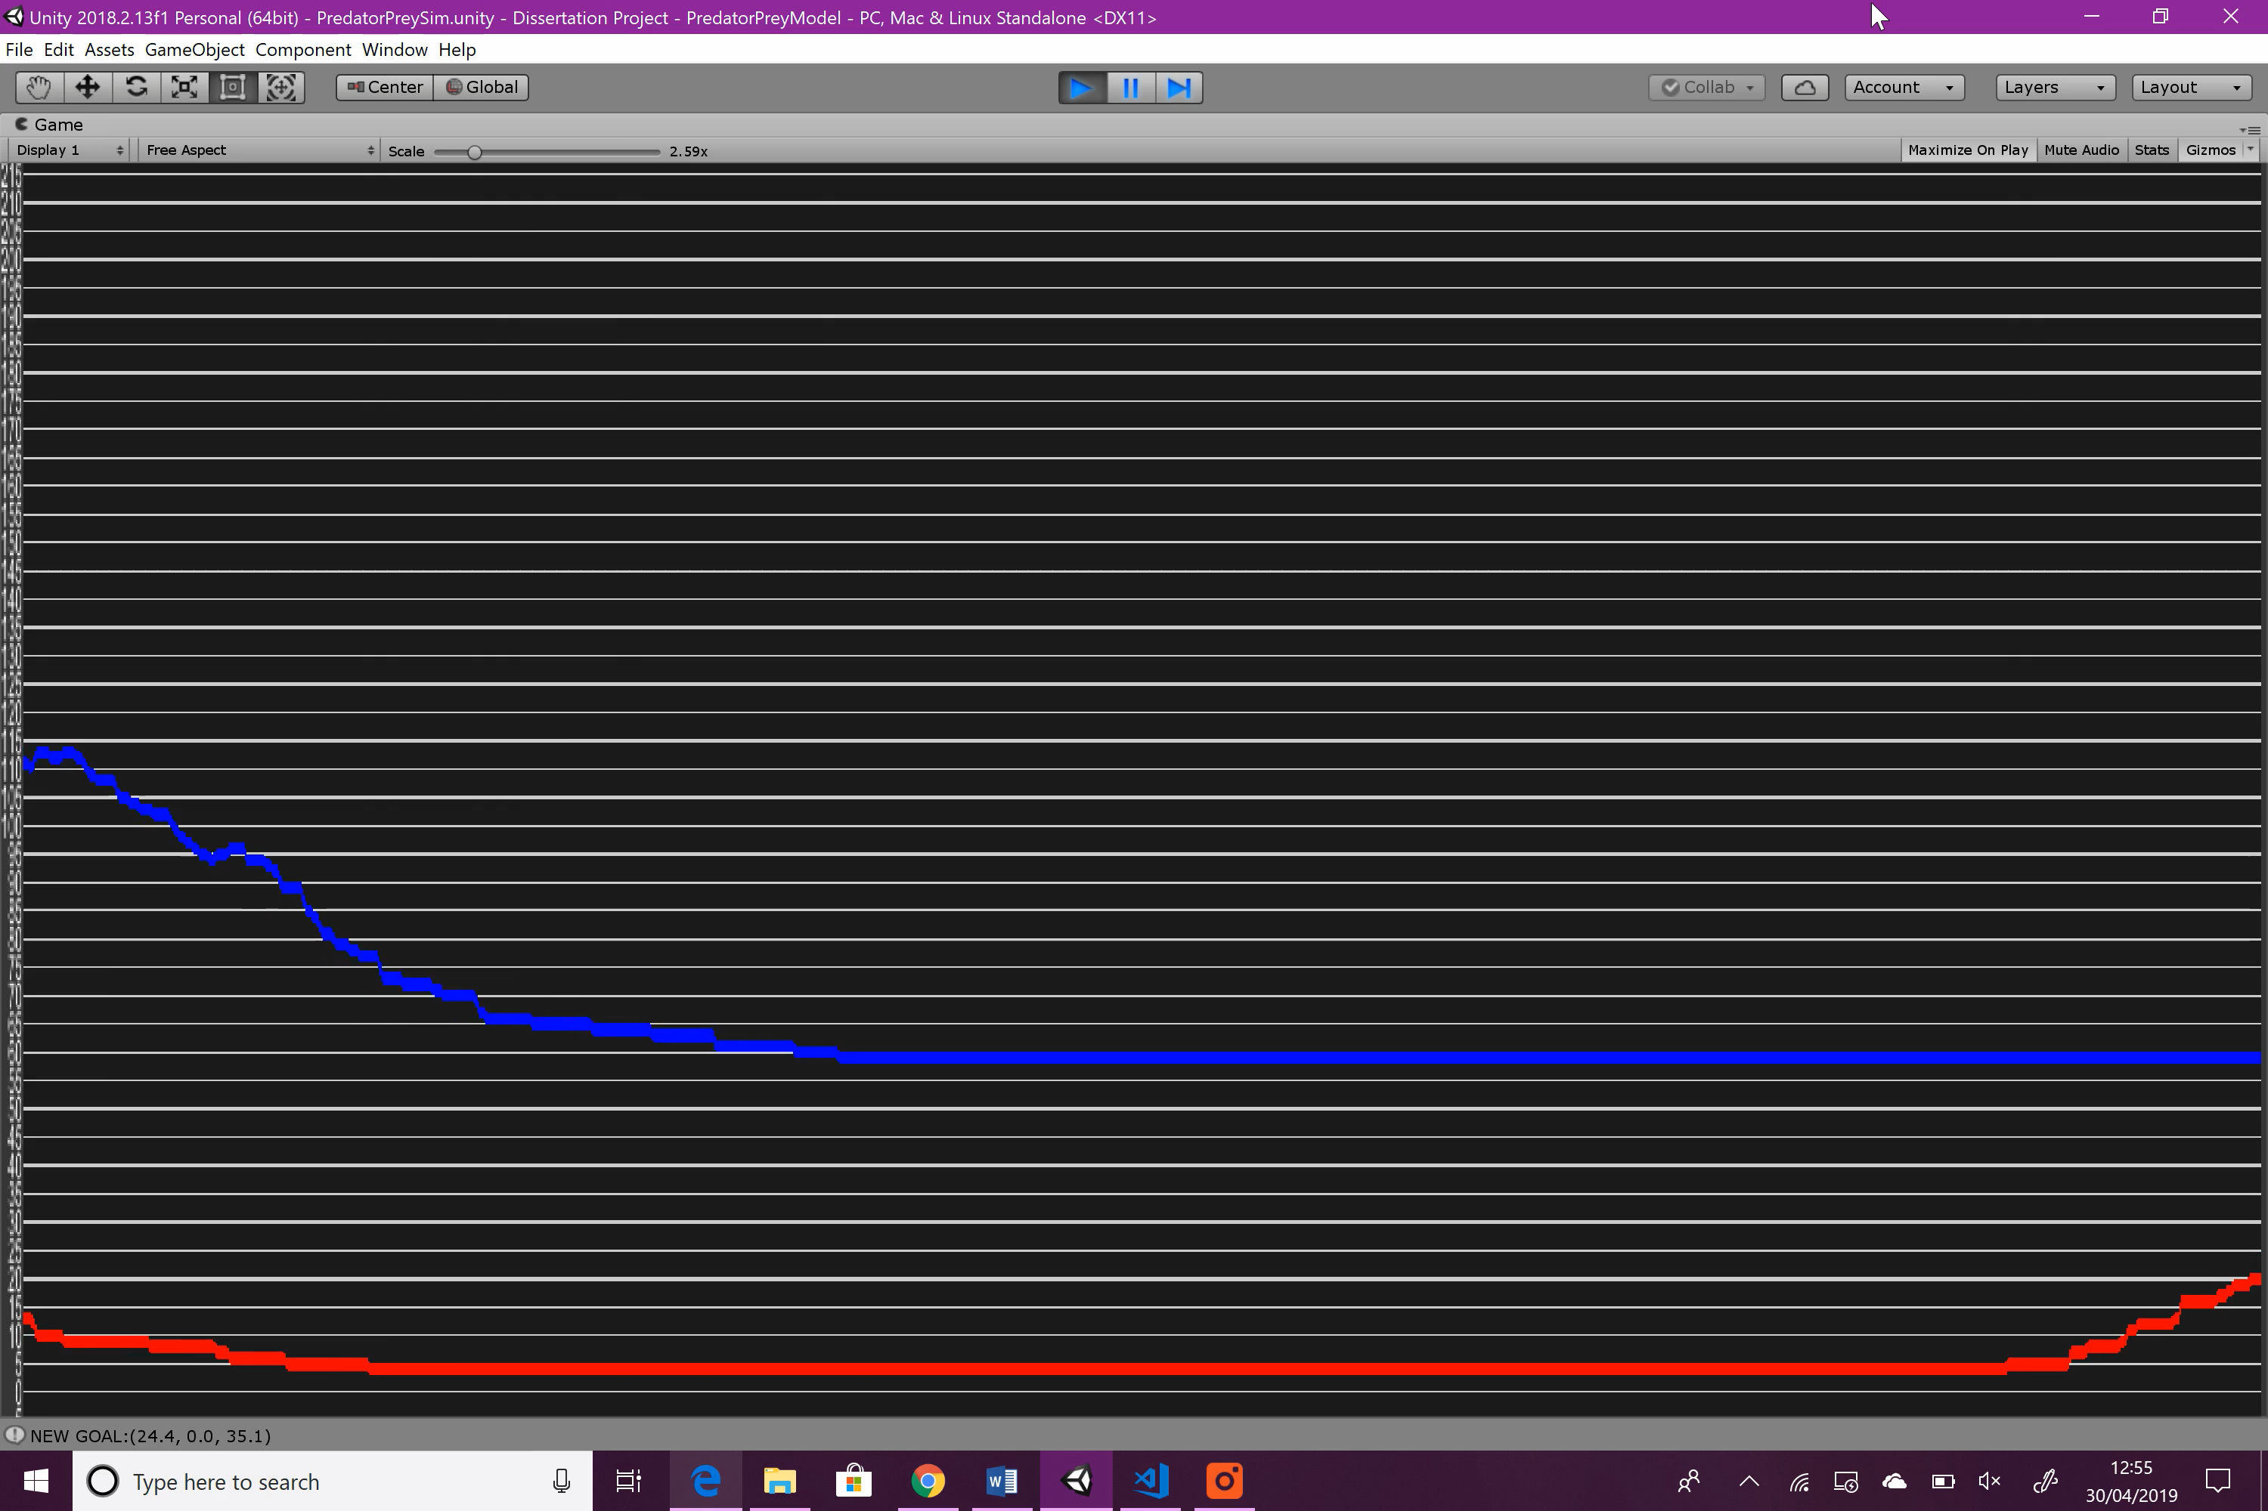

Figure : Variable Experimentation: Prey Speed: graph 3

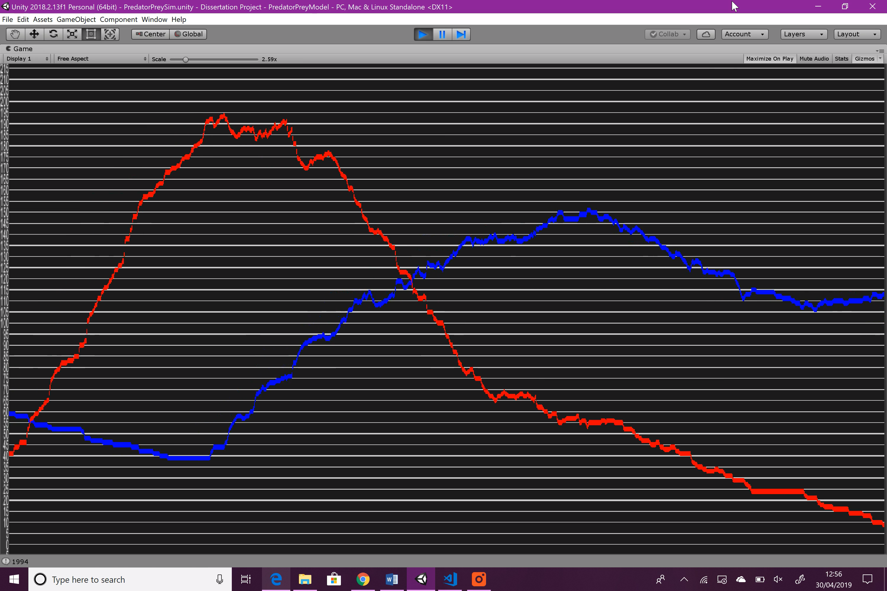

Figure : Variable Experimentation: Prey Speed: graph 4

Note: the passage of ‘time’ goes from right to left

**Summary**

Compared to the original run, increasing prey speed has seemed to benefit the prey population slightly. At the beginning of the simulation, it takes the predators slightly longer to build up their population, so the prey being able to flee at a higher speed obviously has an effect. During the second season, the predators also take longer to build up their population, and the peak is much less sharp compared to the original simulation.

#### Breed rate

Much like speed, each prey object breeds at a different rate which is chosen randomly from between two numbers, however, unlike speed, the number does not change after the prey object is instantiated. A timer is then used to countdown this number and when it reaches 0, a new prey object will be instantiated at the position of the current prey object and the timer is reset using the original number.

When the breed time is too high, the prey population won’t be able to keep up with predation and will get wiped out very quickly. When low, the predator population will always have an abundance of food, and thus will reproduce more quickly, but the prey population will also be a lot harder to wipe out.

Measured in seconds.

|  |  |
| --- | --- |
| Variable | Value |
| Margin original | between 12 – 16 |
| Margin experimental | between 5 – 8 |

Figure : Prey Breed Rate changes

**Result**

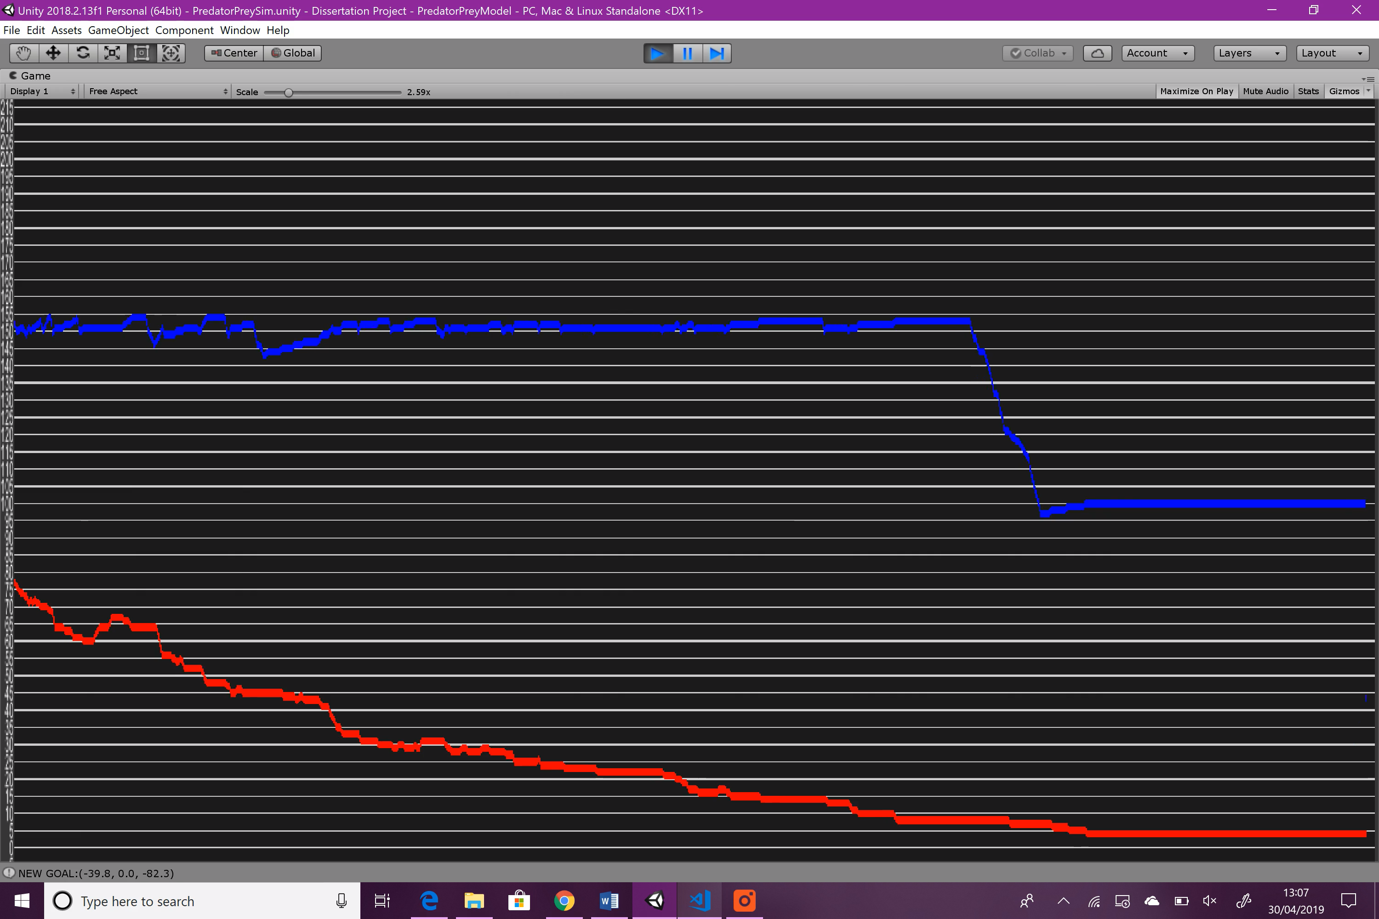

Figure : Variable Experimentation: Prey Breed Rate: graph 1

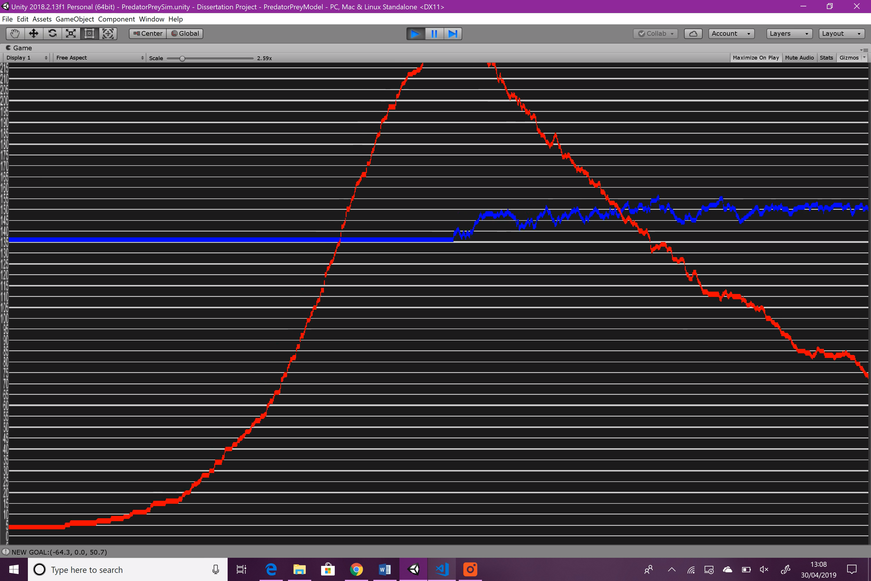

Figure : Variable Experimentation: Prey Breed Rate: graph 2

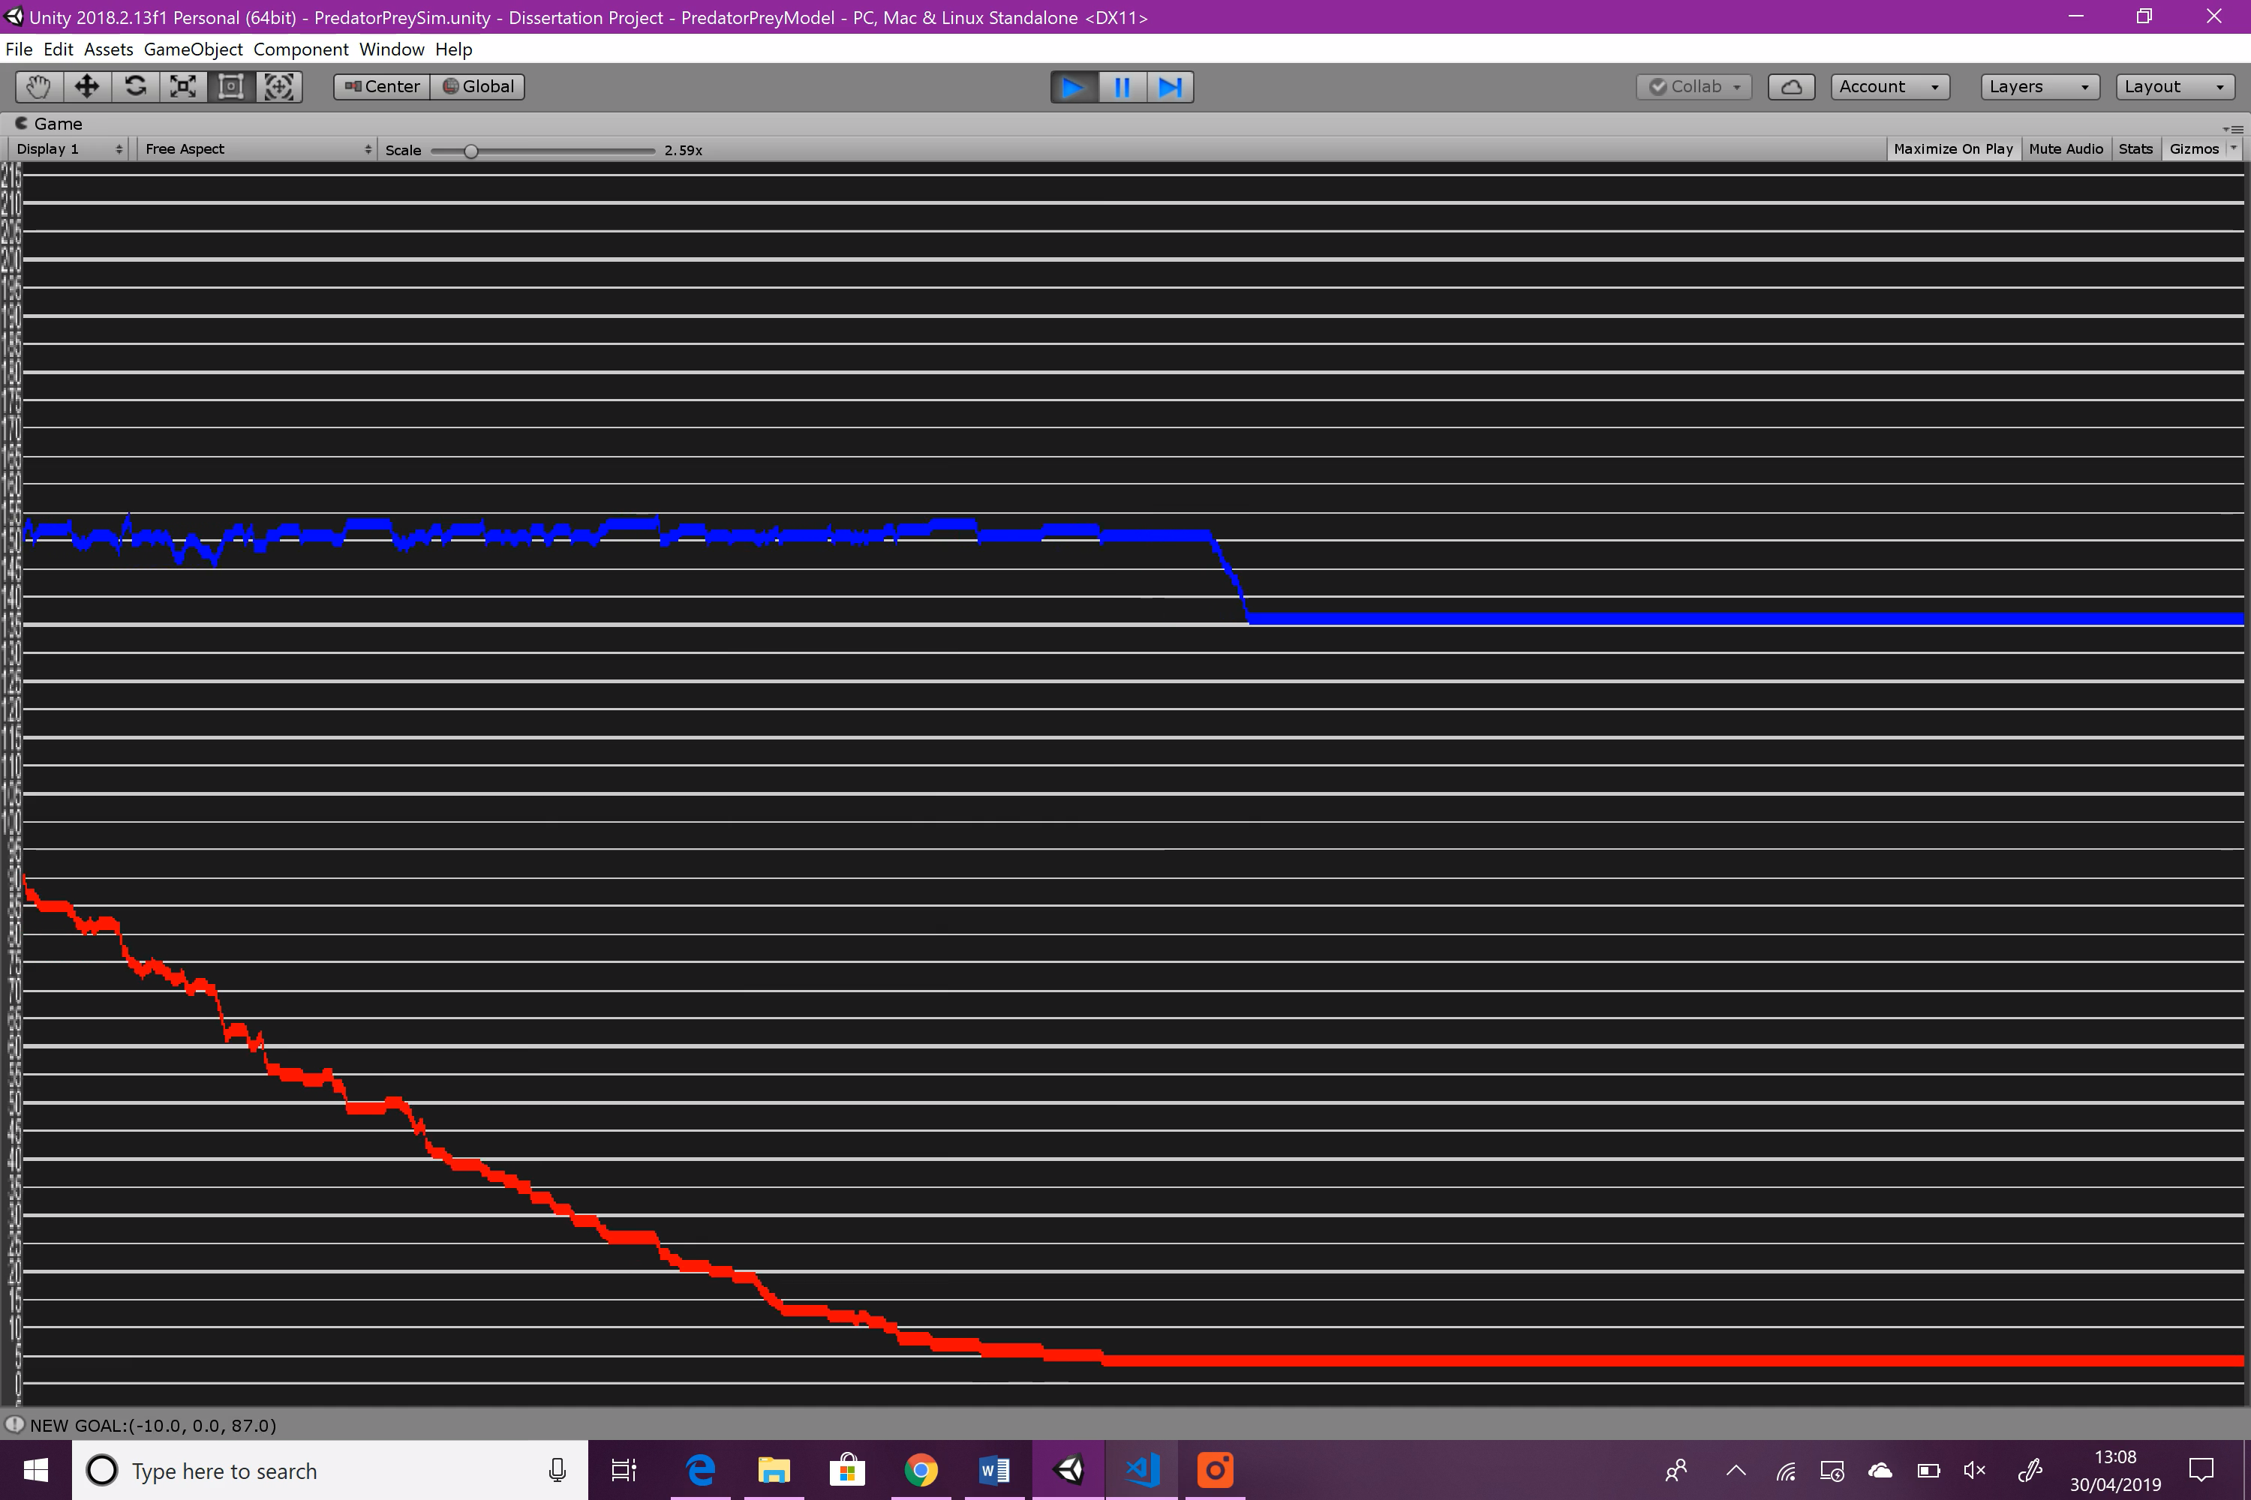

Figure : Variable Experimentation: Prey Breed Rate: graph 3

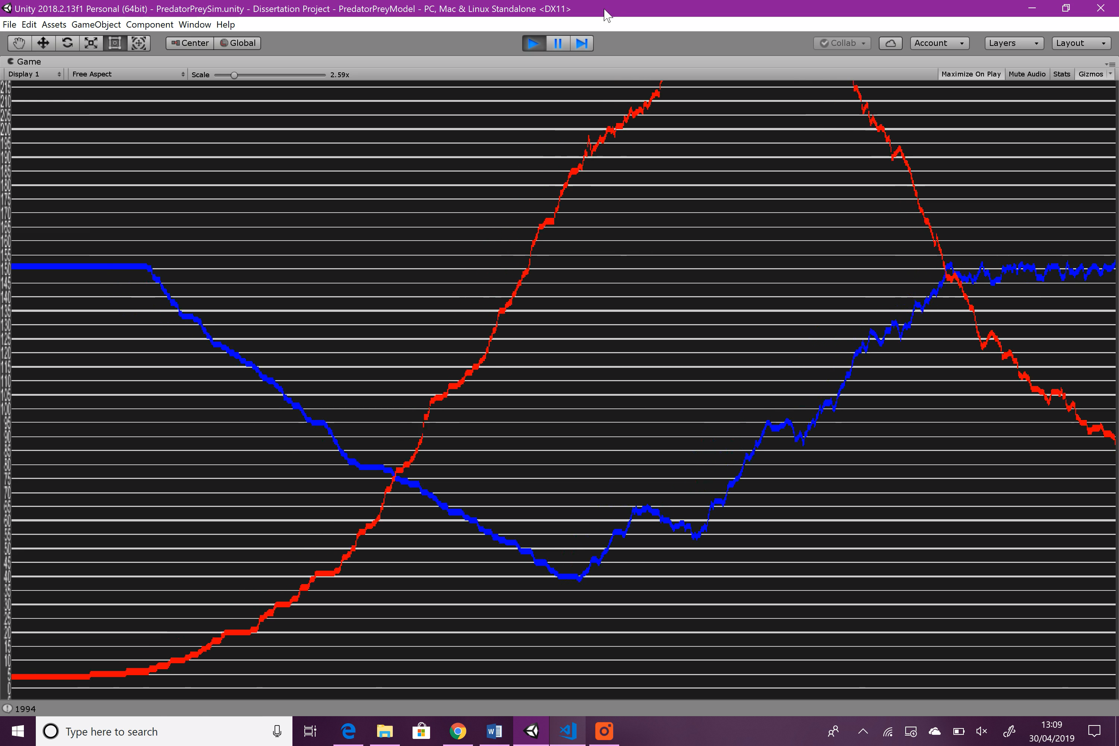

Figure : Variable Experimentation: Prey Breed Rate: graph 4

**Summary**

As expected, the prey increase in population much faster than in the original simulation, and the predators increase in population faster and more steeply too. However, in the initial season, the predators fail to even reduce the prey population below their maximum, let alone wipe them out completely. They do however achieve this in the following season, but the prey population falls more slowly compared to the original simulation.

#### Predator Avoidance Intensity

This variable affects the speed at which a prey will flee from a nearby predator. Higher predator avoidance intensity will cause prey to turn away from nearby predators more quickly. This variable will prove detrimental to prey when the value is very low, as they won’t be able to move away quickly enough.

|  |  |
| --- | --- |
| Variable | Value |
| original | 10 |
| experimental | 0.5 |

Figure : Prey Predator avoidance intensity changes

**Result**

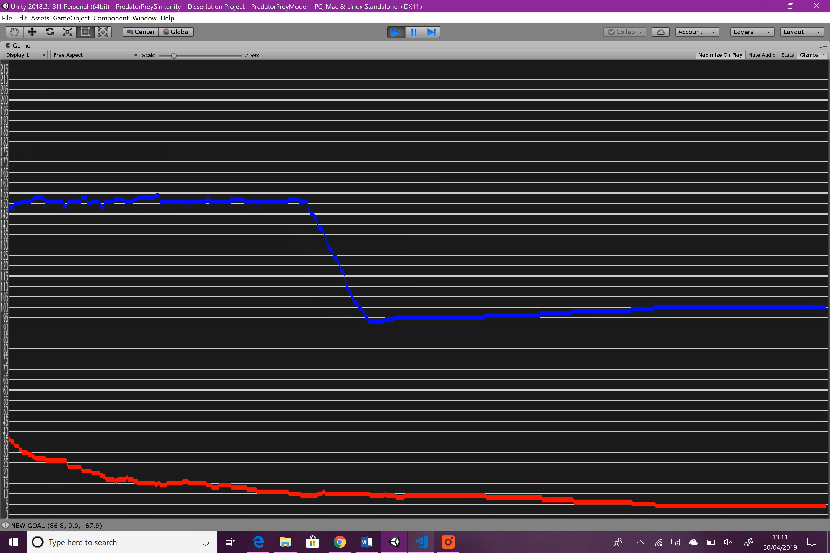

Figure : Variable Experimentation: Predator Avoidance Intensity: graph 1

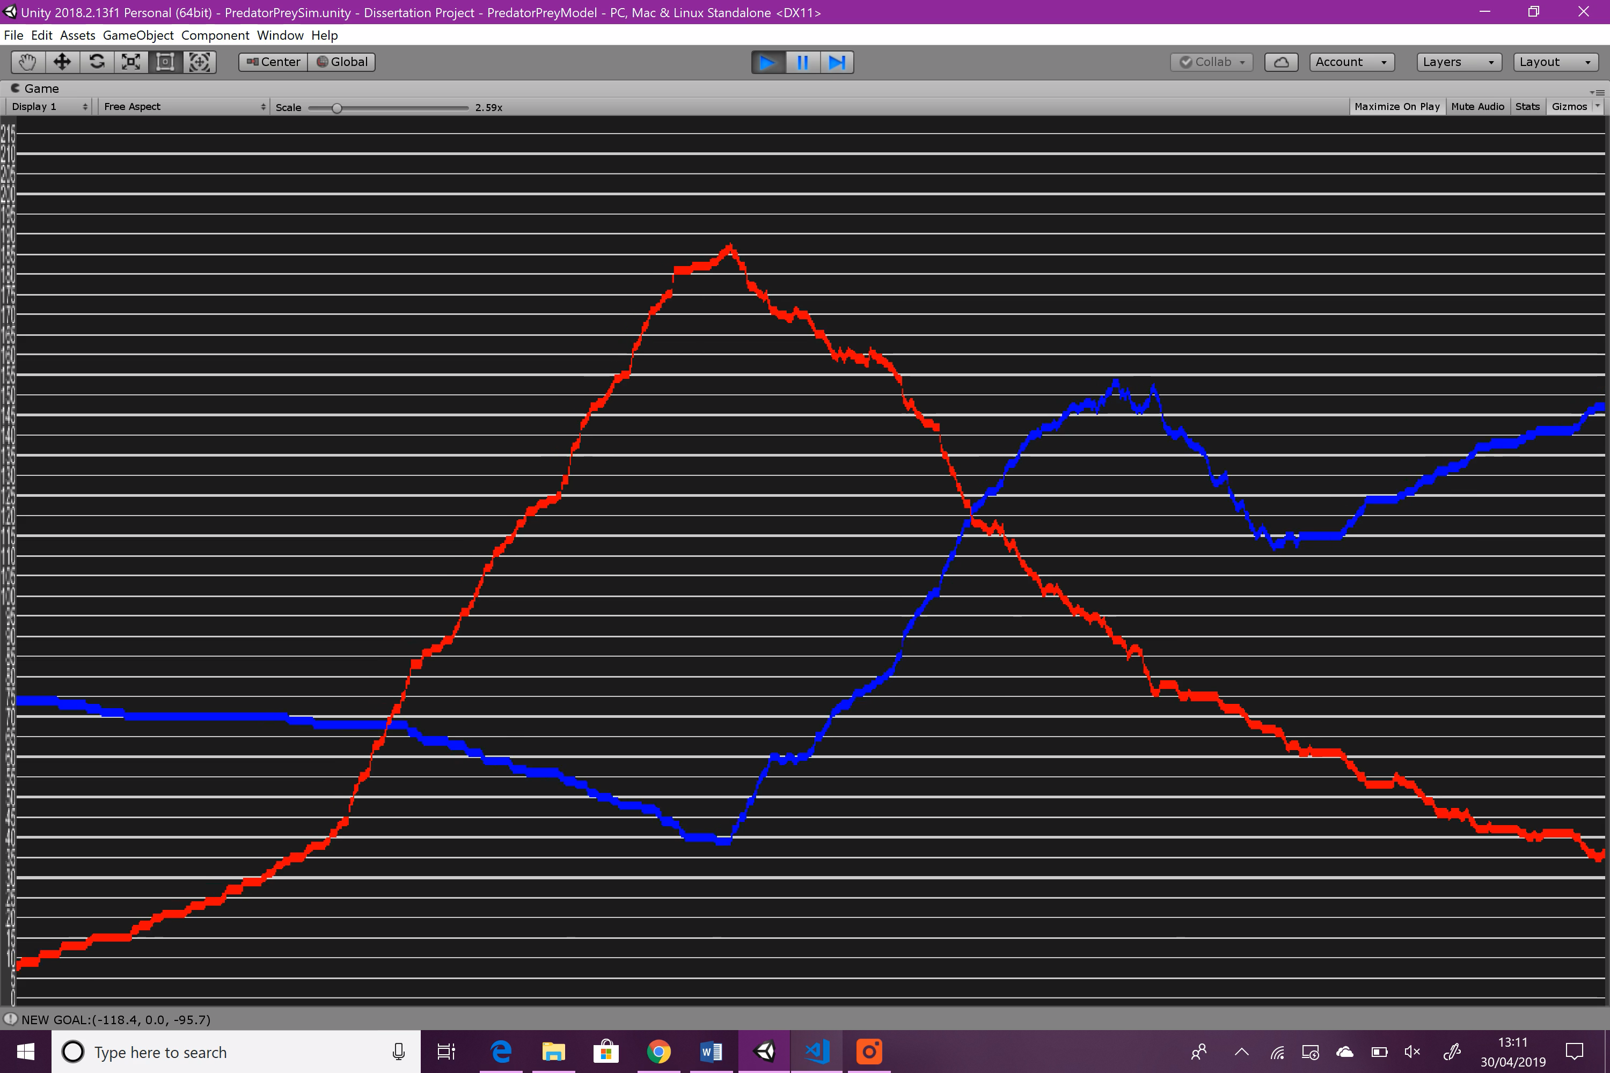

Figure : Variable Experimentation: Predator Avoidance Intensity: graph 2

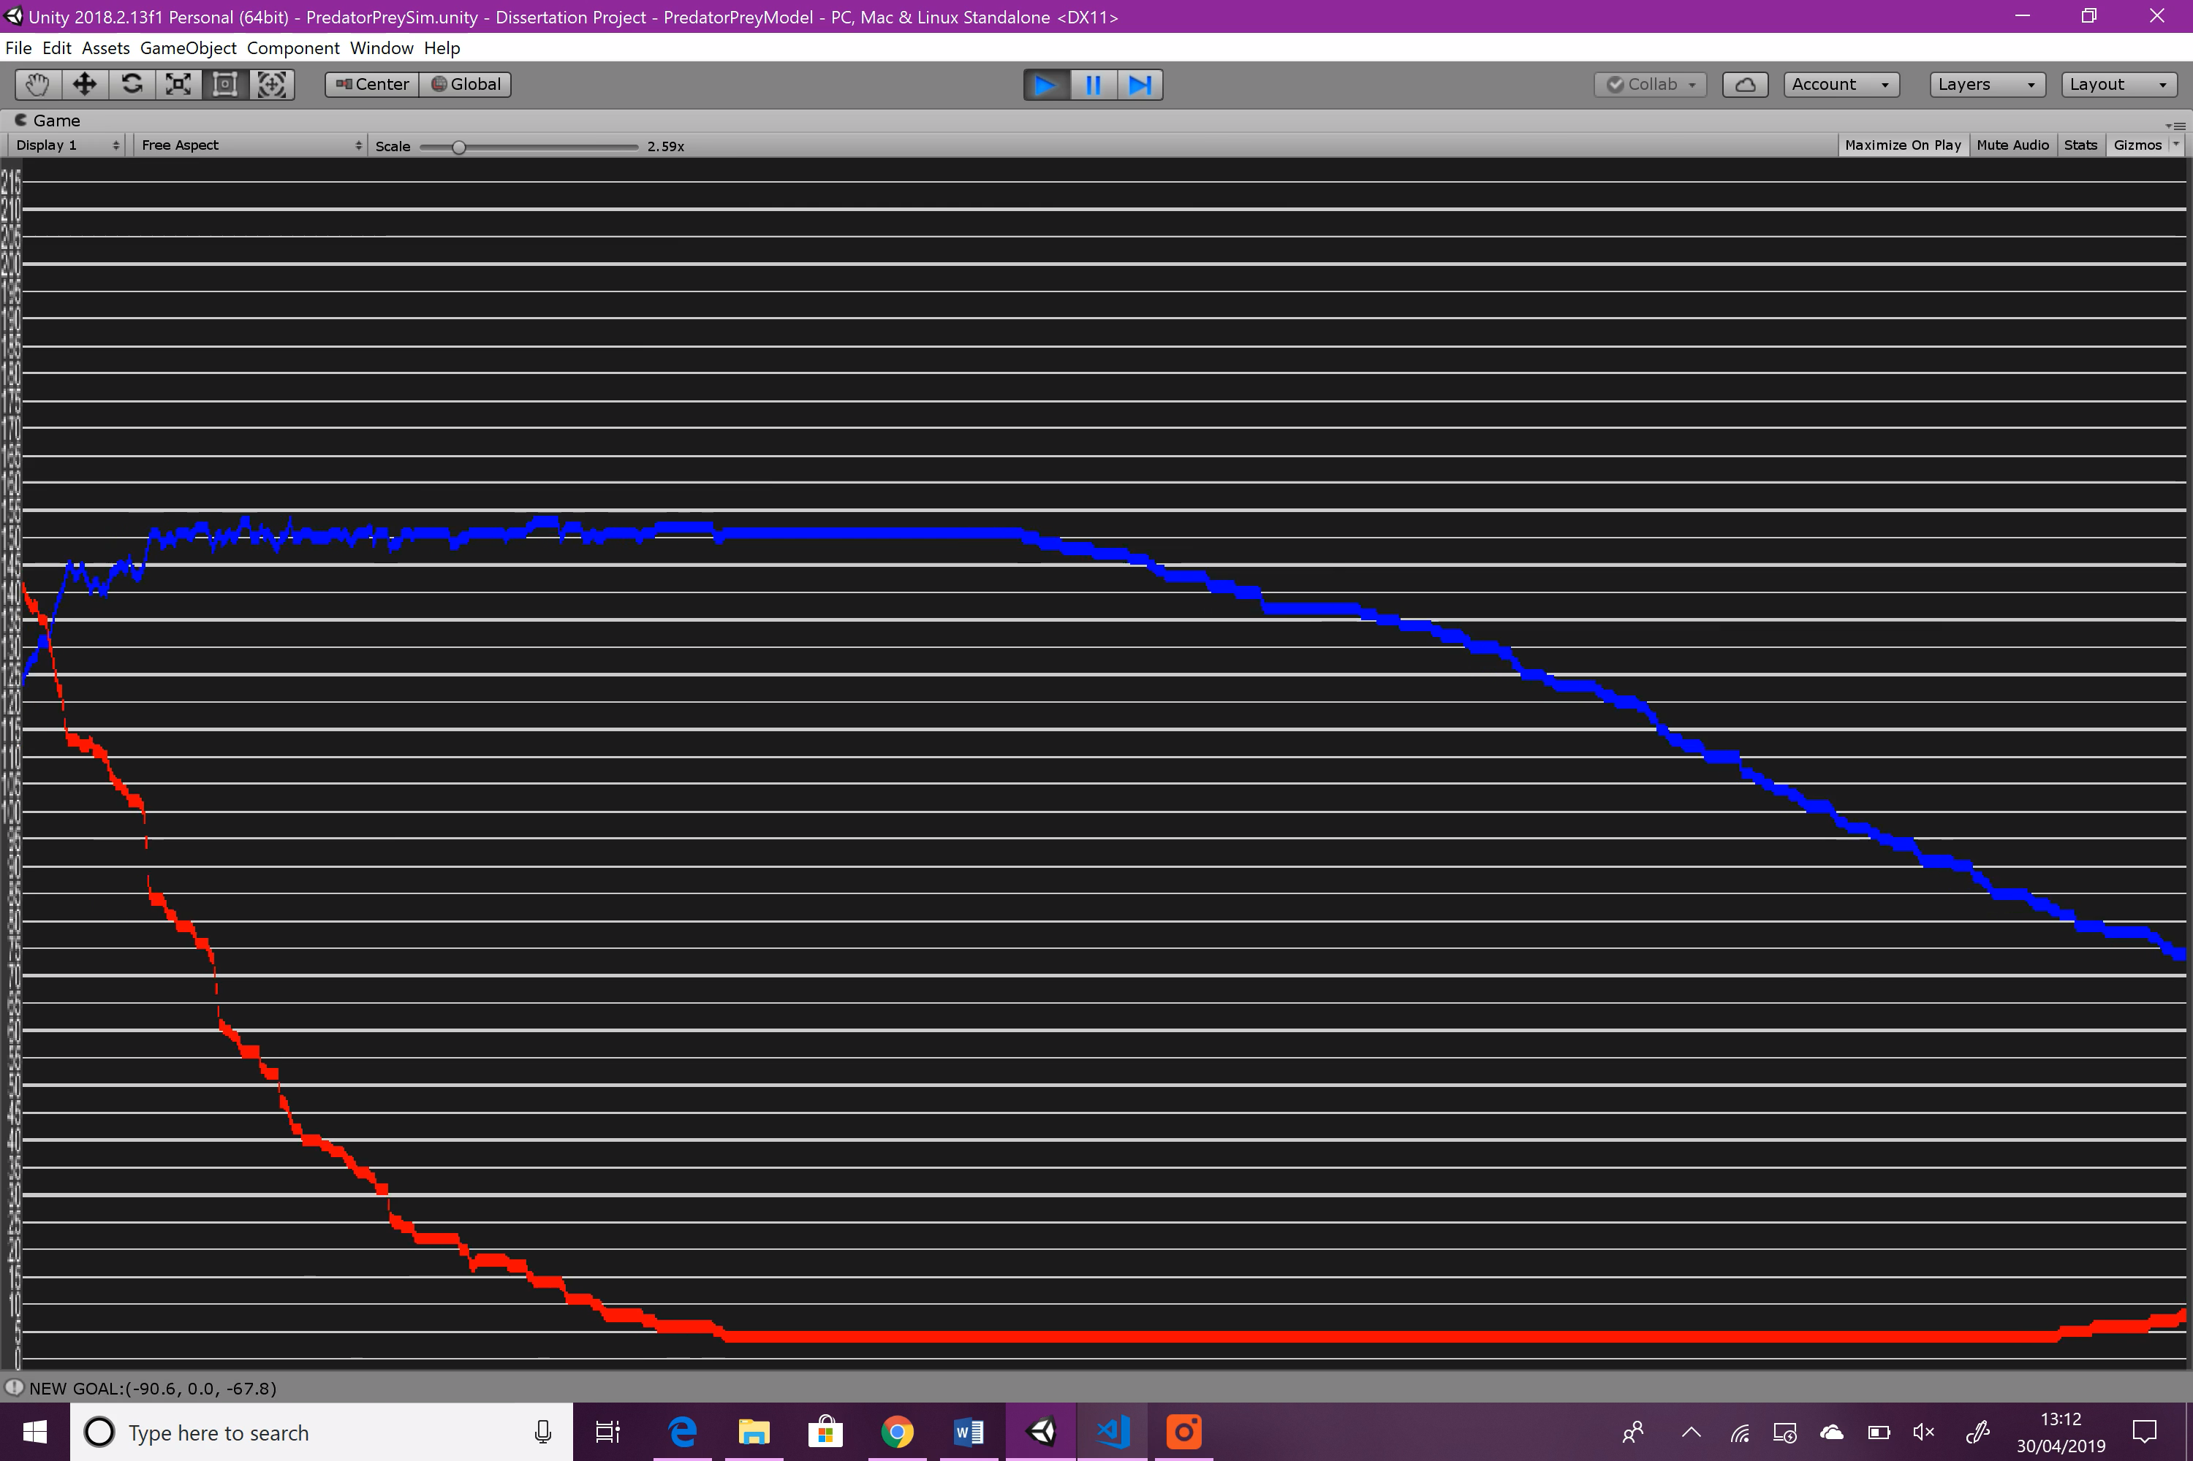

Figure : Variable Experimentation: Predator Avoidance Intensity: graph 3

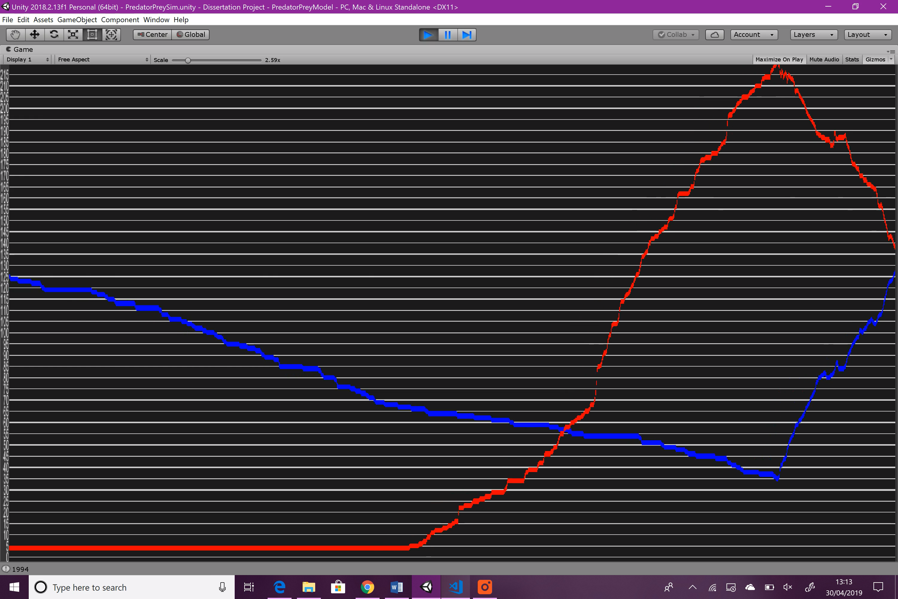

Figure : Variable Experimentation: Predator Avoidance Intensity: graph 4

**Summary**

There is not much of a difference with this variable. The only noticeable change is that the predator population rises slightly slower at the beginning, but then speeds up to roughly match the original graphs. The second season looks mostly the same as the second season from the original simulation.

#### Predator Avoidance Radius

This variable affects the distance between a prey and predator before the prey will begin to flee. At higher values, prey will begin fleeing from predators when the distance between the two objects is greater. Lower values will allow the predators to get closer, which will give a big boost to predation.

|  |  |
| --- | --- |
| Variable | Value |
| original | 10 |
| experimental | 2 |

Figure : Prey Predator Avoidance Radius changes

**Result**

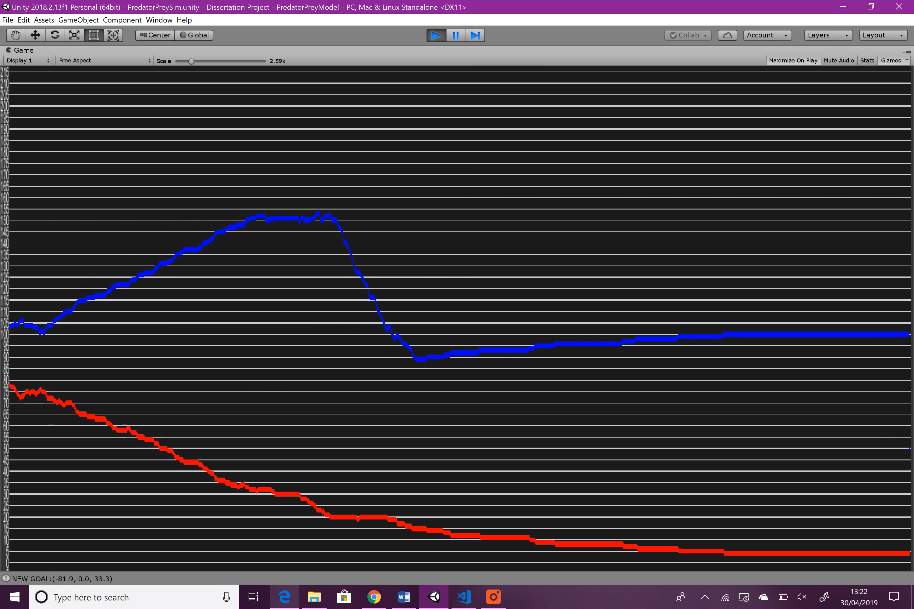

Figure : Variable Experimentation: Predator Avoidance Radius: graph 1

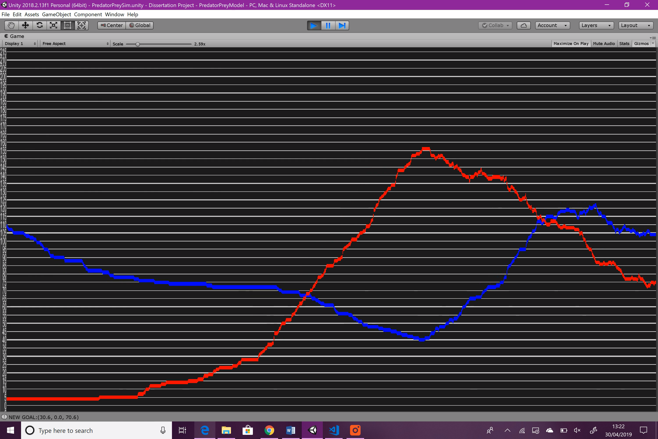

Figure : Variable Experimentation: Predator Avoidance Radius: graph 2

Didn’t include the hibernation period as it was unnecessary.

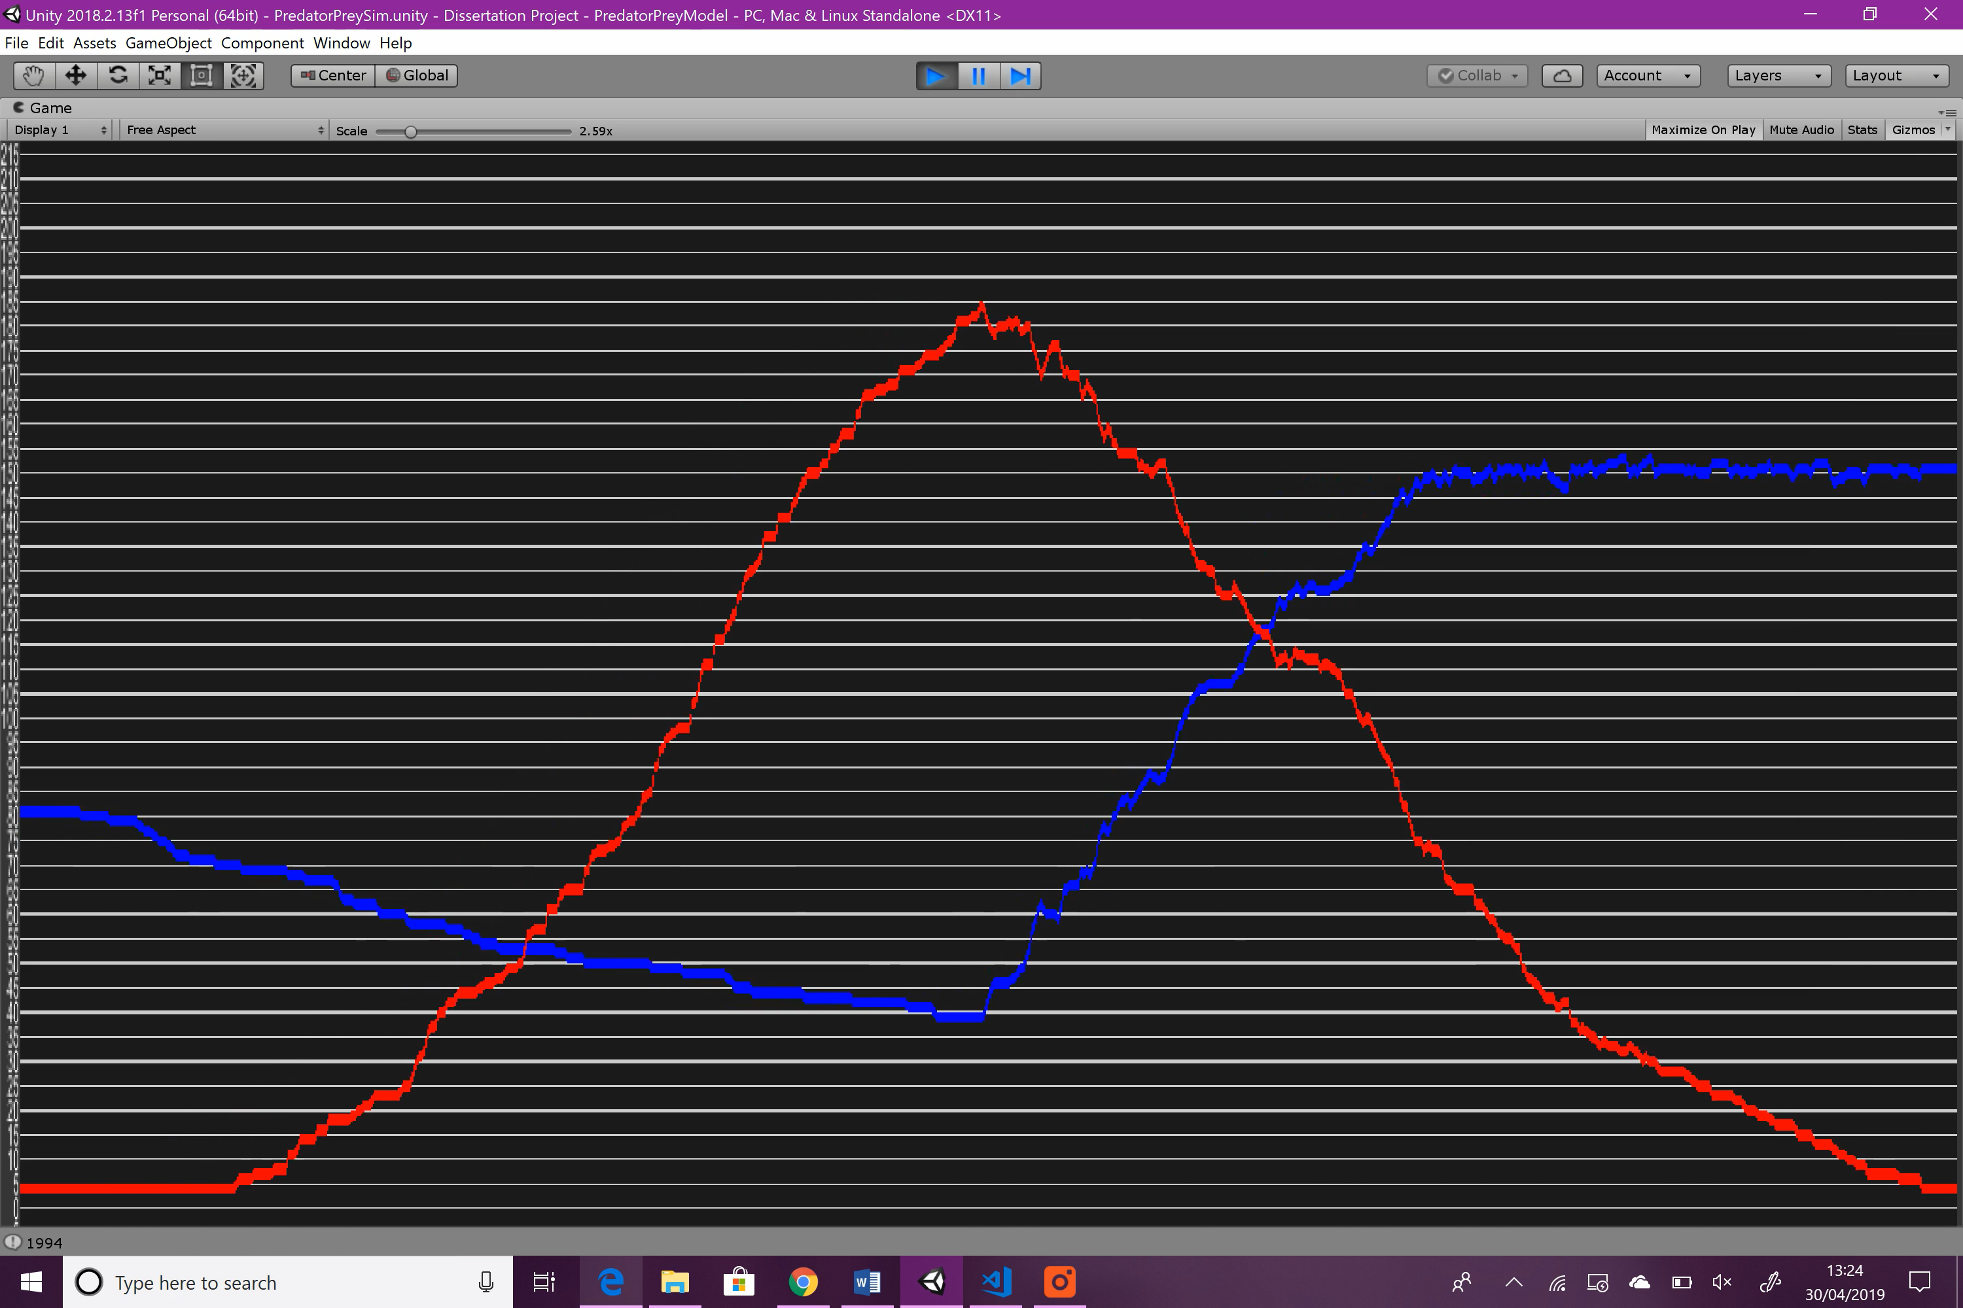

Figure : Variable Experimentation: Predator Avoidance Radius: graph 3

**Summary**

Changing predator avoidance radius doesn’t do anything obvious to the change in populations, the only difference is that the peaks in predator populations might be slightly lower than in the original simulation.

### Predators

#### Chase Speed

The speed at which a predator will chase a prey object when it is seen. This variable will likely have a big impact on the simulation and is noticeably faster than a predator’s normal movement speed. Higher values mean that the predator can reach and eat the prey faster, whereas smaller values does the opposite, and could even result in the predator never catching the prey.

|  |  |
| --- | --- |
| Variable | Value |
| original | 15 |
| experimental | 30 |

Figure : Predator Chase Speed changes

**Result**

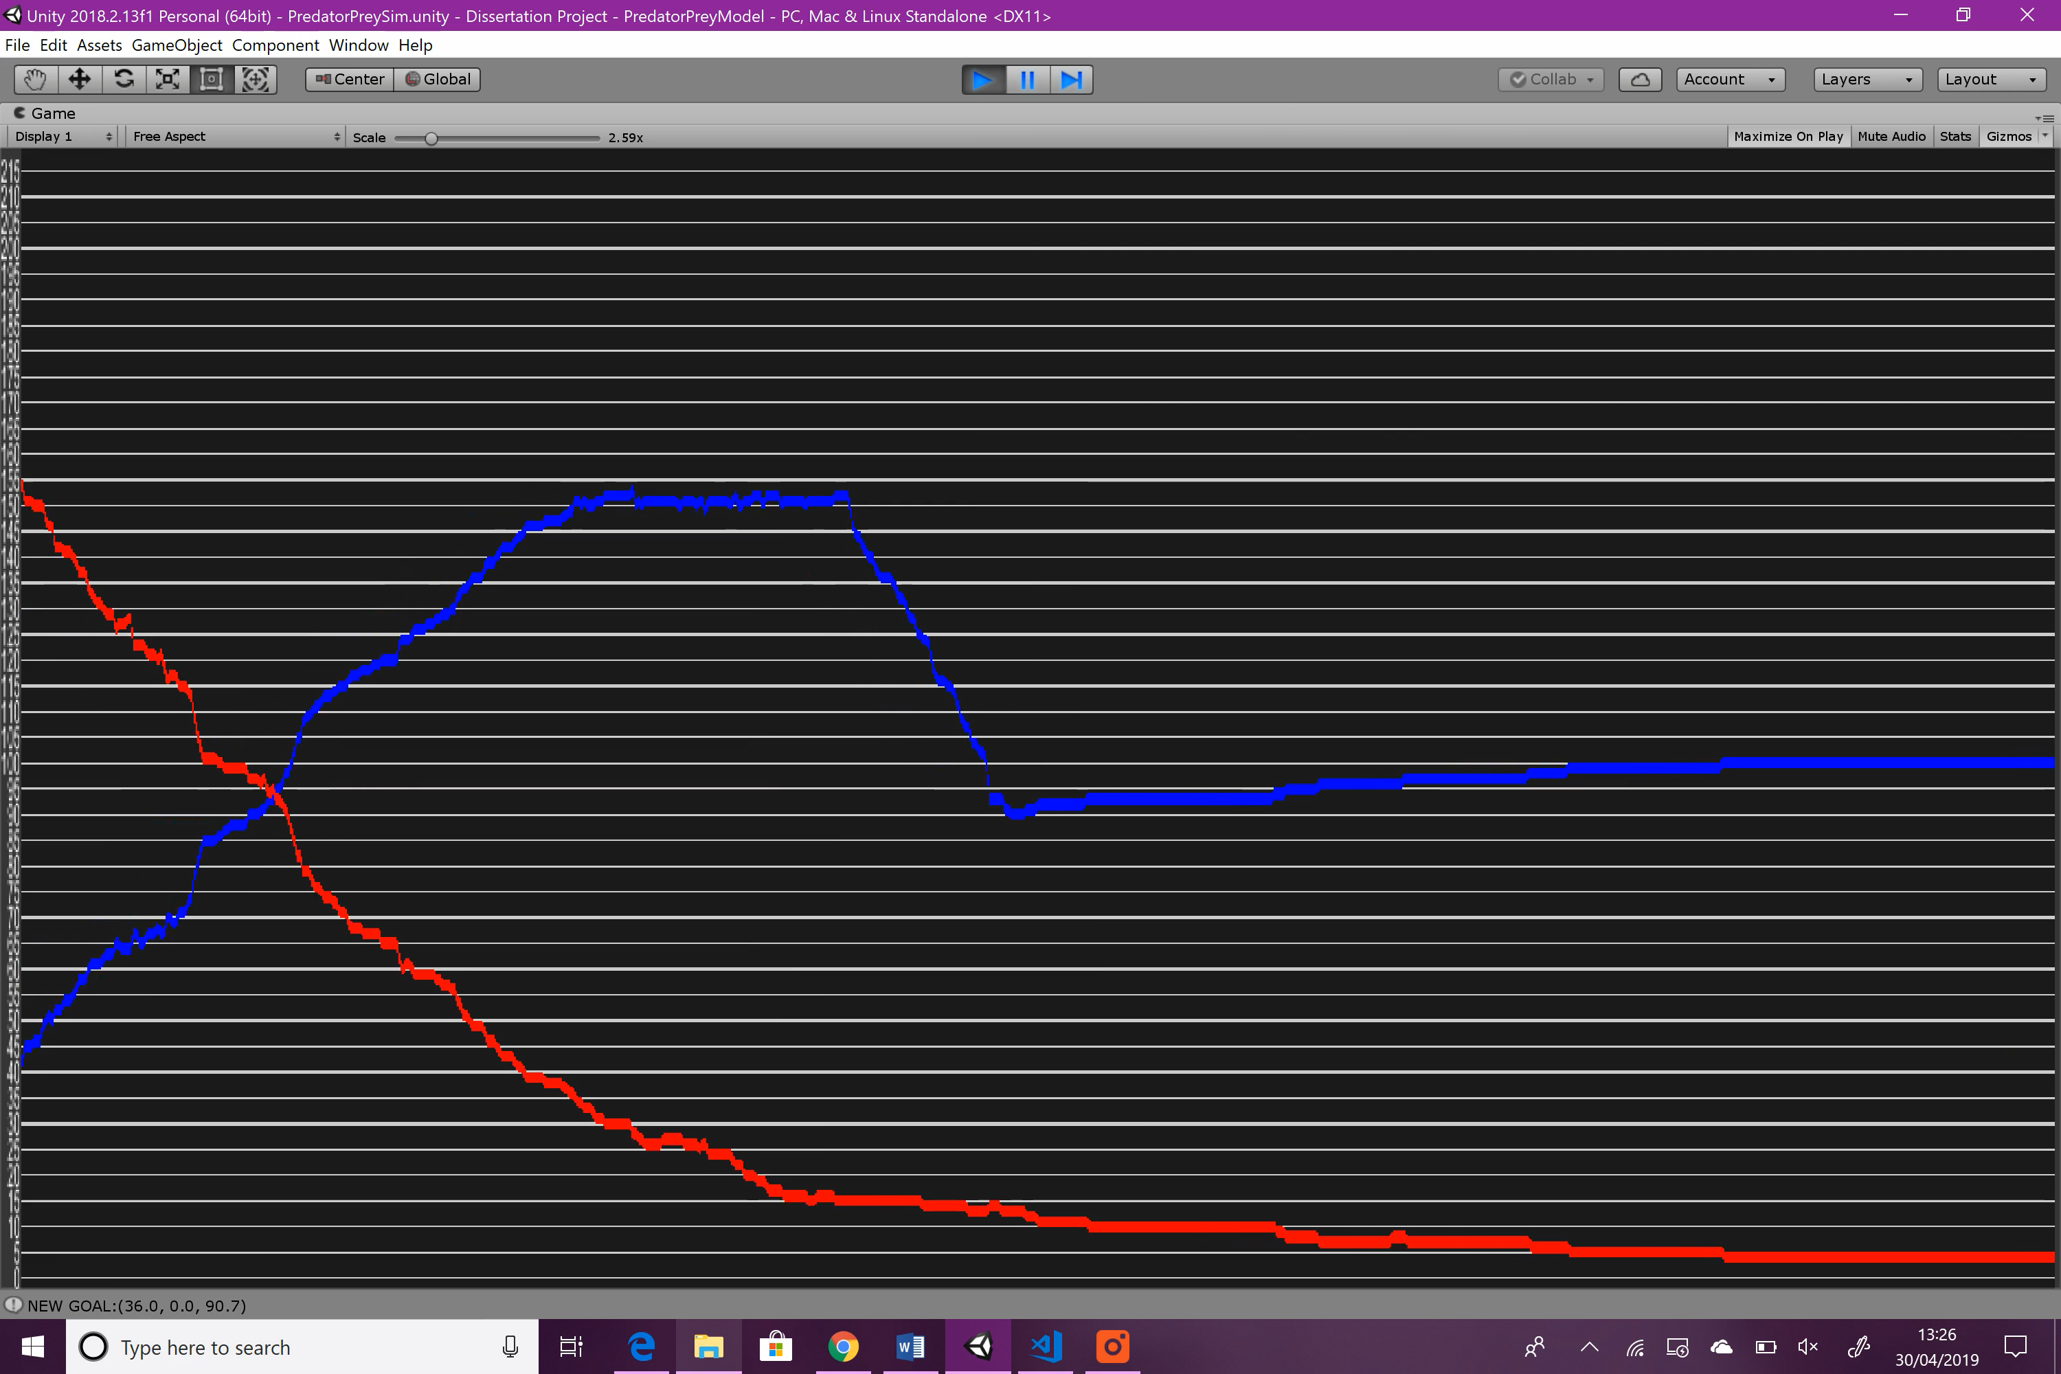

Figure : Variable Experimentation: Predator Chase Speed: graph 1

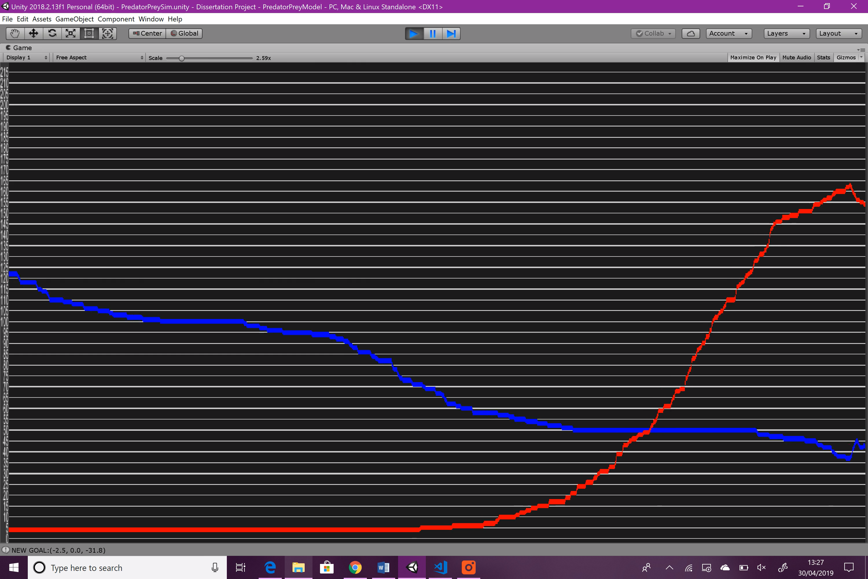

Figure : Variable Experimentation: Predator Chase Speed: graph 2

Didn’t include the hibernation period as it was unnecessary.

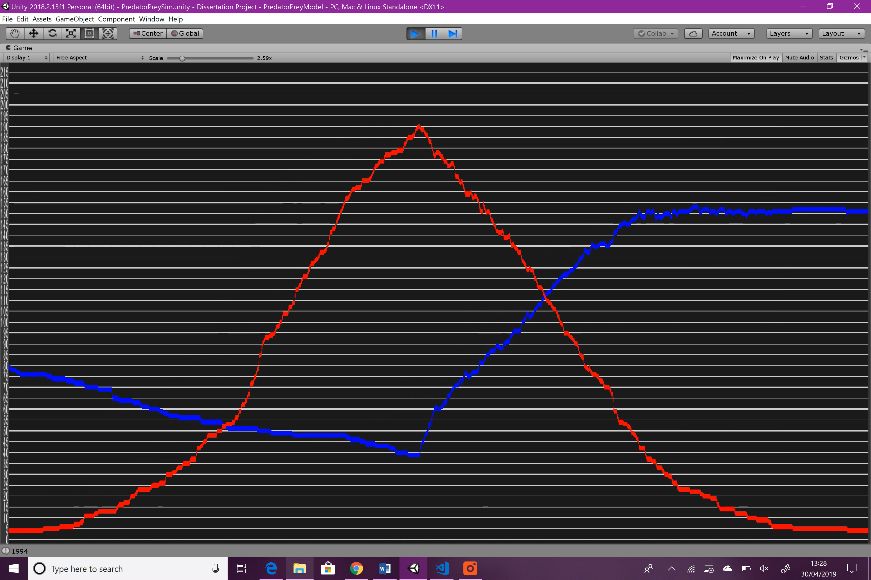

Figure : Variable Experimentation: Predator Chase Speed: graph 3

Note: the passage of ‘time’ goes from right to left

**Summary**

During the first season, the predator population increases much faster than in the original simulation, which is expected as increasing chase speed will give a large boost to predation. Unexpectedly, the predator population rises at roughly the same rate as that of the original simulation. I would have expected it to rise much quicker as well, as it did in the first season.

#### Sight Range

A larger sight range will allow predators to see prey from farther away and begin chasing. A higher value will likely benefit the predator population, but not much. A lower value will prove to be detrimental as predators won’t be able to see prey until they are very close. If the value is too low, the predator may never even see any prey, as the prey will flee before the predator gets close enough.

|  |  |
| --- | --- |
| Variable | Value |
| original | 80 |
| experimental | 20 |

Figure : Predator Sight Range changes

**Result**

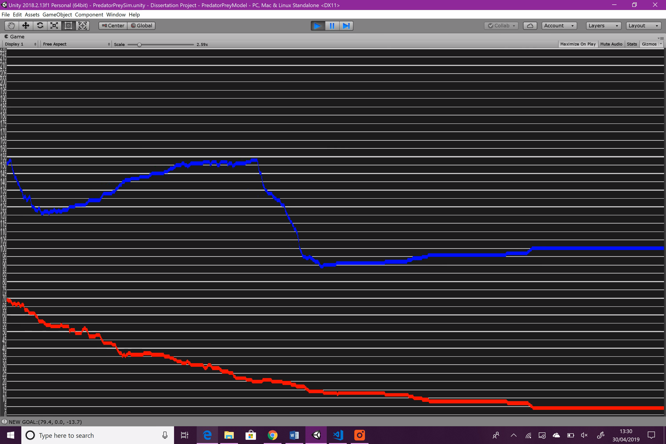

Figure : Variable Experimentation: Predator Sight Range: graph 1

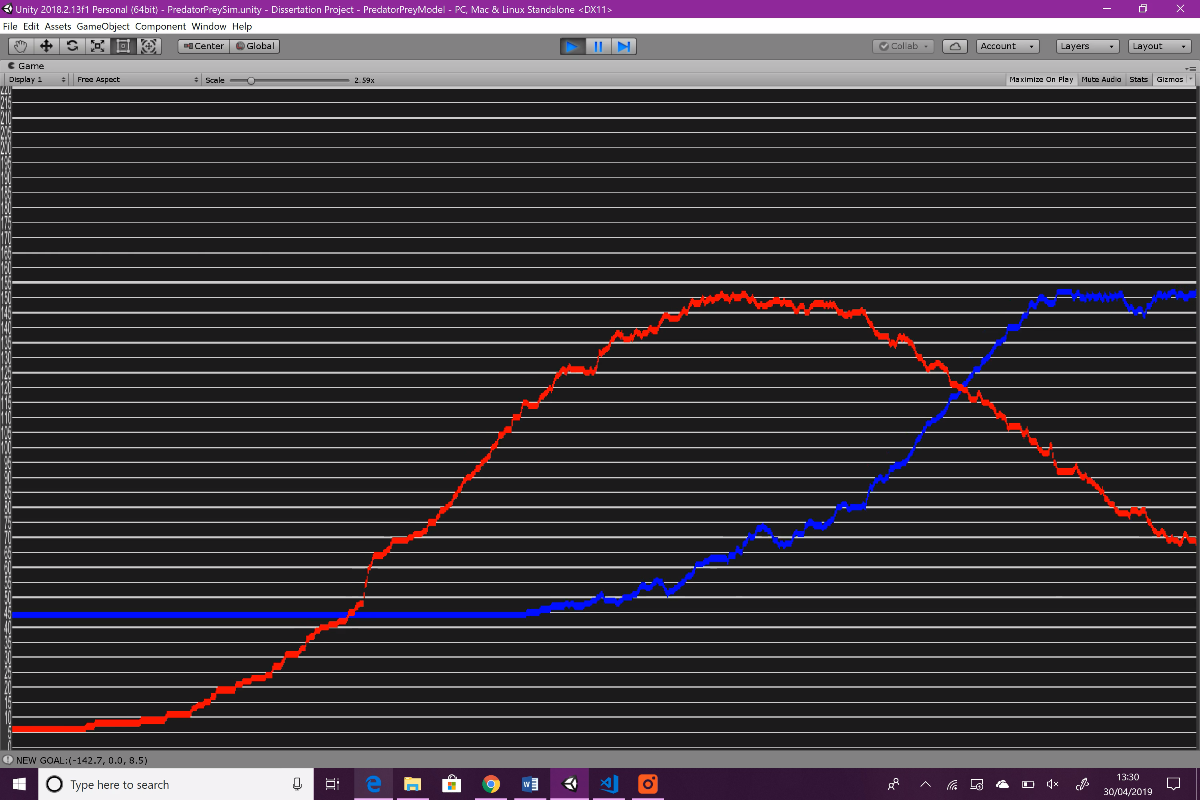

Figure : Variable Experimentation: Predator Sight Range: graph 2

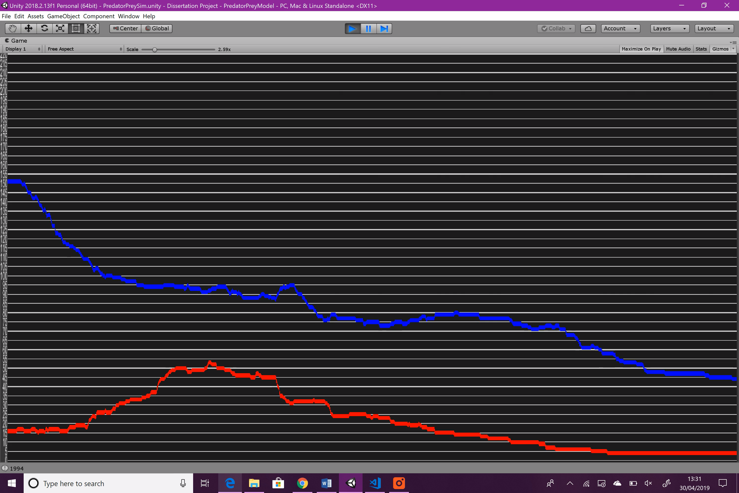

Figure : Variable Experimentation: Predator Sight Range: graph 3

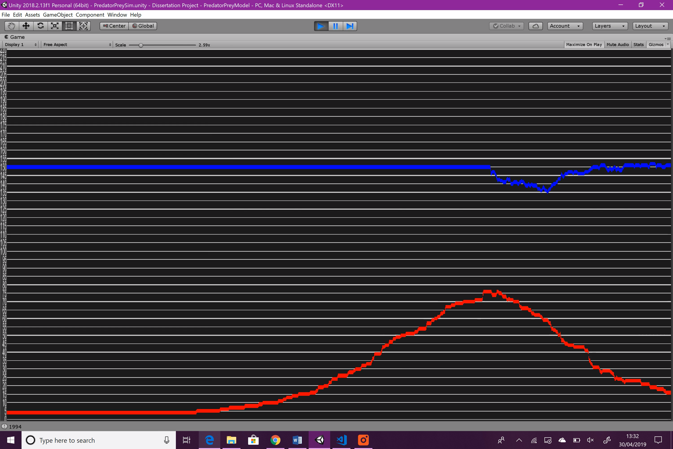

Figure : Variable Experimentation: Predator Sight Range: graph 4

**Summary**

During the first season, reducing the sight distance has no obvious effect. However, shows the most significant change that any of the experiments have shown so far; the predator population rises slightly, but then dies off. It then rises again, only slightly more than before, but then dies off again due to hibernation beginning, and throughout this time, the prey population manages to rise to its maximum and stay there. It’s obvious that reducing sight distance has had a negative effect on predation, and raising it would likely improve predation also.

#### Eat Cooldown

This variable affects how often the predator can begin using predatory behaviours again after they have eaten. Such behaviours include sight and smell. Raising the value will mean that predators can eat less often and therefore cannot reproduce as fast, as they breed whenever they eat a prey.

Measured in seconds.

|  |  |
| --- | --- |
| Variable | Value |
| original | 3 |
| experimental | 0.2 |

Figure : Predator Eat Cooldown changes

**Result**

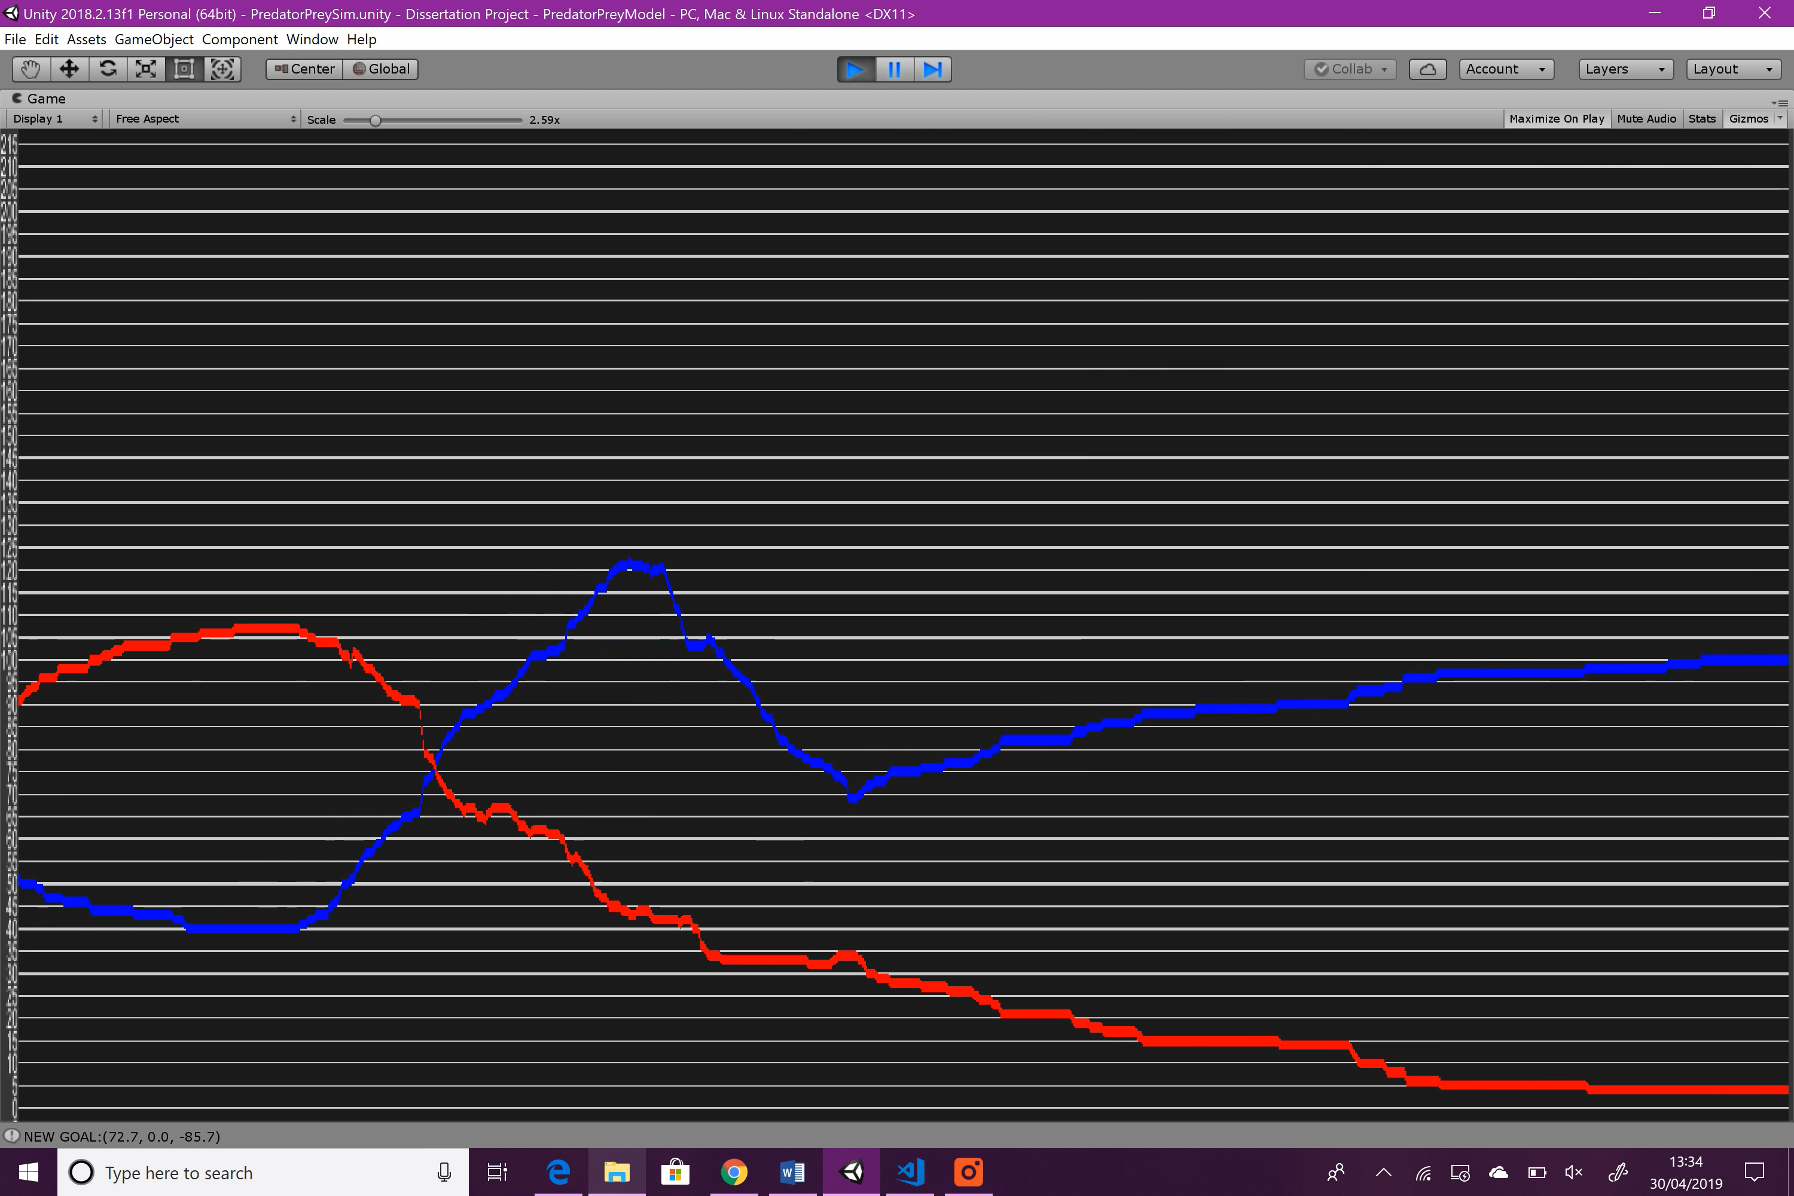

Figure : Variable Experimentation: Predator Eat Cooldown: graph 1

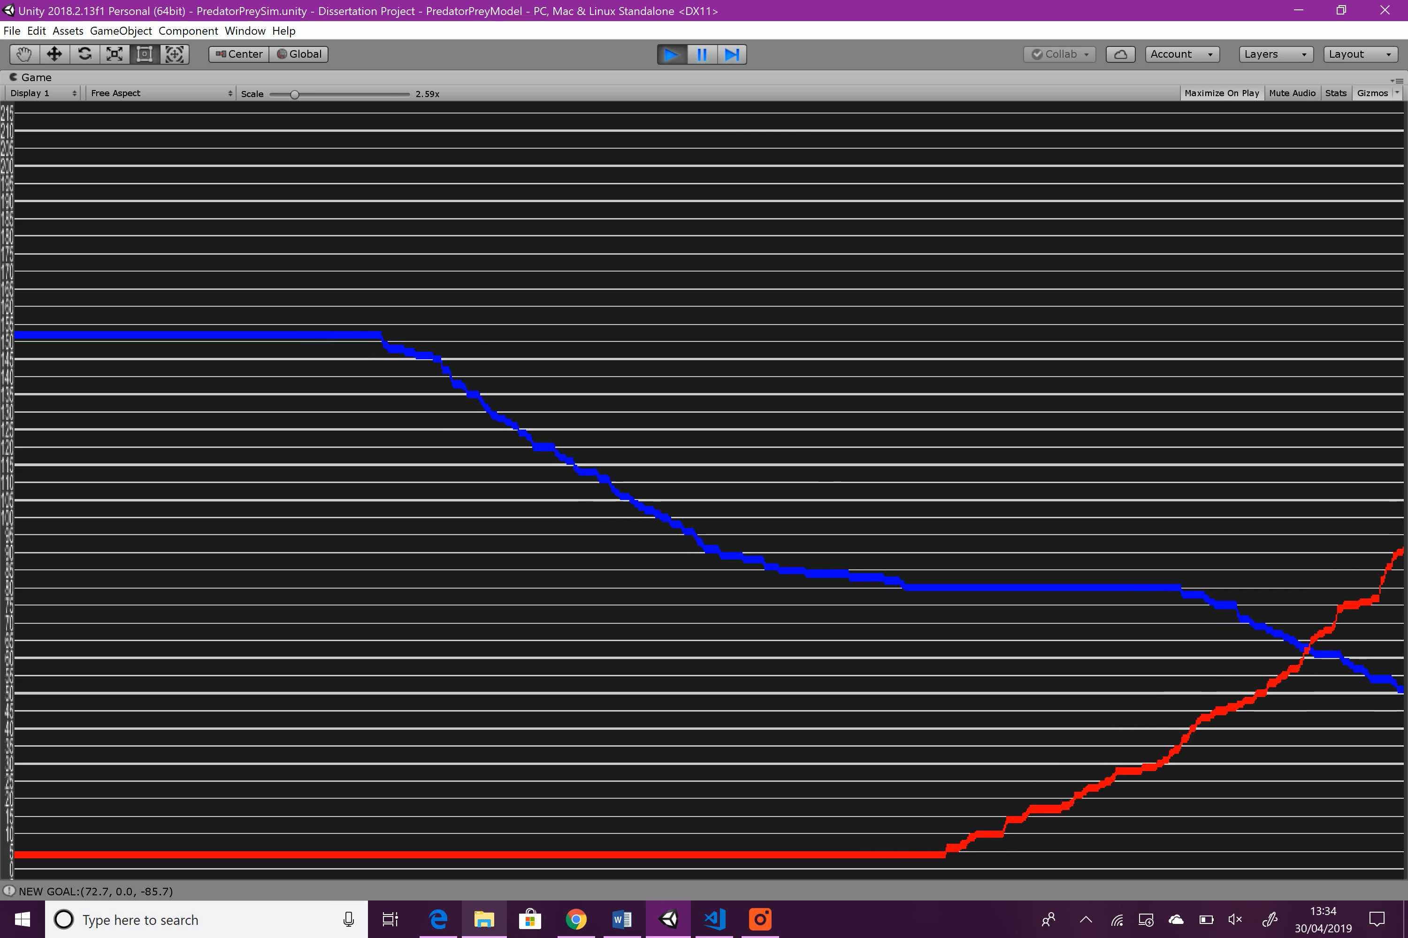

Figure : Variable Experimentation: Predator Eat Cooldown: graph 2

Didn’t include the hibernation period as it was unnecessary.

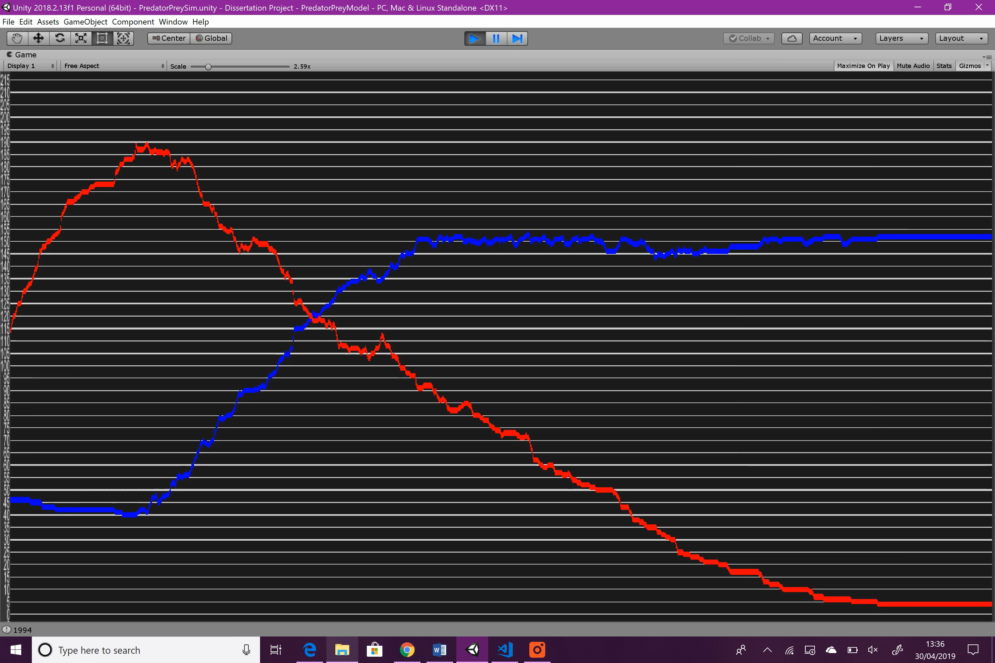

Figure : Variable Experimentation: Predator Eat Cooldown: graph 3

**Summary**

During the first season, the prey population is wiped out almost instantly, and they enter hibernation. The second season however does not show much of a difference to that of the original simulation.

#### Death Time

Affects how long the predator can go before dying. The timer is reset when the predator eats a prey. High death time will be beneficial for predators as they can go longer without eating, and therefore it will be easier for their population to grow. Their population will also fall more slowly.

Measured in seconds.

|  |  |
| --- | --- |
| Variable | Value |
| original | 7 |
| experimental | 20 |

Figure : Predator Death Time changes

**Result**

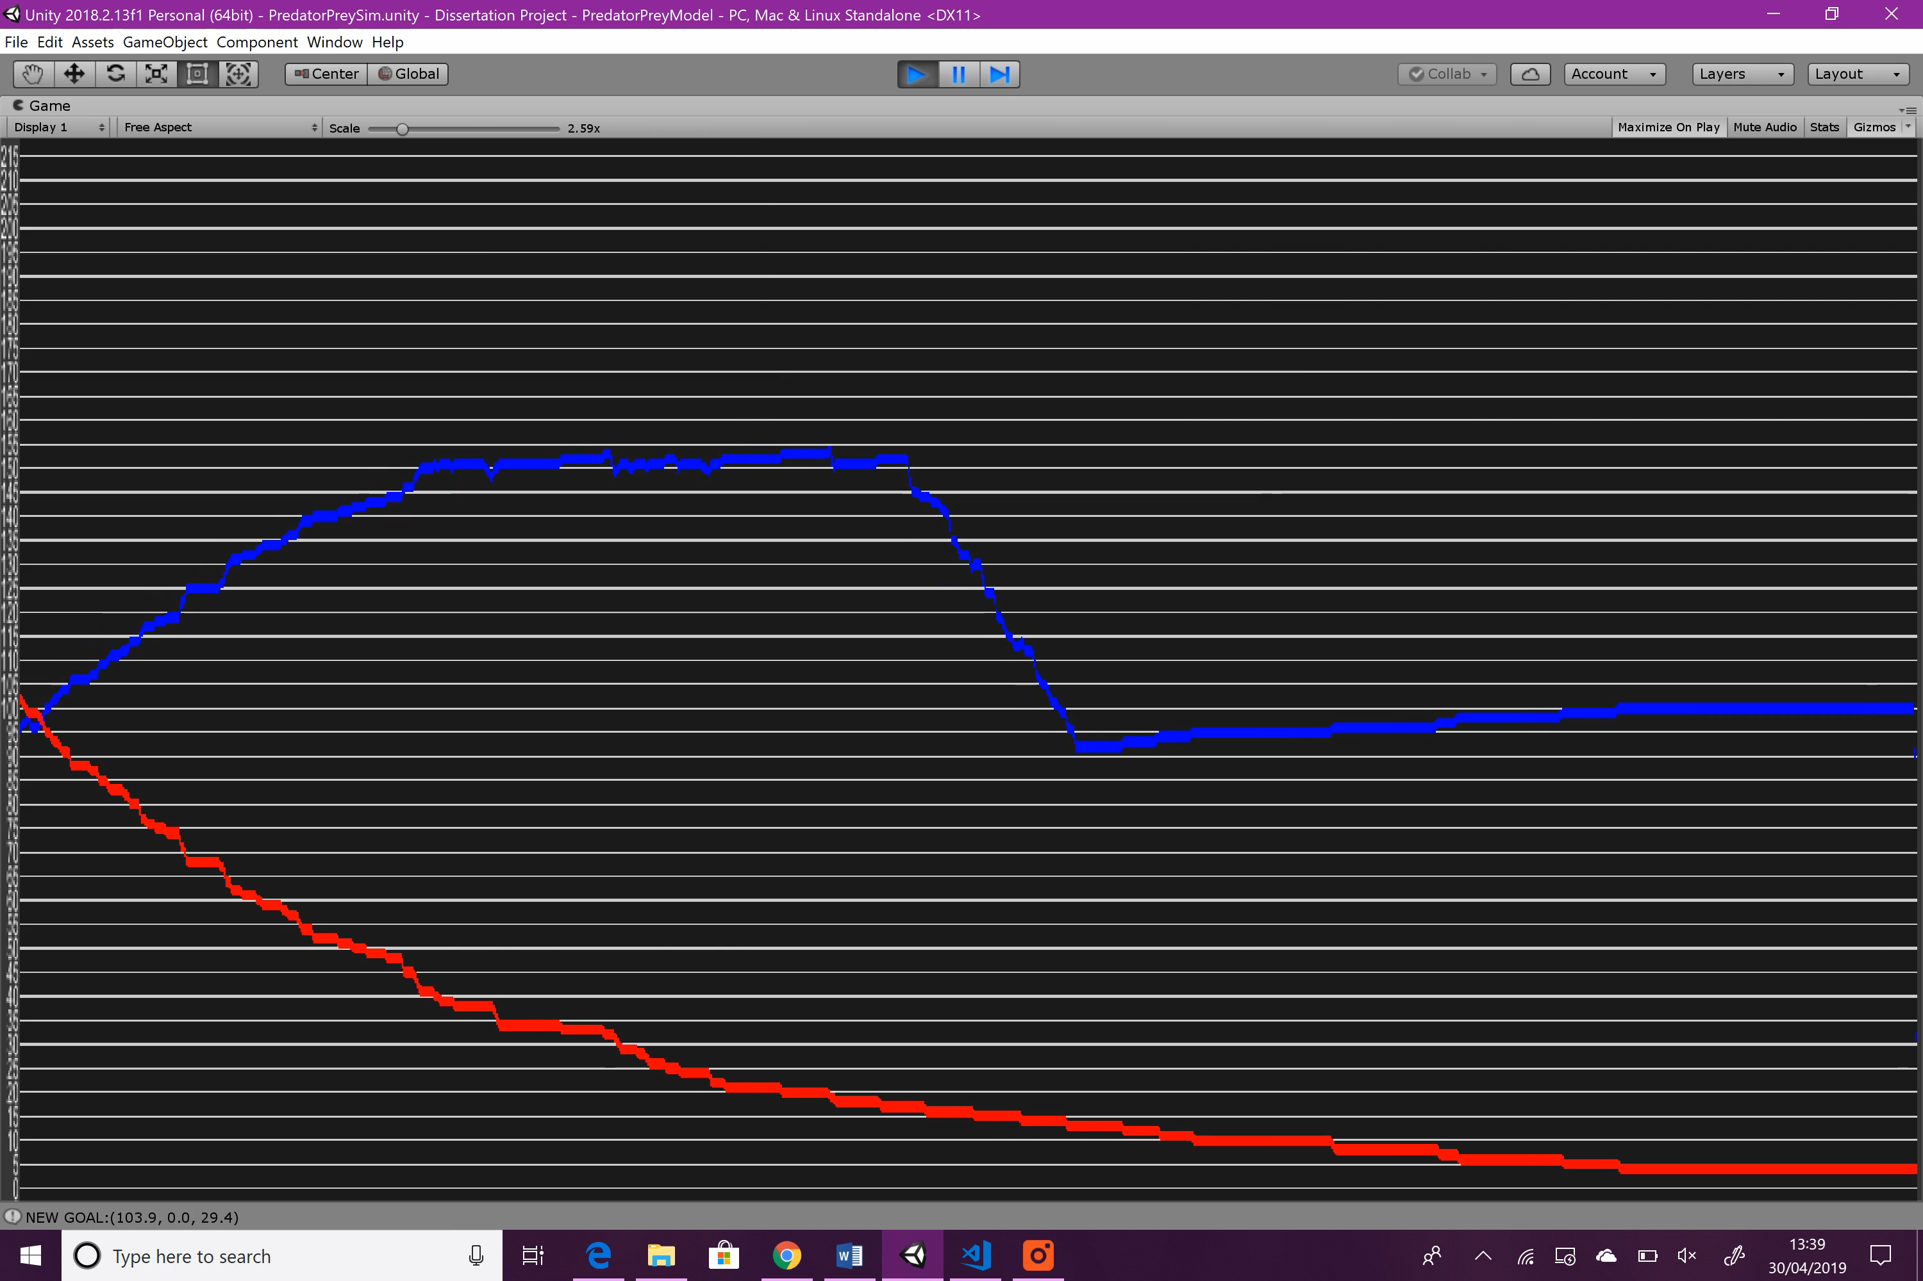

Figure : Variable Experimentation: Predator Death Time: graph 1

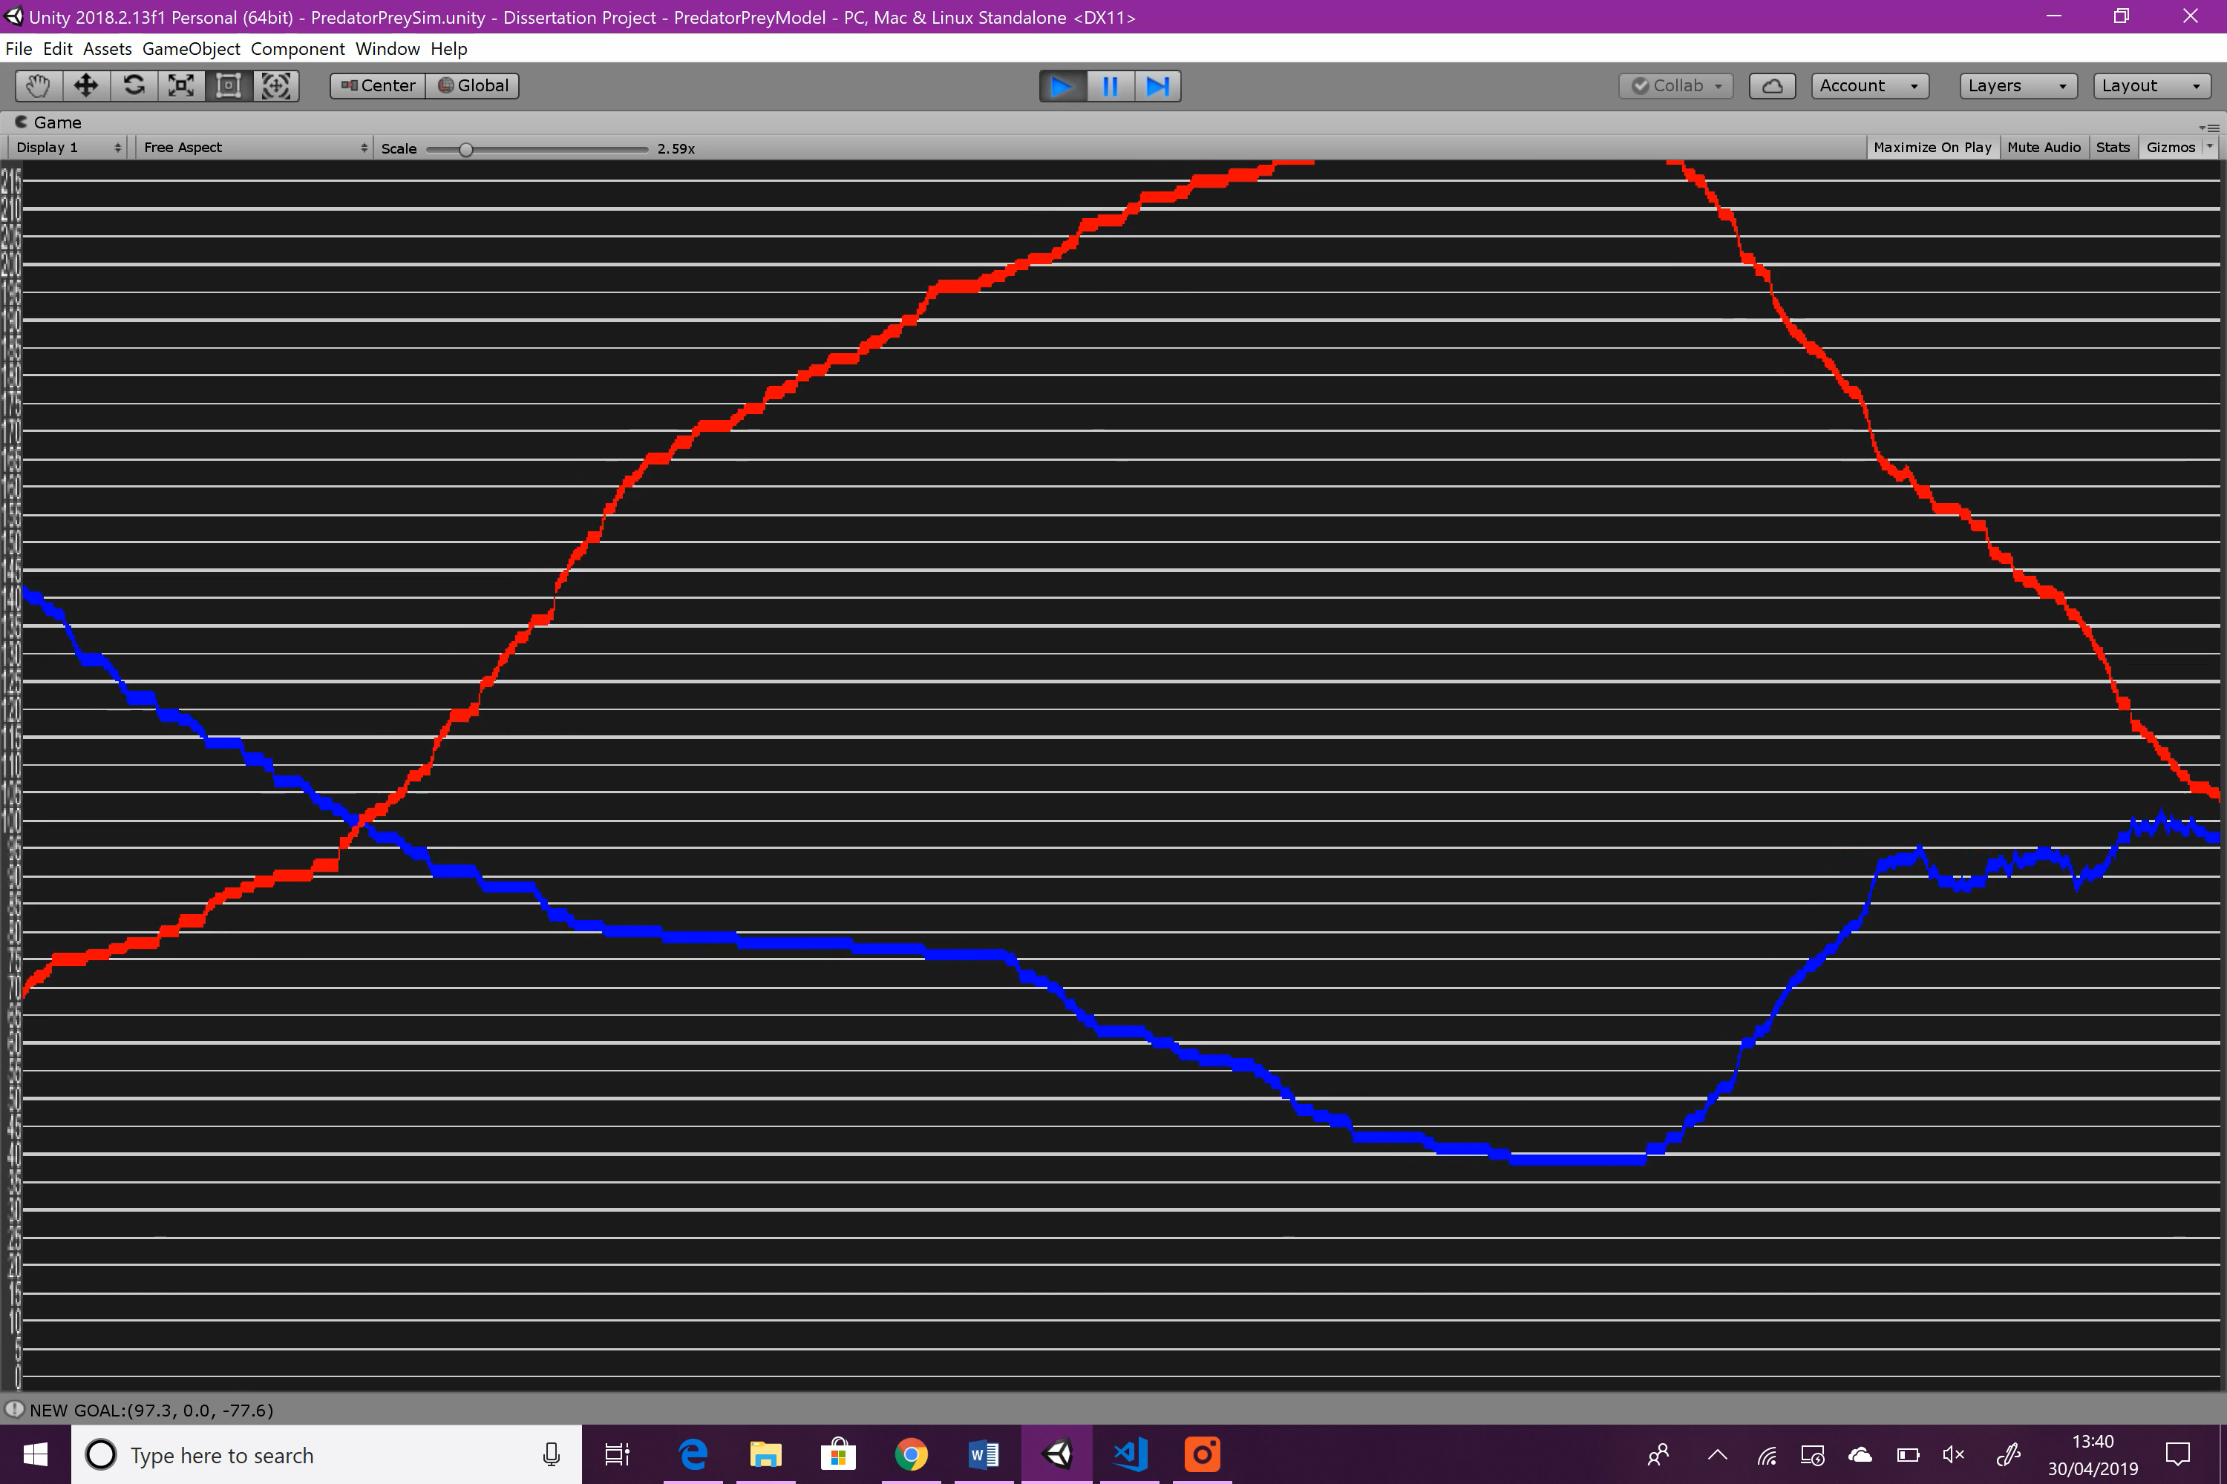

Figure : Variable Experimentation: Predator Death Time: graph 2

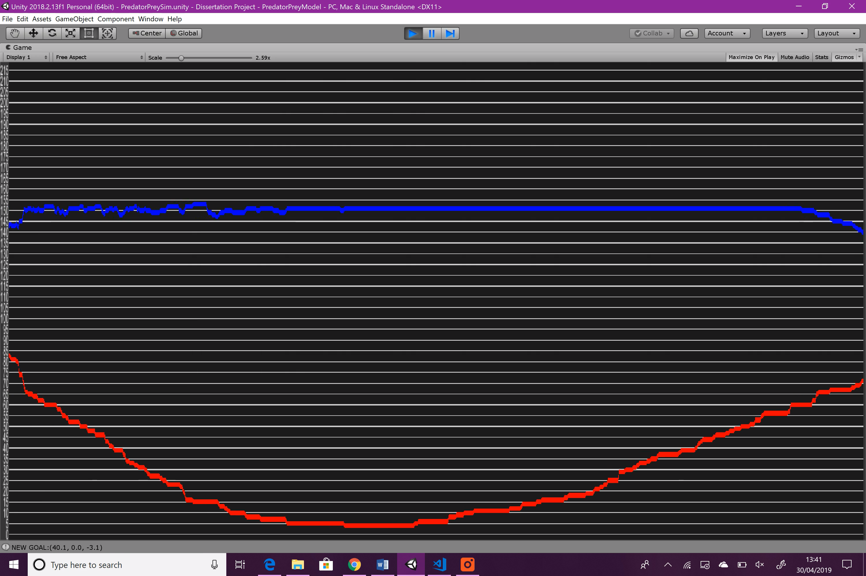

Figure : Variable Experimentation: Predator Death Time: graph 3

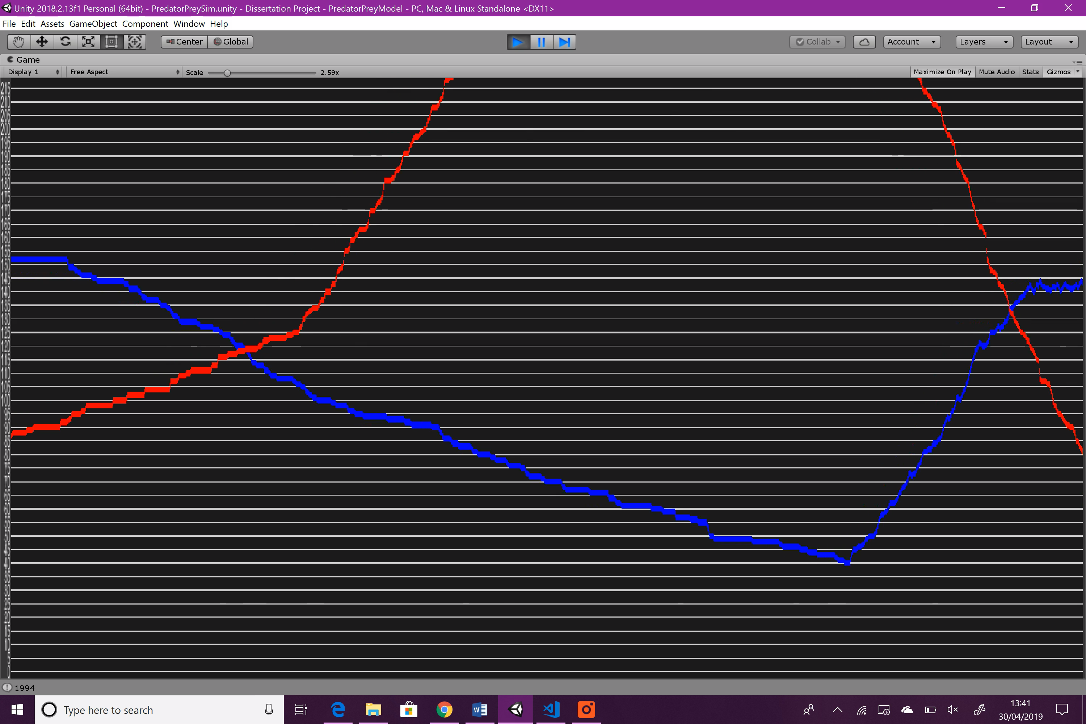

Figure : Variable Experimentation: Predator Death Time: graph 4

**Summary**

Increasing the death time makes the overall line of the predators much smoother. When the predator population rises, they take almost no deaths, so there are no visible drops in the line, as can be seen in the original simulation. Additionally, when hibernation, the predator population dies out much slower. During both seasons, the peak of the predator population is noticeably higher than that of the original simulation, due to less predators dying due to hunger.

#### Max Number of Alphas

Alphas are only really considered at the beginning of a new year after all other predators have died off. With a higher alpha count, the predator population can begin to increase faster at the start of a new seasonal year.

|  |  |
| --- | --- |
| Variable | Value |
| original | 4 |
| experimental | 10 |

Figure : Predator Max Number of Alphas changes

**Result**

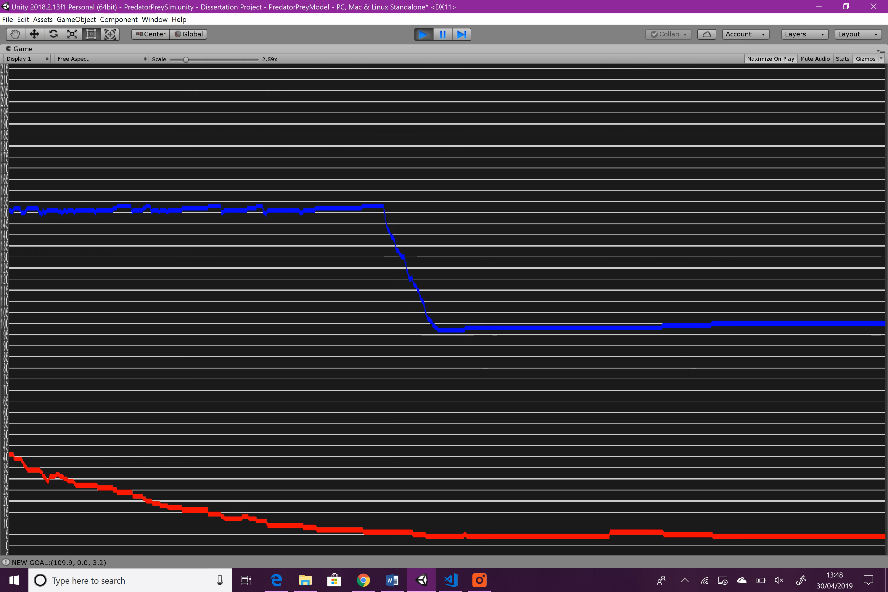

Figure : Variable Experimentation: Predator Max Number of Alphas: graph 1

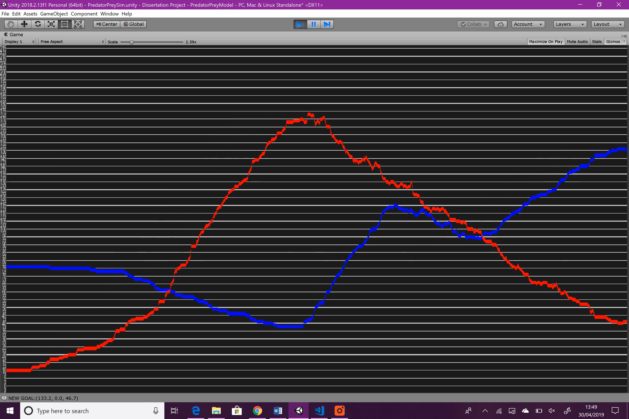

Figure : Variable Experimentation: Predator Max Number of Alphas: graph 2

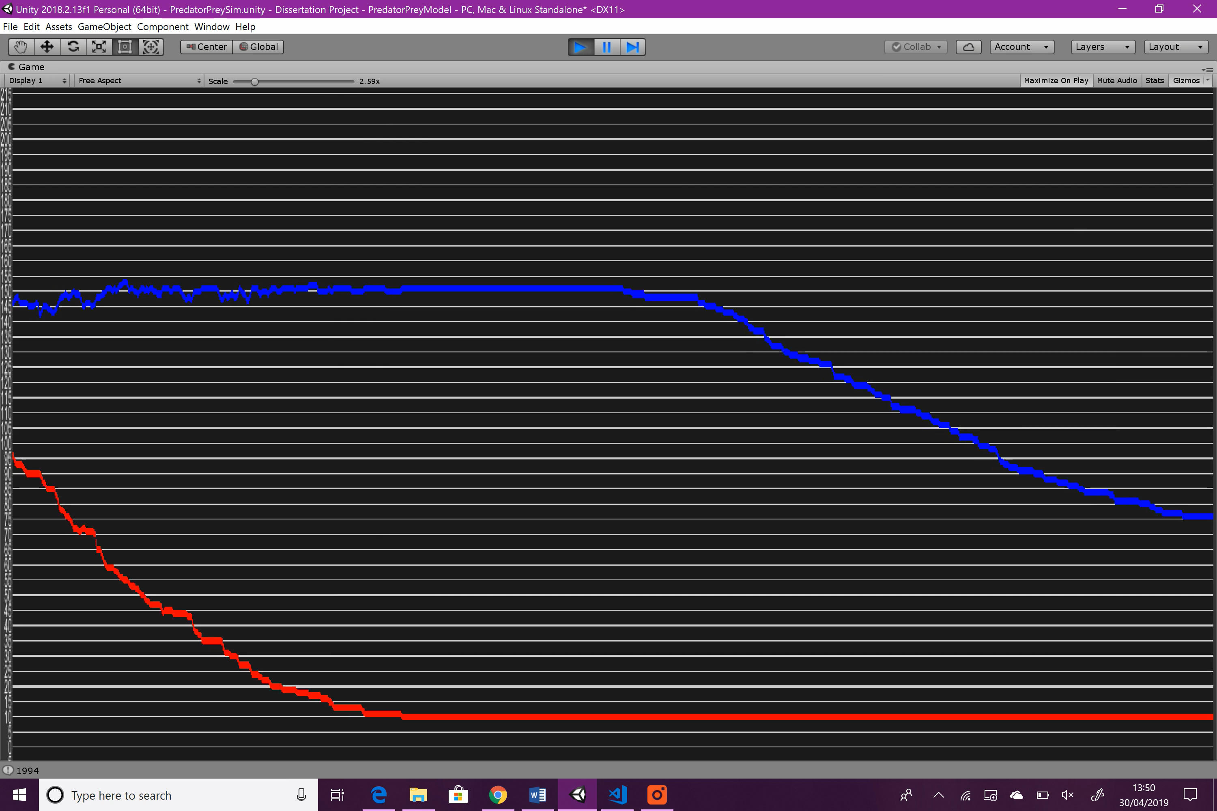

Figure : Variable Experimentation: Predator Max Number of Alphas: graph 3

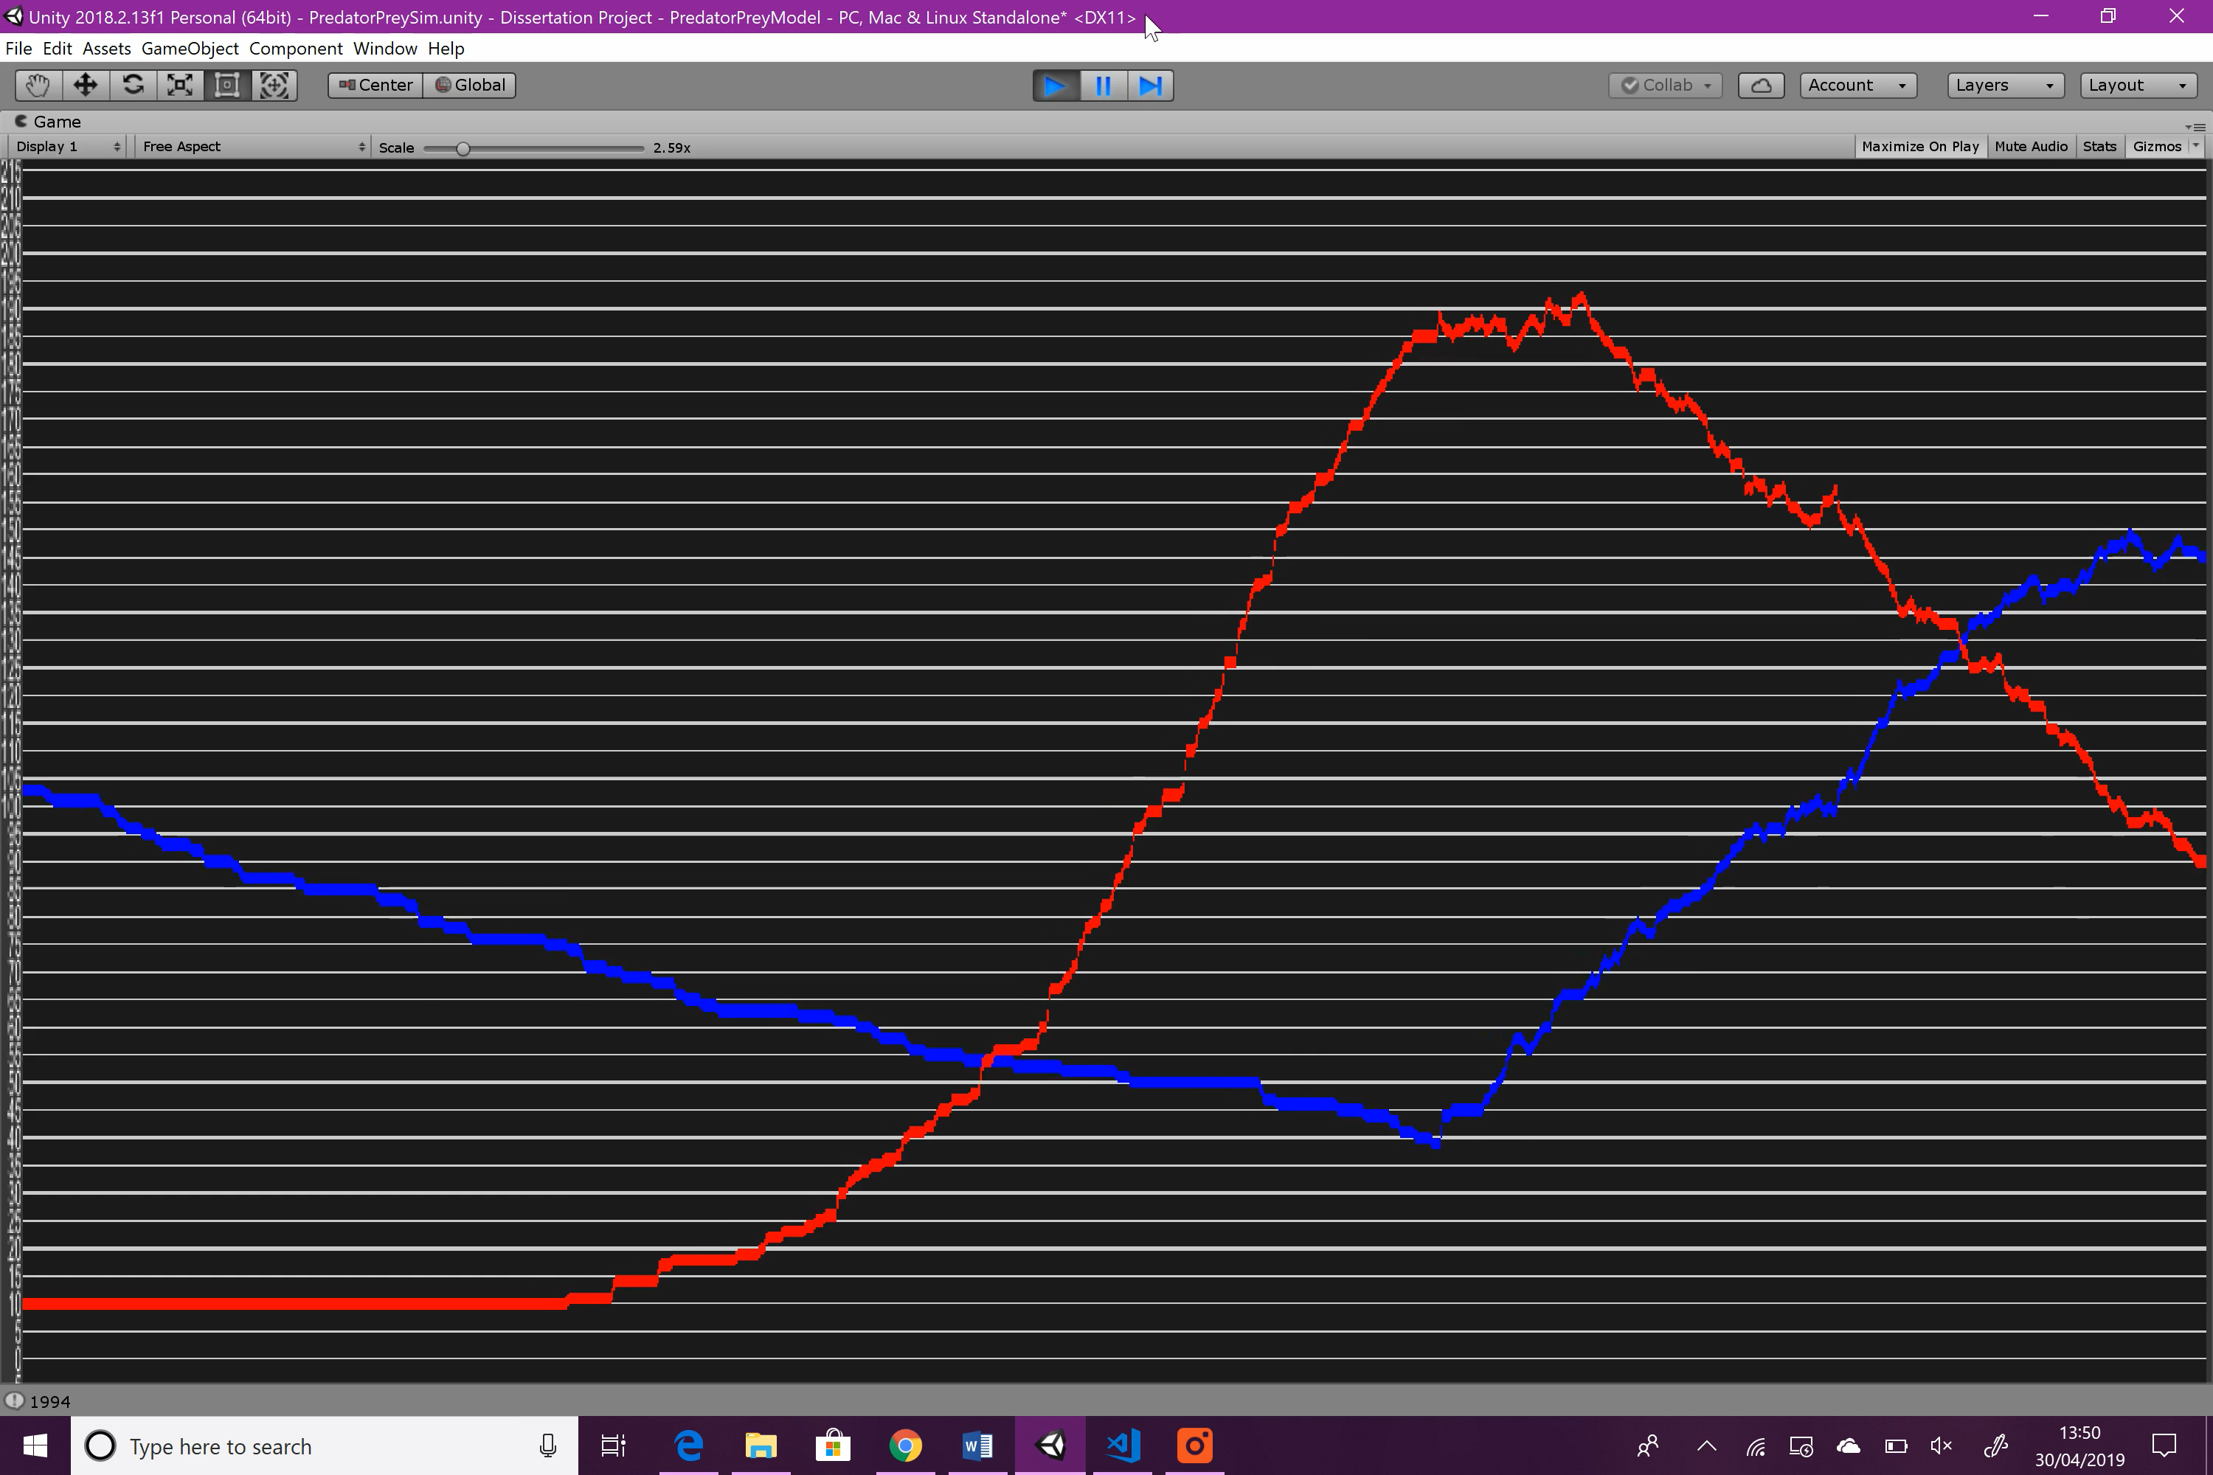

Figure : Variable Experimentation: Predator Max Number of Alphas: graph 4

**Summary**

Increasing the maximum number of alphas has no real effect on the first season, as the number of starting predators is still the same. During the second season however, the predator population rises slightly faster, which is expected as the number of predators still alive after the previous hibernation is significantly higher.

### Manager

#### Starting Prey Population

Having more prey at the start of the simulation is beneficial for the predators, as they will have a very large food supply, allowing them to breed quickly, and vice versa when the prey population is low.

|  |  |
| --- | --- |
| Variable | Value |
| original | 100 |
| experimental | 150 |

Figure : Manager Starting Prey Population changes

**Result**

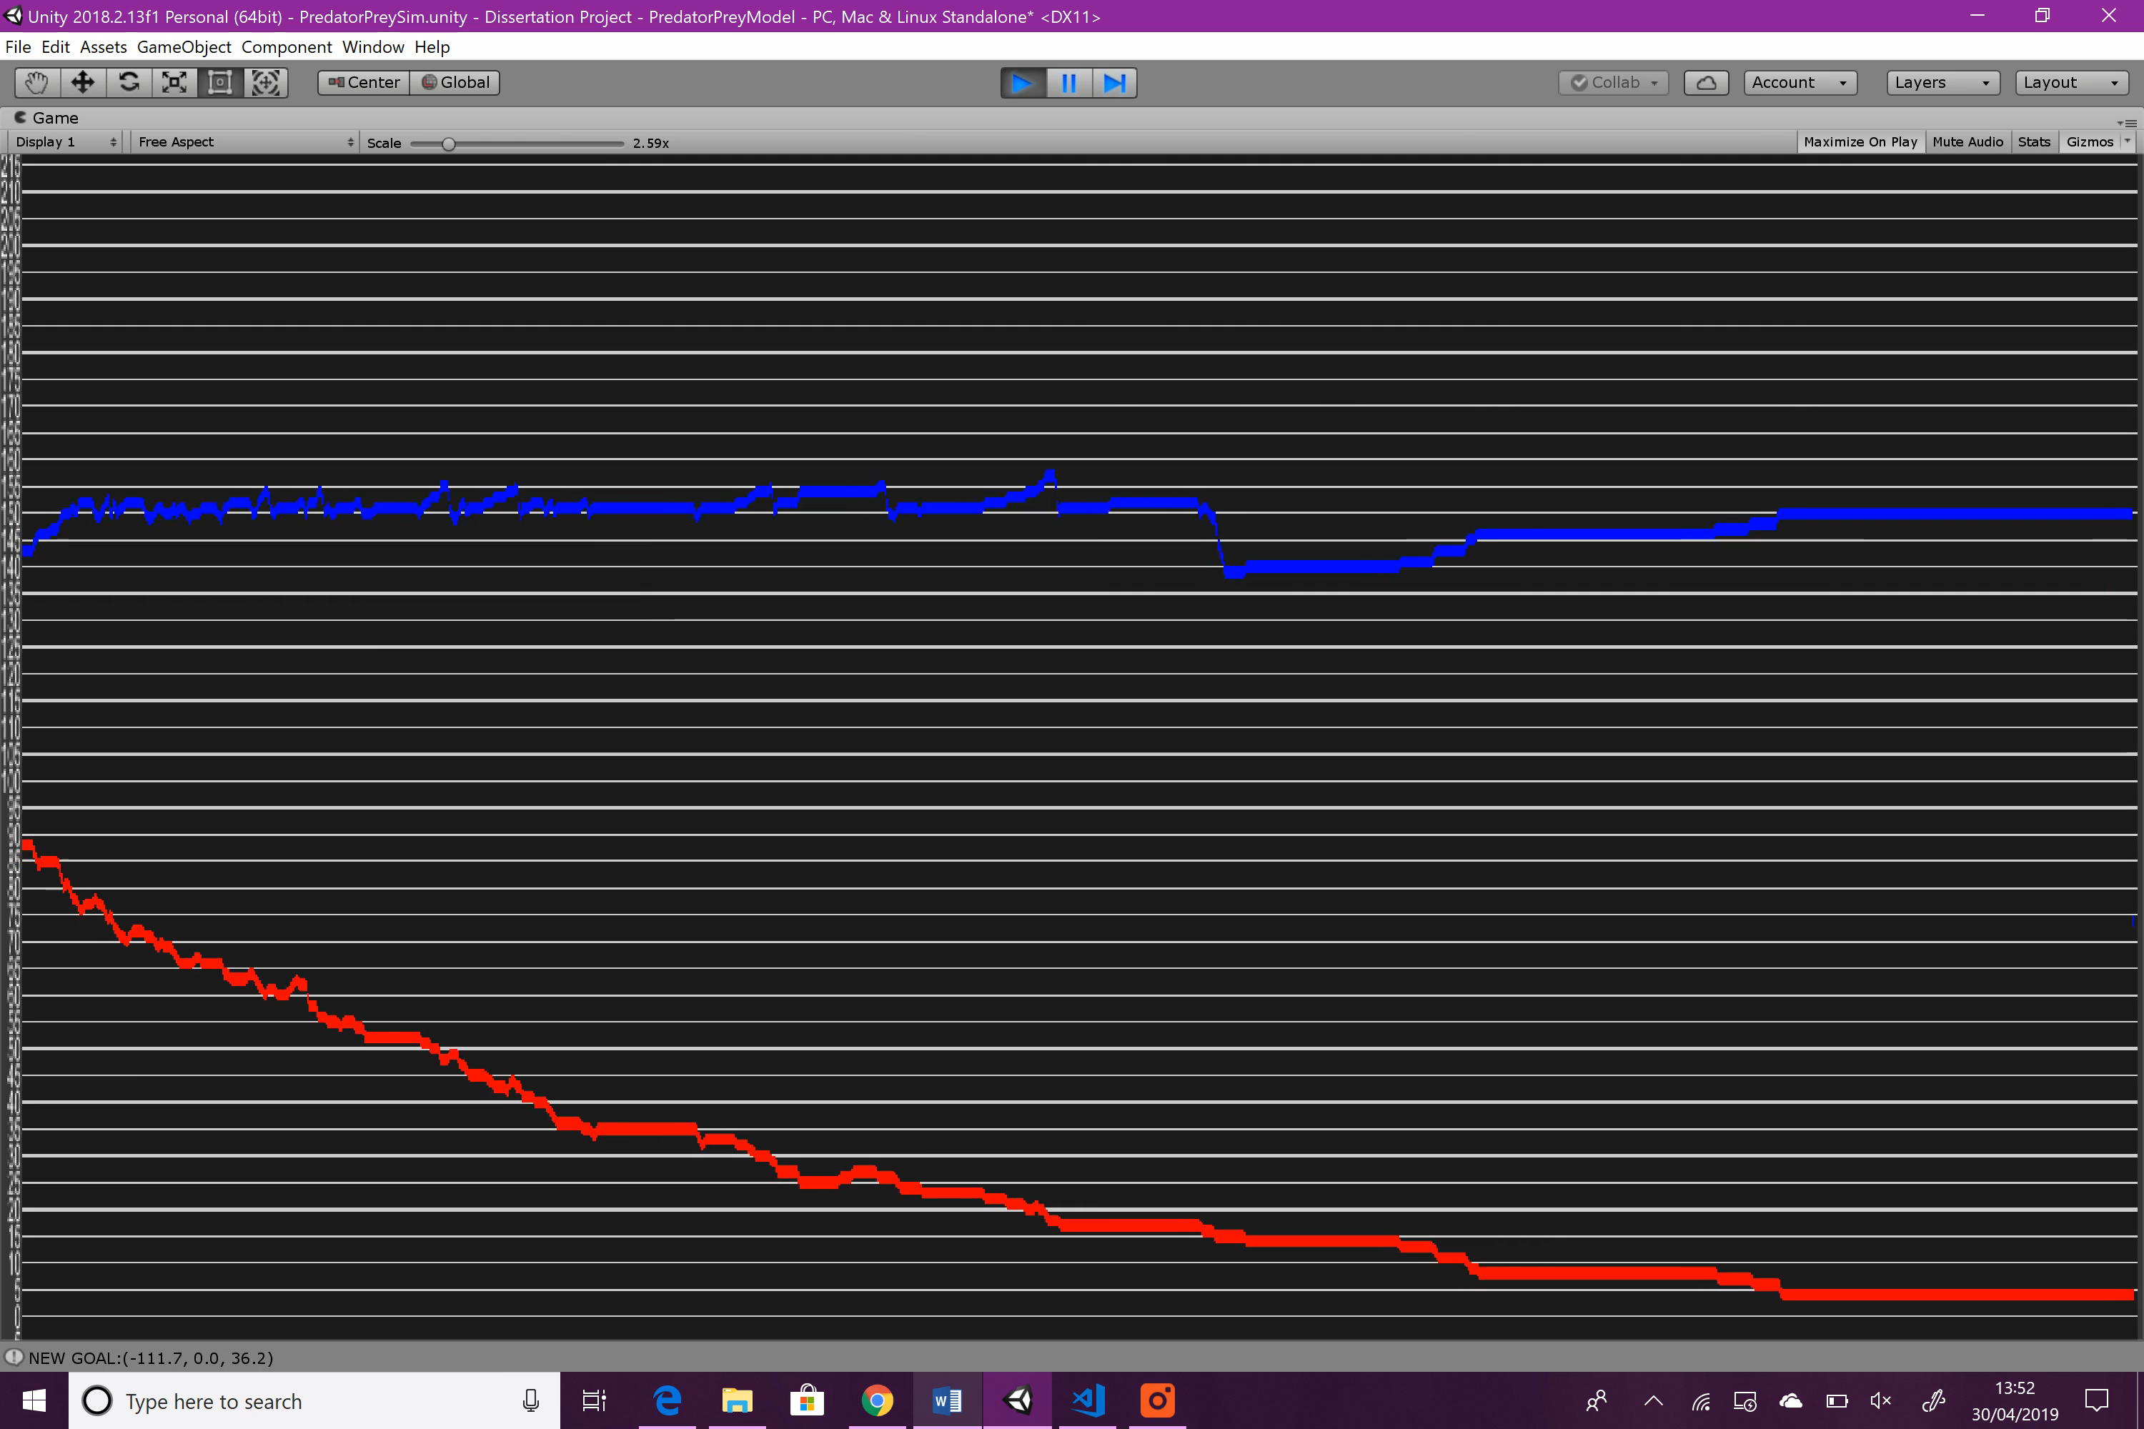

Figure : Variable Experimentation: Starting Prey Population: graph 1

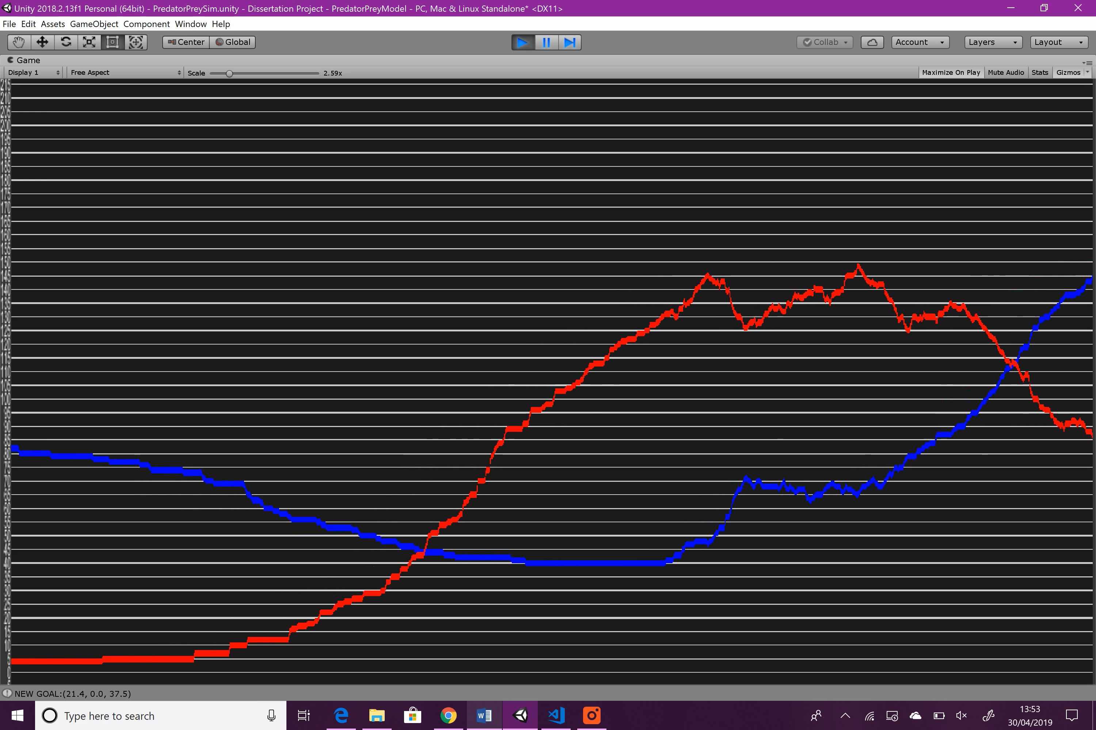

Figure : Variable Experimentation: Starting Prey Population: graph 2

Didn’t include the hibernation period as it was unnecessary.

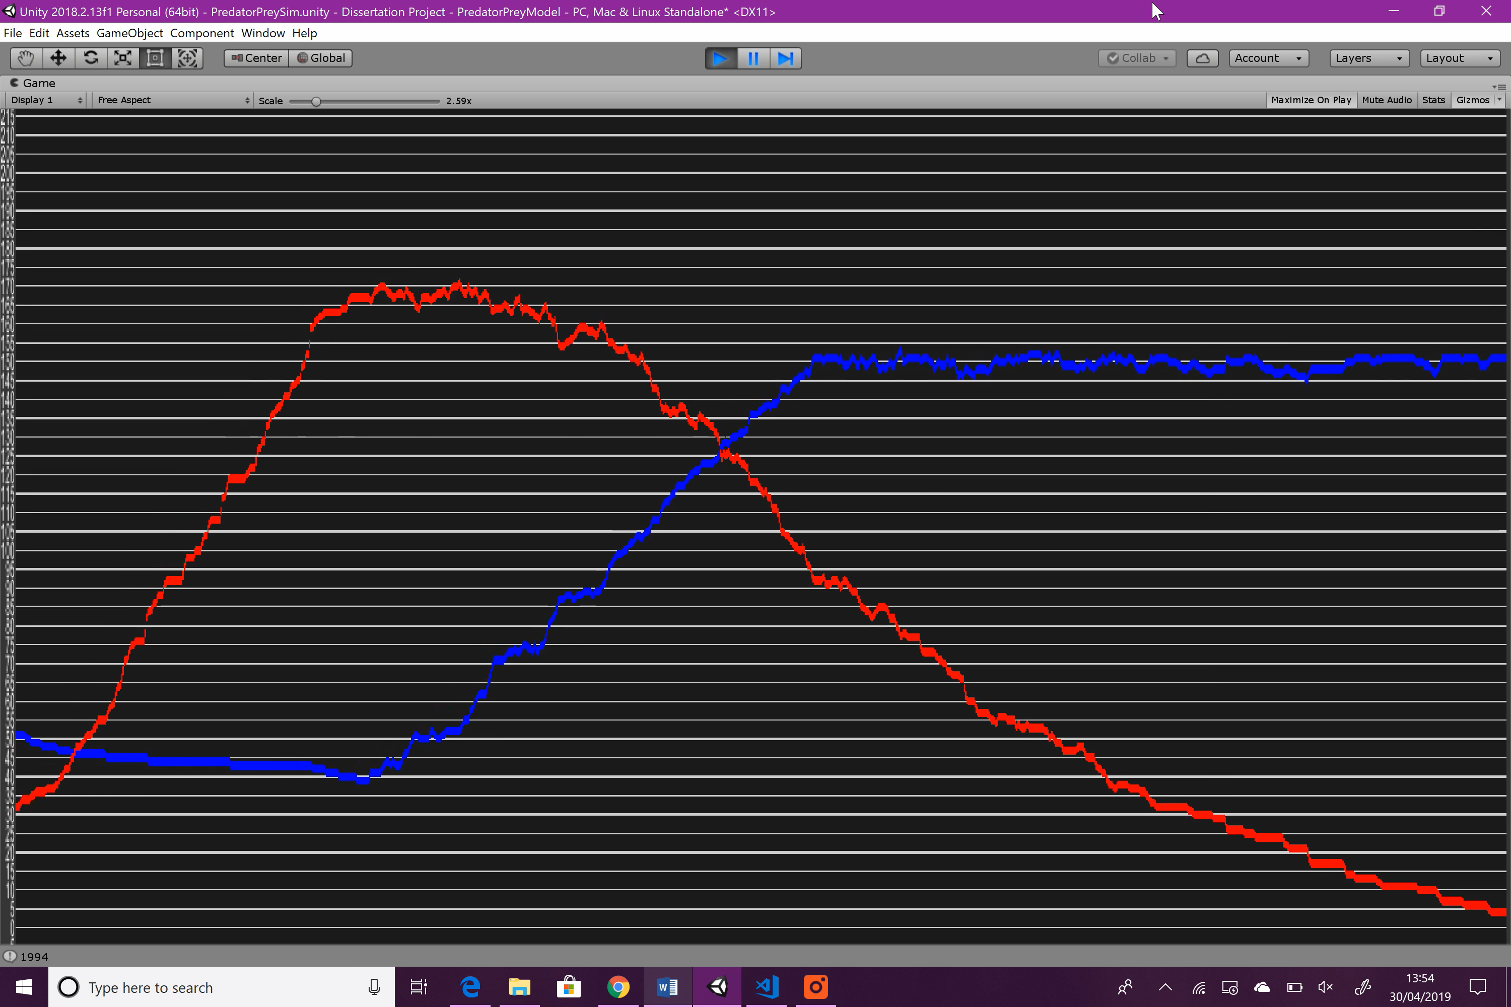

Figure : Variable Experimentation: Starting Prey Population: graph 3

**Summary**

I had expected increasing the prey population at the start would cause the predator population to grow significantly faster, however their growth seems to be roughly the same.

#### Starting Predator Population

Similarly, with starting prey population, when the starting predator is high, the predators will benefit, when low, the prey will benefit due to decreased predation.

|  |  |
| --- | --- |
| Variable | Value |
| original | 4 |
| experimental | 1 |

Figure : Manager Starting Predator Population changes

**Result**

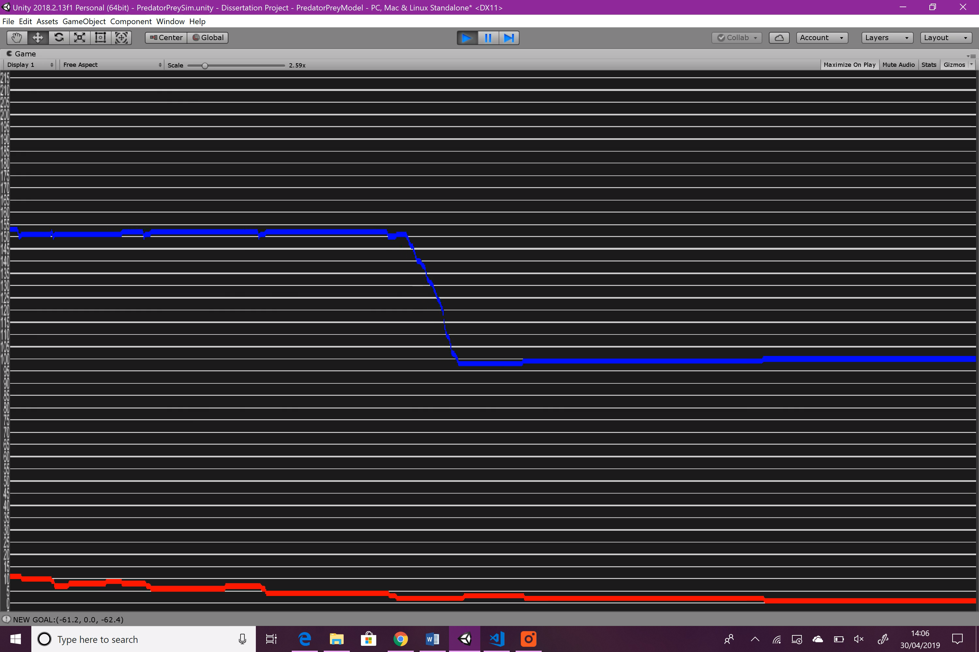

Figure : Variable Experimentation: Starting Predator Population: graph 1

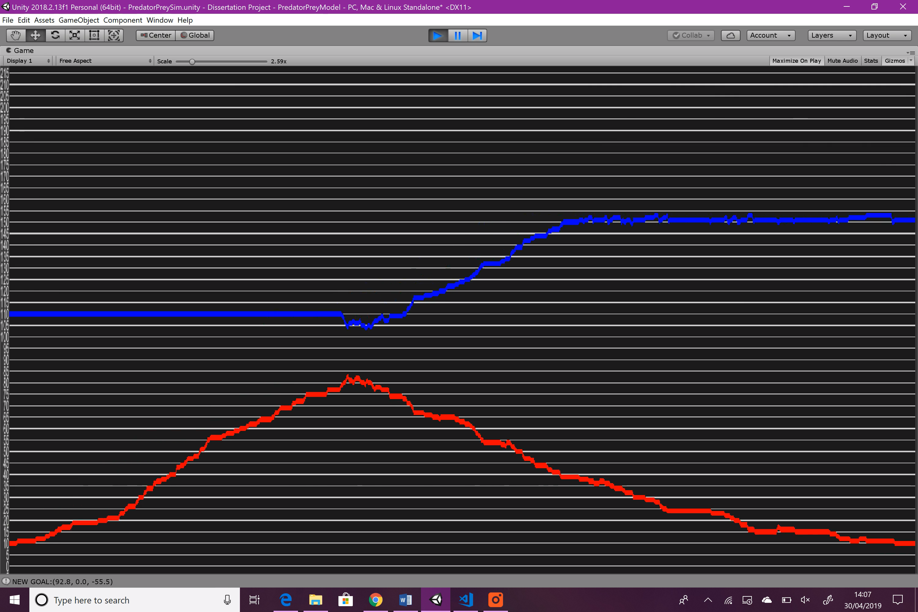

Figure : Variable Experimentation: Starting Predator Population: graph 2

Didn’t include the hibernation period as it was unnecessary.

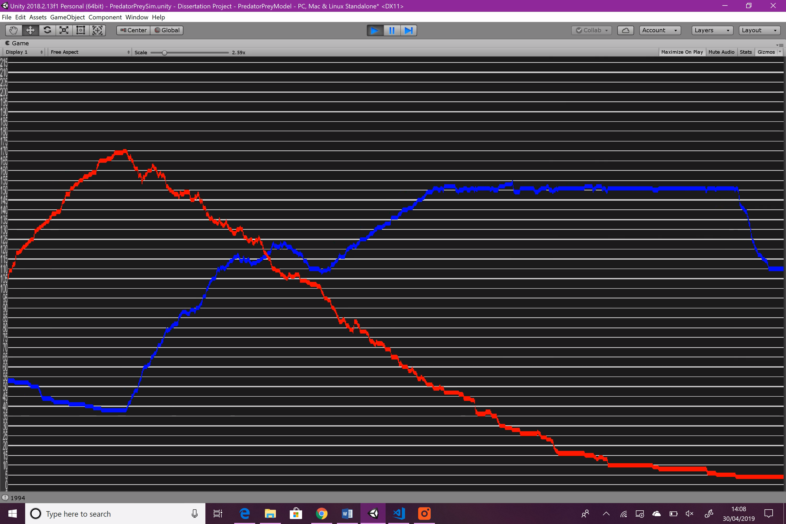

Figure : Variable Experimentation: Starting Predator Population: graph 3

Note: the passage of ‘time’ goes from right to left

**Summary**

As expected, reducing the starting predator population from 4 to 1 has significantly reduced their growth in the first season, to the point that hibernation begins long before the prey can be wiped out. Also as expected, the second season remains relatively unchanged, as the maximum number of alphas is still 4.

### Experimentation Summary

Judging by the results of the various variable experimentation carried out above, most variables can alter how the populations change, and in different ways. This means that any third parties who wish to extrapolate the system for use in their own projects can easily alter the simulation to suit their needs. For example, if it is a very small project, they might need to reduce the starting predator and prey populations, as well as the maximum prey population so that the strain on performance is minimal.

## Background Research Comparison

This section will compare the finished simulation with the results of background research and determine how well my implementation runs in comparison.

### Predator-Prey Models

As described in the background research, a general predator prey model describes a relationship involving two species where one is predator and one is prey. The trends in population that occur in these relationships are as follows.

1. When the predator population is low, the prey population can rise due to lack of predation.
2. When the prey population is high, the predator population can rise to abundance of food,
3. With high predator population, the prey population falls due to increased predation
4. With low prey population, the predator population falls due to lack of food.

This process is repeated continually.

These trends are backed up by the equations that describe the Lotka-Volterra model, as well as many others and is exactly the process that I aimed to recreate with my implementation. To evaluate whether I’ve succeeded in this task, I’ve conducted a series of runs of the simulation to compare the amount of times that it holds up to the definitions of a predator-prey relationship, against the amount of times it fails. The simulation was run for roughly 50 minutes with roughly four season occurring every five minutes. During a season, each trend will occur once. Some screenshots of the graphs used can be found in the appendix.

|  |  |  |  |  |  |
| --- | --- | --- | --- | --- | --- |
| Total Seasons | Times trend 1 failed | Times trend 2 failed | Times trend 3 failed | Times trend 4 failed | Success Rate (%) |
| 39 | 0 | 0 | 14 | 0 | 91.03 |

Figure : Background research comparison: Predator-prey models

Overall, the test is very successful in my opinion. The only times the trend failed were due to the prey population still rising slightly during predation which is because the prey will breed regardless of how much predation there is. This is one area I’d like to revisit in the future because when the prey population is falling, they are not meant to be able to repopulate like this according to predator-prey models like Lotka-Volterra. Below is a picture of the type of trend I’m talking about.

Figure : Trend 3 failure example

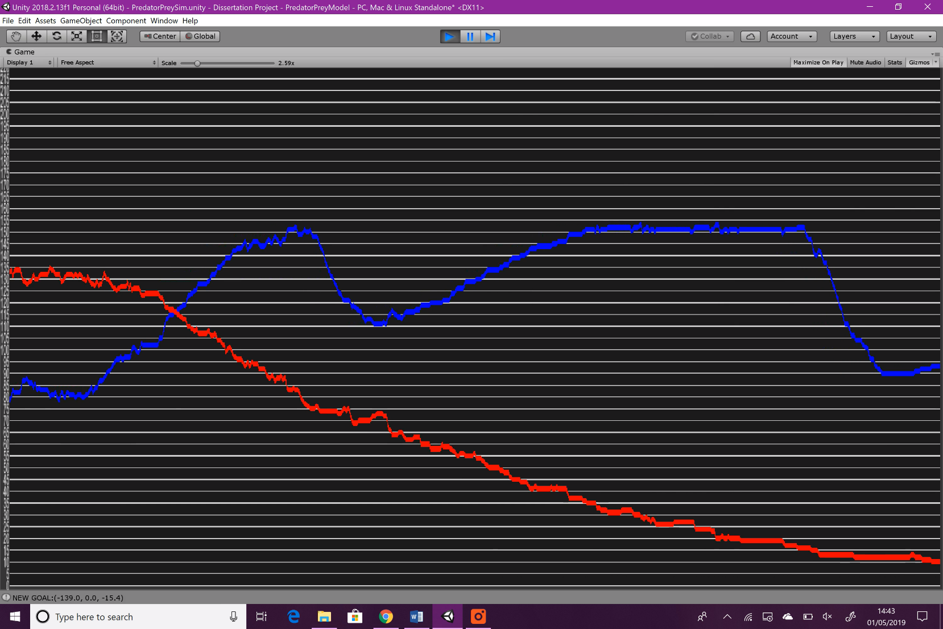

Prey population rises sharply even when predation is high

Prey population rise here is fine because predator population is still very low

Even with the existence of this problem, the prey population still sees an overall descent due to predation which is evident every season, so it isn’t a huge issue. The reason that the other three trends are completely successful is mainly due to the seasonal system, which regulates the entire system to allow the trends to work as intended. This might be thought of as ‘rigging’ the simulation, but this is a feature that is designed to be implemented in video games, and in my opinion, sacrificing some realism for a working and reliable system is necessary.

### Flocking

The results of background research identified three main behaviours that implement the backbone of flocking, and then two extra behaviours which aren’t necessary, but will provide added realism for my system. The first three are alignment, separation and cohesion, and the extra two are goal seeking and obstacle avoidance, which in this case was used as predator avoidance. More information on these behaviours can be found in background research.

Overall, I am very happy with how the flocking algorithms work. They provide the randomness and chaotic kind of movement that real herds and flocks will show, as can be seen in this video:

[https://tinytake.s3.amazonaws.com/pulse/carterjustin67-gmail/attachments/10356294/TinyTake12-04-2019-05-53-51.mp4](https://tinytake.s3.amazonaws.com/pulse/carterjustin67-gmail/attachments/10356364/TinyTake12-04-2019-06-09-02.mp4)

The flocks can form and deform dynamically due to the goal seeking behaviour that I implemented. As explained in the background research, it was my plan to adapt the cohesion behaviour into goal seeking, and the result is splendid. The area in which the goals are chosen can be changed (by editing the code) and the rate at which the flock will choose a new goal to travel towards can also be altered. 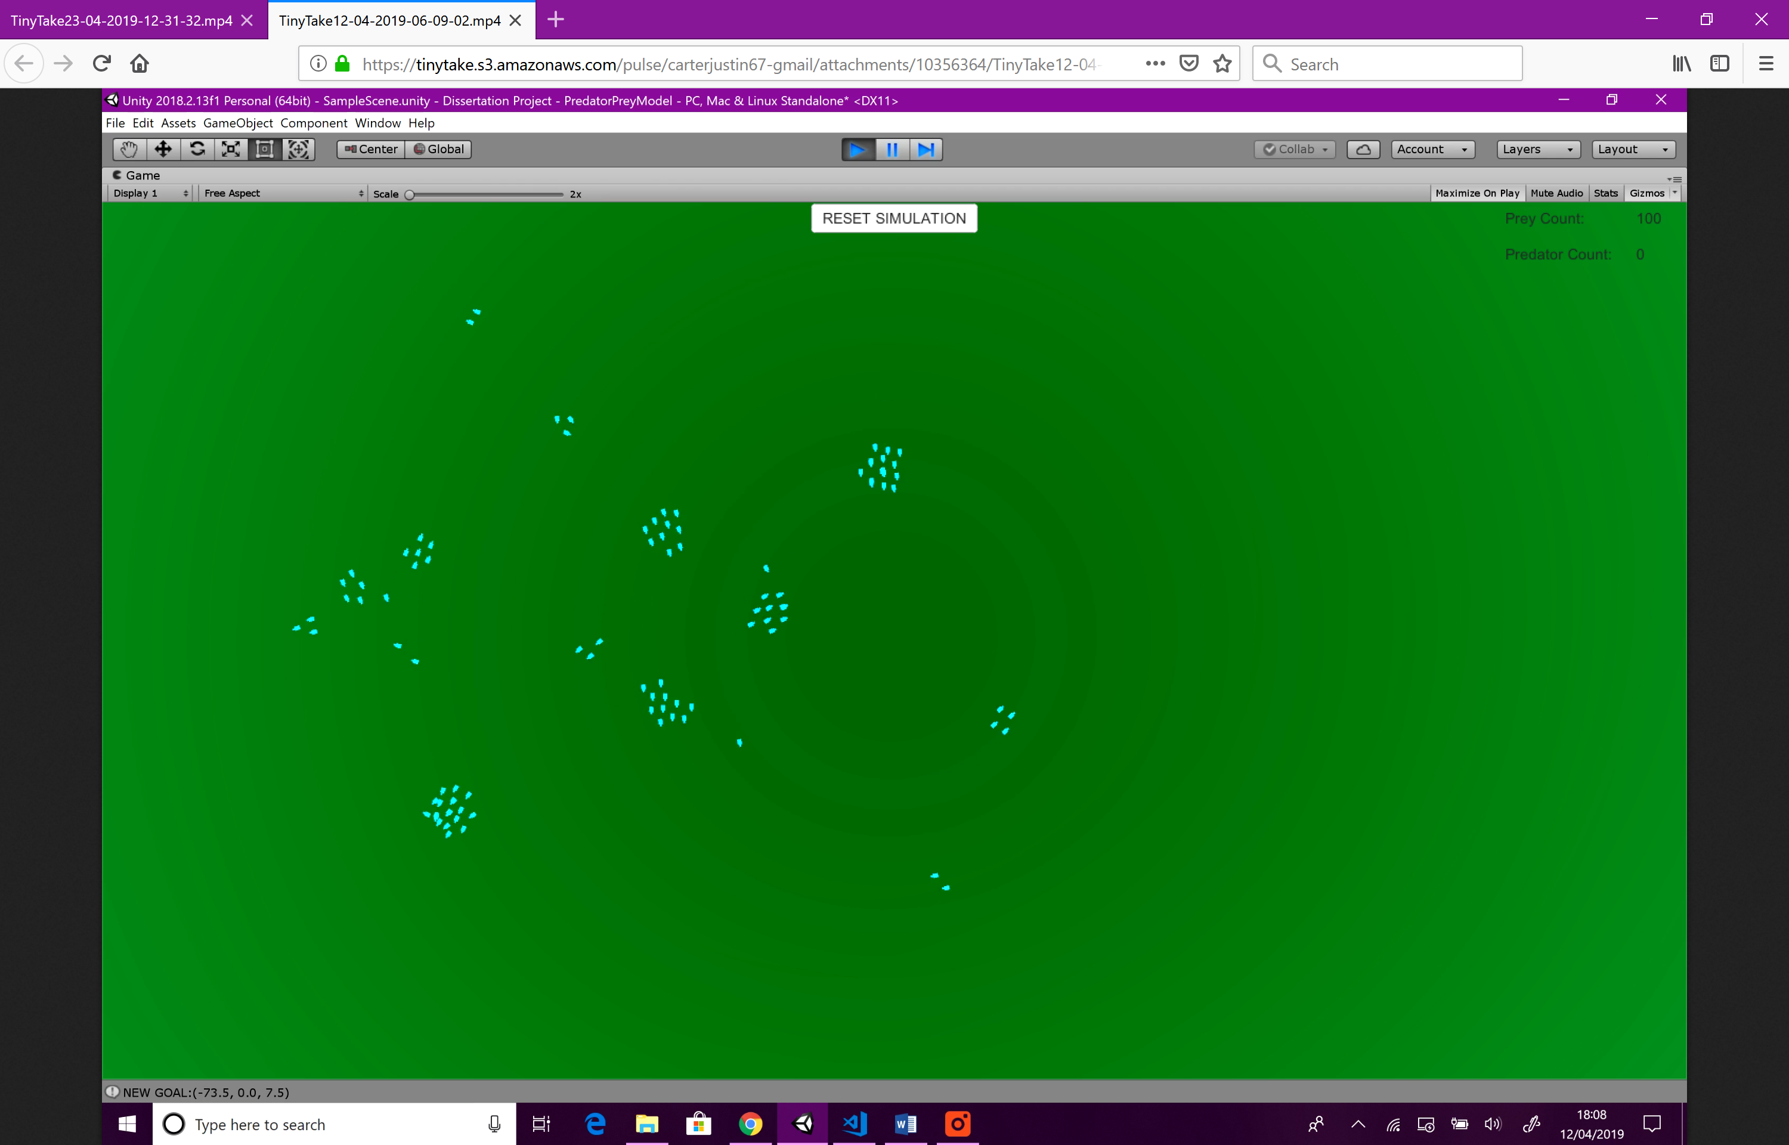

Figure : Flocking implementation

As can be seen above, the original flocking behaviours outlined in research are working as expected. The only issue I have found with the current implementation is that sometimes, prey objects will get too close to each other, but for the most part, the separation behaviour works well.

The predator avoidance behaviour is also working as expected, as can be seen in the video below:

<https://tinytake.s3.amazonaws.com/pulse/carterjustin67-gmail/attachments/10434743/TinyTake23-04-2019-12-31-32.mp4>

This behaviour is also an adaptation of one of the originals which I identified to be used for implementation in the background research. This behaviour adapts the separation flocking behaviour to be used for predators. The only problem with my implementation is that when fleeing from predators, the prey objects don’t seem to use their separation behaviour, as they tend to clump up together, as can be seen in the screenshot below.

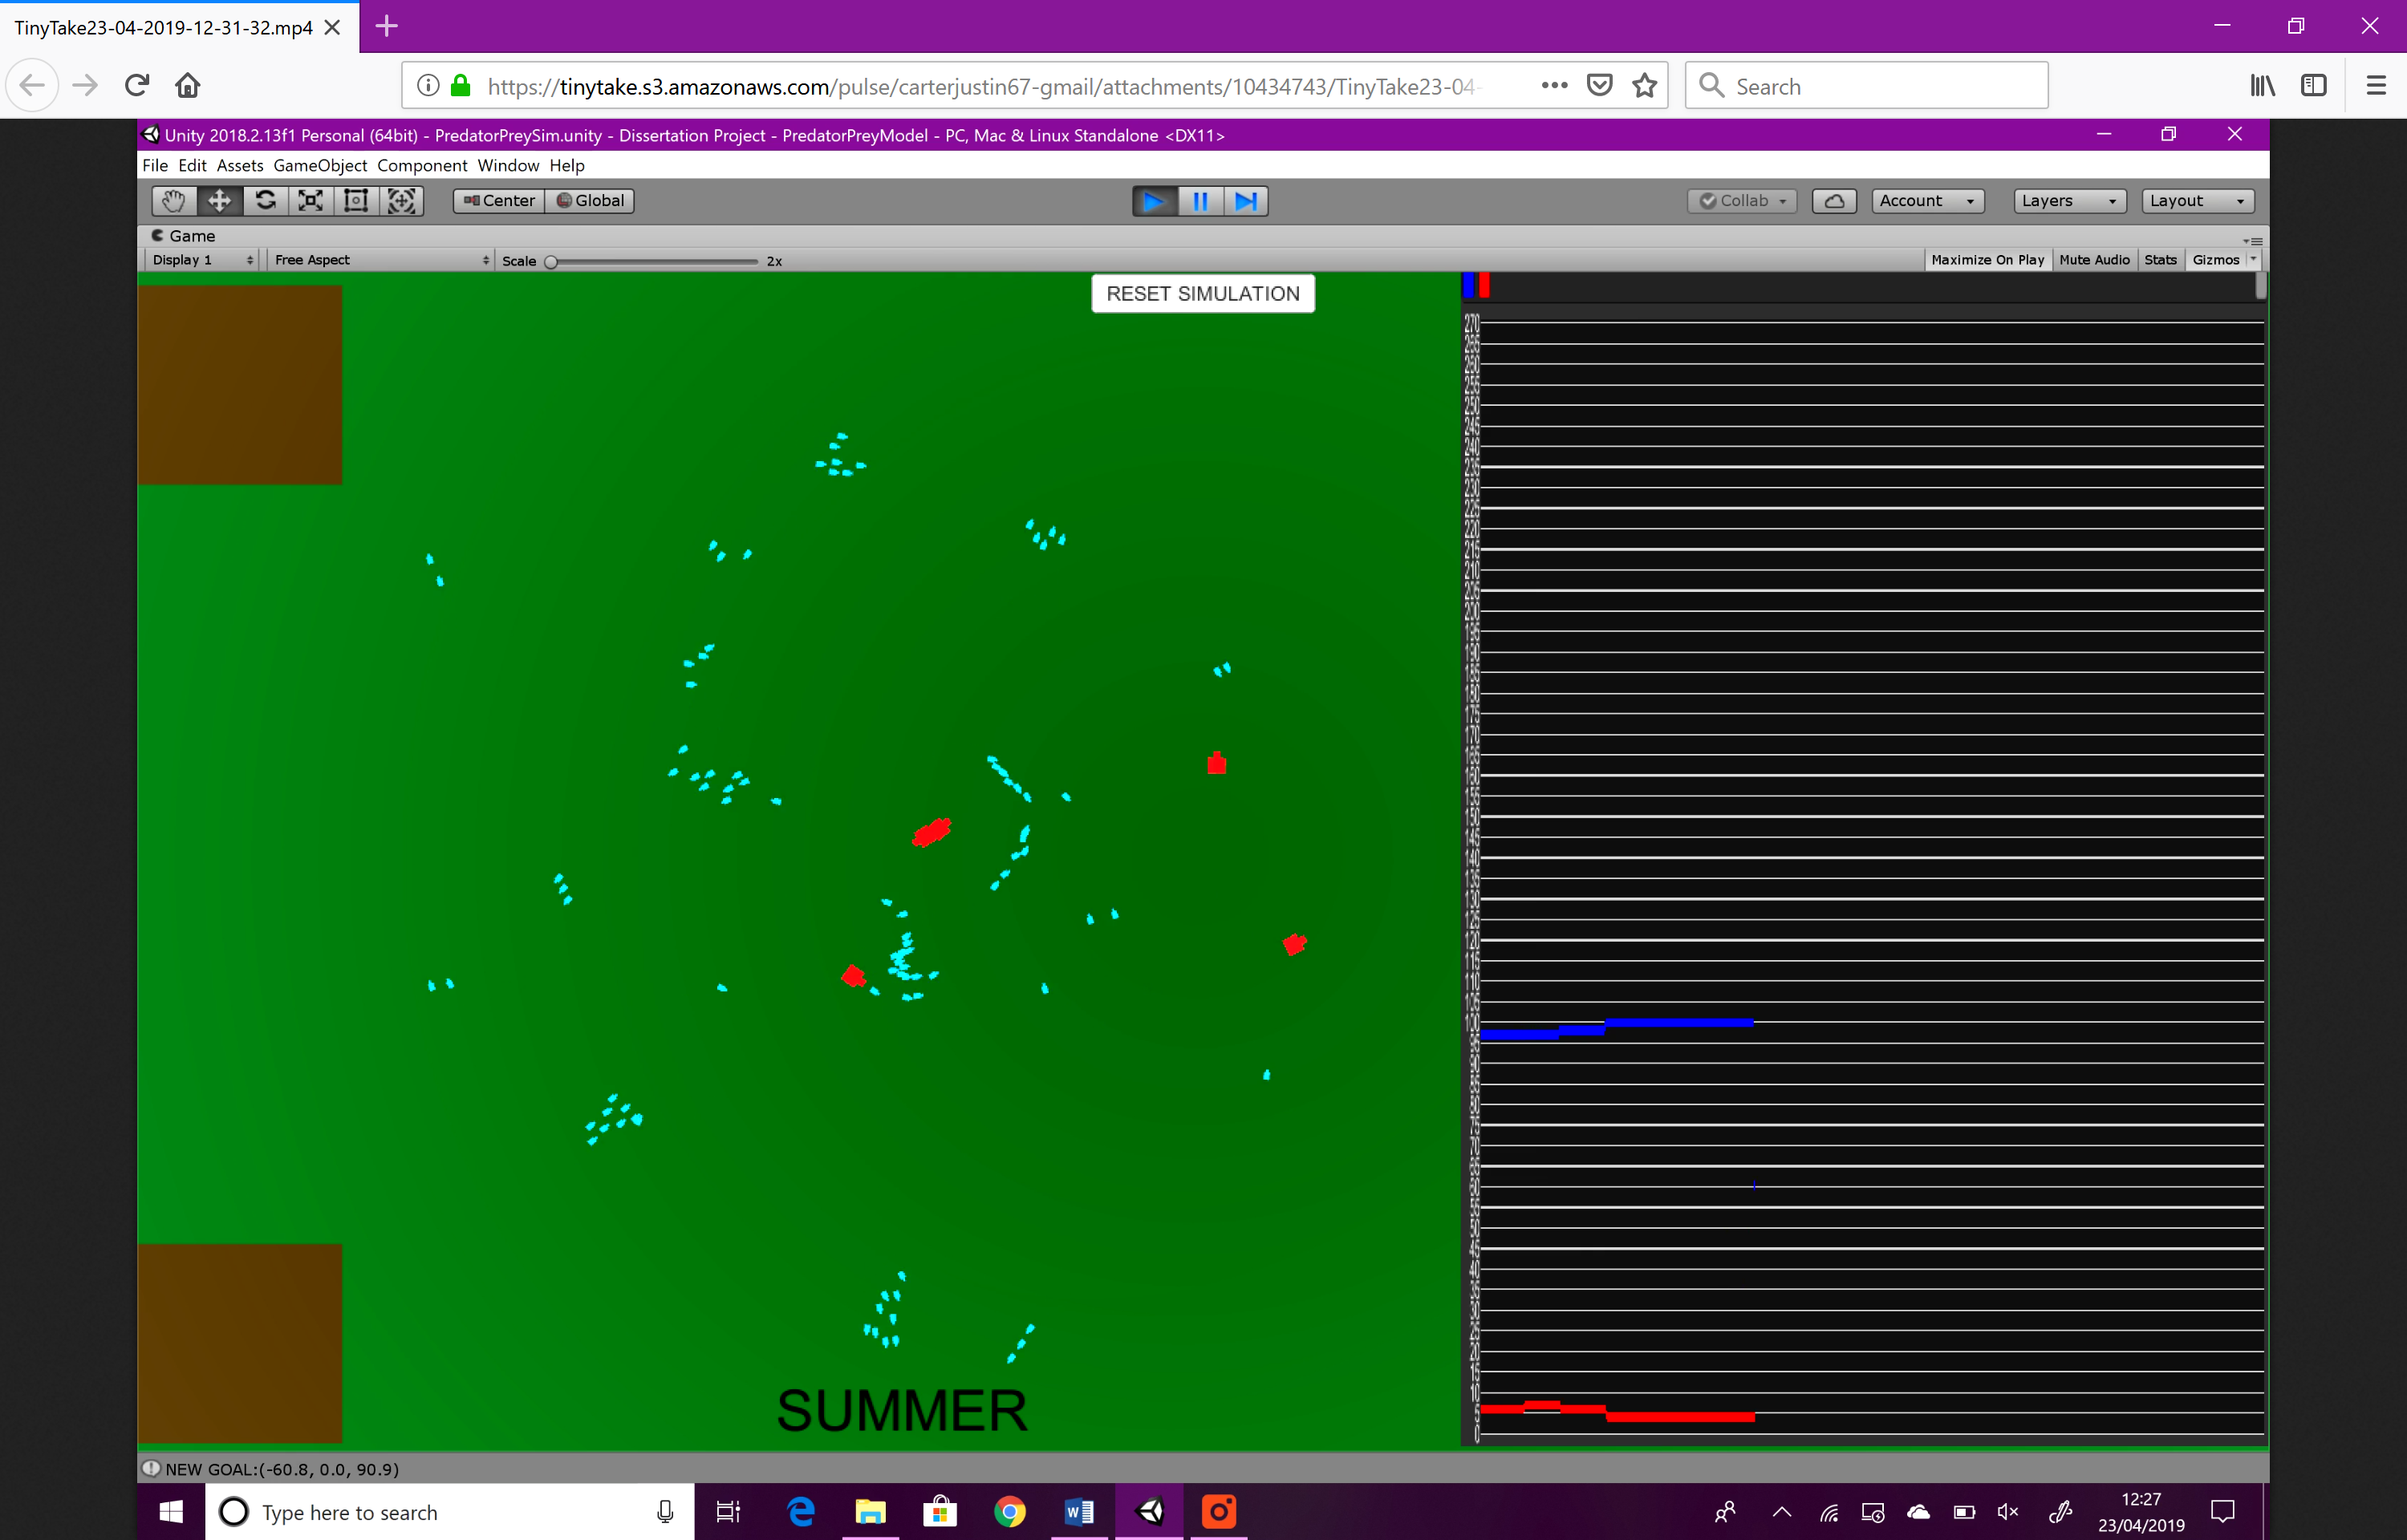

Figure : Separation fails when fleeing

# Conclusion

## Objectives Achievement

Below are the objectives that I set for the project at its start. I’ll explain whether these objectives have been met, how and whether I am happy with them.

* *“Use published articles and case studies documenting Predator-Prey models & Flocking to research and identify a technique for implementing the AI”*

I believe that this objective has been met fully and am very happy with it. As can be seen in the background research chapter, I have done a lot of research into predator-prey models, flocking, and current implementations in the games industry. This research helped expand my knowledge of the subject and led me to easily begin design and implementation.

* *“Establish a set of at least 5 rules that the AI must follow to keep the conditions controlled (e.g. Predators can only attack every 3 seconds)”*

The rules that I established are as follows, these were also outlined in the design section of the methodology chapter.

1. Predators have a fixed speed
2. Predators have a maximum sight distance
3. Predators have a cooldown period before they can begin chasing again after catching a prey
4. Prey have a min and max breed timer limit
5. Prey have a maximum speed

Overall I am very happy with these rules, they help keep the conditions of the simulation fair and prevent any individual prey or predator from becoming too strong.

* *“Define a set of 3 pass criteria that the system must achieve in which it can be said that the results of research were accurately reproduced”*

The pass criteria I defined are below:

1. When the population of prey rises, so does population of predators
2. When the population of prey drops, so does the population of predators
3. This process repeats itself continually

These criteria are based around how predator-prey models work on a basic level. I’m happy with this set of criteria and I feel that it accurately defines how the populations of two species react to each other.

* *“Implement AI to simulate the actions of both predator and prey in their natural environment as accurately as possible”*

As can be seen in the methodology chapter, I have certainly implemented AI that can simulate how predator and prey act in their natural environment. However, I’m not sure if their actions can be considered accurate to how they would act in the real world, as nature is extremely complex, and replicating all the actions an animal could do would take far too long and is overall not suited for video games. By this I mean that animals with too much behaviour would likely have a huge impact on performance, so implementing such an abundance of features would simply be unrealistic. Overall, I am very happy with the implementation, and I feel that I have completed the project that I set out to do.

* *“Evaluate if, and to what extent the results from research can be reproduced using the predator and prey AI (using pass criteria mentioned previously)”*

As can be seen in the video of the finished simulation and the evaluation, all three pass criteria have been met successfully. The first two criteria were relatively easy to meet, but the third however took some extra effort. In order to make sure that the process could be repeated continually, I had to implement both the seasonal system and give the prey a maximum population. Both features prevent the prey population from rising too high and falling too low.

## What Has Been Learned

Overall, the implementation of the project proceeded smoothly and mostly without issue. However, the main problem I encountered was the difficulty of implementing flocking. This is because I didn’t have a lot of experience using Vector3’s to move GameObjects, as in my previous projects I would simply use Unity’s built in functions that make the process much easier. The implementation of flocking required direct manipulation of each objects Vector3 position every frame, and it took a while for me to wrap my head around the process.

One other area that I feel could have been better is the script that runs flocking. Although the implementation works as intended and I’m happy with the outcome, the flocking script is quite taxing as it is required to loop through every single prey object several times every frame. If I was given the chance to start again, I would make sure that the flocking algorithms are as efficient as possible.

The final area in which I feel I could have done better is an error that I couldn’t find a way to fix without using a very naive solution. The problem was that at seemingly random times, all the scripts of a predator object would become disabled, and the object would simply freeze in place. I have no idea if this error was a fault of mine, or the engine itself, but I couldn’t find a way to prevent it from occurring. The solution I implemented was to have the manager script loop through every predator every frame and delete it if its controller script was disabled. If given more time, I would have found a more efficient solution that prevents this issue from occurring in the first place.

## Personal Development

Completing this project has allowed me to develop skills in many areas, and coming out of it, I feel content with the things I’ve learnt. Below are the areas in which I feel I’ve developed the most.

* Unity – Although I have some experience in Unity from previous projects, I feel that my skills in the engine have grown vastly, and I am a lot more comfortable using it.
* Flocking – Having never really heard of flocking before starting this project, coming out of it I have developed my knowledge of the behaviours enormously, and enjoyed learning about them in the process.
* Problem Solving – Throughout the project I was constantly presented with obstacles to overcome, such as how to achieve the third pass criteria to keep the simulation repeating itself continually. Due to having to solve many problems like this, my problem-solving skills have developed greatly.
* Programming – The project was certainly heavy in the programming area, as the prey and predators require a large amount of code to implement their behaviours. Coming out of the project, I feel a lot more confident with C# and the overall programming skills I’ve learnt using the language.
* Game Development – Although the simulation isn’t exactly a game, it is a feature that could be implemented in a video game. Due to this, and the fact that I used a game development engine, I feel I have improved my game development skills.

## Future Work

Although I’m satisfied with the current implementation, there are certainly some areas that could be improved, and some extra features that I feel could prove beneficial:

* Better graphical representation for predator and prey.

By this I mean that actual 3D models are used to represent the predator and prey, and these models can be interchanged easily. For example, the prey could be represented by a 3D rabbit model, and the predators a fox model. This would improve the realism of the system overall.

* Implementation of third dimension to represent airborne animals.

Currently, the AI only use the x and z axis in their movement but allowing them to also use the y axis would be useful when representing airborne or water borne animals. This would also allow the implementation of interesting new behaviours such as climbing high, then diving at prey, as some predatory birds do.

* Improvement of flocking algorithms and predator controls.

As explained further above, the flocking algorithms could use some work to make them more efficient, even though they currently work as intended. As for the predators, I believe implementing more behaviours for them would be beneficial. Extra behaviours could include capturing prey and taking them back to a nest rather than eating them straight away.

* Presets for different predator/prey relationships.

Remembering all the different variables that were altered to achieve a certain model can be quite taxing, so providing a way to save these variables into presets would prove useful.

* Inclusion of multiple species to represent a complete food chain.

As explained in the personal motivation section of the introduction, I completed a project at school documenting how the artificial removal of wolves from Yellowstone National Park affected all the other species in the ecosystem. I find this very interesting a feel that implementing a similar system, where multiple species rely on each other, would be very interesting.

# Form / References

1. Bevilacqua, F. 2012. Understanding Steering Behaviours. [Online]. [30 November 2018]. Available from:

https://gamedevelopment.tutsplus.com/series/understanding-steering-behaviors--gamedev-12732

1. Scholarpedia. 2006. Predator-Prey Model. [Online]. [30 November 2018]. Available from: http://www.scholarpedia.org/article/Prey-predator
2. Bohemia interactive. [no date]. DayZ. [Online]. [30 November 2018]. Available from: https://www.bohemia.net/games/dayz
3. Reynolds, C. 1995. Boids. 29th June. Red3dcom. [Online].[30 November 2018]. Available from: https://www.red3d.com/cwr/boids/
4. Pemmaraju, V. 2013. Gamedevelopment 3 Simple Rules of Flocking Behaviors: Alignment, Cohesion, and Separation.[Online]. [30 November 2018]. Available from: https://gamedevelopment.tutsplus.com/tutorials/3-simple-rules-of-flocking-behaviors-alignment-cohesion-and-separation--gamedev-3444
5. Professor Penny de Byl. 2016. Flocking Fish in Unity 5: Creating Schooling behaviour with simple AI. [Online]. [30 November 2018]. Available from: https://www.youtube.com/watch?v=eMpI1eCsIyM
6. Unity3dcom. 2018. Unity. [Online]. [30 November 2018]. Available from: https://unity3d.com/
7. Unity3dcom. 2017. Interactive Tutorials. [Online]. [30 November 2018]. Available from: https://unity3d.com/learn/tutorials/s/interactive-tutorials
8. Teamganttcom. 2018. Teamgantt. [Online]. [30 November 2018]. Available from: <https://www.teamgantt.com>
9. Craig W. Reynolds. 1987. Flocks, Herds, and Schools: A Distributed Behavioral Model. [Online]. [02 May 2019]. Available from: <https://www.red3d.com/cwr/papers/1987/SIGGRAPH87.pdf>
10. Tim Burton. 1992. Batman Returns. [Online]. [02 May 2019]. Available from: <https://www.imdb.com/title/tt0103776/>
11. Film Music Central. The Lion King “To Die For” (1994). [Online]. [02 May 2019]. Available from: <https://filmmusiccentral.com/2016/09/01/the-lion-king-to-die-for-1994/>
12. Press Books. Flocking Systems. [Online]. [02 May 2019]. Available from: <https://ohiostate.pressbooks.pub/graphicshistory/chapter/19-2-flocking-systems/>
13. M. Beals. 1999. PREDATOR-PREY DYNAMICS: LOTKA-VOLTERRA. [Online]. [02 May 2019]. Available from: <http://www.tiem.utk.edu/~gross/bioed/bealsmodules/predator-prey.html>
14. Avalanche Studios. The Hunter: Call of the Wild. [Online]. [30 November 2018]. Available from: <http://callofthewild.thehunter.com/en>
15. Fandom. The Hunter: Call of the Wild Wiki. [Online]. [30 November 2018]. Available from: <https://thehuntercotw.fandom.com/wiki/TheHunter:_Call_of_the_Wild_Wiki>
16. reddit. 2019. Are there any Predator-Prey relationships in the game. [Online]. [30 November 2018]. Available from: <https://www.reddit.com/r/theHunter/comments/bajxca/are_there_any_predatorprey_relationships_in_the/>
17. ZaggiDK. 2018. PUMA KILLED MY PERFECT DIAMOND!! TheHunter Call of the Wild. [Online]. [30 November 2018]. Available from: <https://www.youtube.com/watch?v=pdaNvNMKK3U&t=174s>
18. DayZ Wiki. Wildlife. [Online]. [30 November 2018]. Available from: <https://dayz.gamepedia.com/Wildlife>
19. Ubisoft. Farcry Primal. [Online]. [30 November 2018]. Available from: <https://www.ubisoft.com/en-gb/game/far-cry-primal>
20. Fandom. Far Cry Primal Animals. [Online]. [30 November 2018]. Available from: <https://farcry.fandom.com/wiki/Category:Far_Cry_Primal_Animals>
21. Unity3D. Unity. [Online]. [30 November 2018]. Available from: <https://unity3d.com/unity?_ga=2.196018988.1024408852.1554808736-23527472.1492103099>
22. Unity3D. Unity Store. [Online]. [30 November 2018]. Available from: <https://store.unity.com/>
23. Unity3D. Unity Asset Store. [Online]. [30 November 2018]. Available from: <https://assetstore.unity.com/>
24. Kelley Hecker. 2015. Unity scripting languages. [Online]. [30 November 2018]. Available from: <https://www.lynda.com/Unity-tutorials/Unity-scripting-languages/365280/379703-4.html>
25. Yun Shit. Dynamic Line Chart. [Online]. [30 November 2018]. Available from: <https://assetstore.unity.com/packages/tools/gui/dynamic-line-chart-108651>
26. Unity Docs. 2019. Physics.Raycast. [Online]. [30 November 2018]. Available from: <https://docs.unity3d.com/ScriptReference/Physics.Raycast.html>
27. Unity Docs. 2019. Physics.OverlapSphere. [Online]. [30 November 2018]. Available from: <https://docs.unity3d.com/ScriptReference/Physics.OverlapSphere.html>
28. Creately. Creately. [Online]. [30 November 2018]. Available from: [https://creately.com](https://creately.com/)
29. Lewis Lewin. 2019. Red Dead Redemption 2 Legendary Animals Guide. [Online]. [30 November 2018]. Available from: <https://www.rdr2.org/guides/red-dead-redemption-2-legendary-animals-guide/>
30. Rockstar. 2018. Red Dead Redemption 2. [Online]. [30 November 2018]. Available from: <https://www.rockstargames.com/reddeadredemption2/features/wildlife>
31. Dr. Umran Ali. 2018. Red Dead Redemption 2: Virtual ecology is making game worlds eerily like our own. [Online]. [30 November 2018]. Available from: <https://theconversation.com/red-dead-redemption-2-virtual-ecology-is-making-game-worlds-eerily-like-our-own-107068>
32. reddit. 2019. Are there any Predator-Prey relationships in Farcry Primal?. [Online]. [30 November 2018]. Available from: <https://www.reddit.com/r/farcry/comments/baukqi/are_there_any_predatorprey_relationships_in/>
33. reddit. 2019. Are there any Predator-Prey relationships in the game. [Online]. [30 November 2018]. Available from: <https://www.reddit.com/r/dayz/comments/baufr1/are_there_any_predatorprey_relationships_in_the/>
34. Saber Interactive. 2019. World War Z. [Online]. [30 November 2018]. Available from: <https://wwzgame.com/en/>
35. SIE Bend Studio. 2019. Days Gone. [Online]. [30 November 2018]. Available from: <https://www.playstation.com/en-gb/games/days-gone-ps4/>
36. GameSpot. 2018. World War Z: Introducing The Horde – Official Gameplay Trailer | Gamescom 2018[Online]. [30 November 2018]. Available from: <https://www.youtube.com/watch?v=EAoDX2hyvB8>
37. altchar. 2018. Days Gone gets gameplay video, how many zombies can you count?. [Online]. [30 November 2018]. Available from: <https://www.altchar.com/games-news/569838/days-gone-gets-gameplay-video-how-many-zombies>
38. URFAN. 2018. Red Dead Redemption 2 Bear and Wolf FIGHT over dead prey (MOST RARE ENCOUNTER). [Online]. [30 November 2018]. Available from: <https://www.youtube.com/watch?v=R1WZrs-T_Rc>
39. Unity Docs. 2019. Asset Workflow[Online]. [30 November 2018]. Available from: <https://docs.unity3d.com/Manual/AssetWorkflow.html>
40. Unity Docs. 2019. GameObject[Online]. [30 November 2018]. Available from: <https://docs.unity3d.com/Manual/class-GameObject.html>
41. Unity Docs. 2019. Prefabs[Online]. [30 November 2018]. Available from: <https://docs.unity3d.com/Manual/Prefabs.html>
42. Unity Docs. 2019. Variables and the Inspector[Online]. [30 November 2018]. Available from: <https://docs.unity3d.com/Manual/VariablesAndTheInspector.html>

# Appendix

## Scripts

### PreyController.cs

using System.Collections;

using System.Collections.Generic;

using UnityEngine;

// Author: Justin Carter

// Date: 02/05/2019

public class PreyController : MonoBehaviour {

    float rotationSpeed = 6.0f;

    public float cohesionRadius;

    public float separationRadius;

    public float alignmentRadius;

public float predatorAvoidRadius;

    public float cohesionIntensity;

    public float separationIntensity;

    public float alignmentIntensity;

    public float predatorAvoidIntensity;

    public float speed;

    public float goalBoundsX;

    public float goalBoundsZ;

    public int superiority;

    public PreyController flockLeader;

    public Vector3 goal = Vector3.zero;

public float hibernationSpeed;

public float timeTillBreed;

public float breedTimer;

public bool isHibernating = false;

public Transform hibernationSpot;

    public SimulationManager preyManager;

    public float breedLowerBound;

public float breedUpperBound;

    // Use this for initialization

    void Start () {

        preyManager = FindObjectOfType<SimulationManager>();

        superiority = Random.Range(1, 101);

        flockLeader = this;

        speed = Random.Range(2f, 8f);

        timeTillBreed = Random.Range(breedLowerBound, breedUpperBound);

breedTimer = timeTillBreed;

    }

    // Update is called once per frame

    void Update () {

        if (!isHibernating)

{

            if (!preyManager.preyPopulationMaxed)

            {

         breed();

            }

flocking();

// Reset speed if too high

if (speed > 10)

{

speed = Random.Range(2f, 8f);

}

} else

{

hibernate();

// Allow the prey to breed when hibernating if they're endangered

if (preyManager.preyEndangered)

{

if (!preyManager.preyPopulationMaxed)

                {

                    breed();

                }

}

}

    }

    // The prey object duplicates

    void breed()

{

breedTimer -= Time.deltaTime;

if (breedTimer <= 0)

{

Instantiate(gameObject, transform.position, transform.rotation);

breedTimer = timeTillBreed;

}

}

    // Prey object hibernates

    void hibernate()

{

if (Vector3.Distance(transform.position, hibernationSpot.transform.position) > 1)

{

gameObject.tag = "PreyHibernating";

gameObject.layer = 0; // Set layer to default

Vector3 direction = hibernationSpot.position;

Vector3 directionLockY = new Vector3 (direction.x, 0, direction.z); // Remove movement on the y axis

transform.position = Vector3.MoveTowards(transform.position, directionLockY, Time.deltaTime * hibernationSpeed);

if (direction != Vector3.zero)

{

transform.rotation = Quaternion.Slerp(transform.rotation,

Quaternion.LookRotation(directionLockY),

rotationSpeed * Time.deltaTime);

}

}

}

    // Combine all behaviours

    void flocking()

    {

        Vector3 cohesionVector = cohesion();

        Vector3 separationVector = separation();

        Vector3 alignmentVector = alignment();

        Vector3 predatorAvoidVector = predatorAvoid();

        flockLeader = null;

        getGoal();

        // If there is a goal, add it to cohesion

        if (flockLeader.goal != Vector3.zero)

        {

            cohesionVector += flockLeader.goal - transform.position;

        }

        // If there are predators, add the, to separation

        if (predatorAvoidVector != Vector3.zero)

        {

            separationVector += predatorAvoidVector * predatorAvoidIntensity;

        }

        Vector3 finalVector = cohesionVector * cohesionIntensity +

                                separationVector * separationIntensity +

                                alignmentVector * alignmentIntensity;

        finalVector = new Vector3(finalVector.x, 0, finalVector.z);

        if (finalVector != Vector3.zero)

        {

            // Rotate to the final vector

            transform.rotation = Quaternion.Slerp(transform.rotation,

    Quaternion.LookRotation(finalVector),

rotationSpeed * Time.deltaTime);

        }

        transform.Translate(0, 0, Time.deltaTime * speed); // Move the prey forward

    }

    // Gets the goal of the flock

    void getGoal()

    {

        // Get all neighbouring prey

Collider[] hitColliders = Physics.OverlapSphere(transform.position, cohesionRadius);

        flockLeader = this;

        foreach (Collider c in hitColliders)

        {

            if (c.tag == "Prey")

            {

                PreyController script = c.gameObject.GetComponent<PreyController>();

                if (script.superiority > flockLeader.superiority)

                {

                    if (script.superiority > superiority)

                    {

                        flockLeader = script; // Find the most superior prey object

                    }

                    else

                    {

                        flockLeader = this;

                    }

                }

            }

        }

if (flockLeader == this && goal == Vector3.zero)

{

goal = randomPosInBounds(); // Get a random position within the bounding box to be the goal

            Debug.Log("NEW GOAL:" + goal);

} else if (flockLeader != this && goal != Vector3.zero)

{

goal = Vector3.zero;

} else if (flockLeader == this && goal != Vector3.zero)

{

// Choose a new goal on occasion

if (Random.Range(1, 100) <= 2)

{

goal = randomPosInBounds(); // Get a random position within the bounding box to be the goal

}

}

    }

    Vector3 predatorAvoid()

    {

        Vector3 predatorAvoid = Vector3.zero;

        int predatorCount = 0;

        // Get all neighbouring predator

Collider[] predHitColliders = Physics.OverlapSphere(transform.position, predatorAvoidRadius);

        foreach (Collider c in predHitColliders)

        {

if (c.tag == "Predator")

{

predatorAvoid += c.gameObject.transform.position - transform.position;

                predatorCount++;

}

}

        if (predatorCount == 0)

        {

            return Vector3.zero;

        }

        predatorAvoid /= predatorCount;

        predatorAvoid *= -1;

        return predatorAvoid;

    }

    Vector3 cohesion()

    {

        Vector3 cohesion = Vector3.zero;

        int preyCount = 0;

        float flockSpeed = 0.1f;

        // Get all neighbouring prey

Collider[] hitColliders = Physics.OverlapSphere(transform.position, cohesionRadius);

        foreach (Collider c in hitColliders)

        {

            if (c.tag == "Prey")

            {

                flockSpeed = flockSpeed + c.gameObject.GetComponent<PreyController>().speed;

                cohesion += c.gameObject.transform.position;

                preyCount++;

            }

        }

        if (preyCount > 0)

        {

            speed = flockSpeed / preyCount;

        } else

        {

            speed = Random.Range(2f, 8f);

            return Vector3.zero;

        }

        cohesion /= preyCount;

        cohesion -= transform.position;

        return cohesion;

    }

    Vector3 separation ()

    {

        Vector3 separation = Vector3.zero;

        int preyCount = 0;

        // Get all neighbouring prey

Collider[] hitColliders = Physics.OverlapSphere(transform.position, separationRadius);

        foreach (Collider c in hitColliders)

        {

            if (c.tag == "Prey")

            {

                separation += c.gameObject.transform.position - transform.position;

                preyCount++;

            }

        }

        if (preyCount == 0)

        {

            return Vector3.zero;

        }

        separation /= preyCount;

        separation *= -1;

        return separation;

    }

    Vector3 alignment ()

    {

        Vector3 alignment = Vector3.zero;

        int preyCount = 0;

        // Get all neighbouring prey

Collider[] hitColliders = Physics.OverlapSphere(transform.position, alignmentRadius);

        foreach (Collider c in hitColliders)

        {

            if (c.tag == "Prey")

            {

                alignment += c.gameObject.transform.forward;

                preyCount++;

            }

        }

        if (preyCount == 0)

        {

            return Vector3.zero;

        }

        alignment /= preyCount;

        return alignment;

    }

    // Returns a random position within a set area

    Vector3 randomPosInBounds()

{

return new Vector3 (Random.Range(-goalBoundsX, goalBoundsX),

0,

Random.Range(-goalBoundsZ, goalBoundsZ));

}

}

### PredatorController.cs

using System.Collections;

using System.Collections.Generic;

using UnityEngine;

// Author: Justin Carter

// Date: 02/05/2019

public class PredatorController : MonoBehaviour {

public SimulationManager manager;

public float roamingSpeed;

public float chasingSpeed;

float speed;

public float sensorLength = 10.0f;

public float frontSensorPos = 0.5f;

public float frontSensorAngle = 30f;

bool chasing = false;

bool eaten = false;

public float originalTimeTillDeath;

float timeTillDeath;

public float coolDownLength;

float coolDownTimer;

public float timeAlive = 0;

float deathTimer;

GameObject prey = null;

public Vector3 smelledPreyPosition = Vector3.zero;

public GameObject smelledPrey;

public float smellRange = 30f;

public float timeBetweenSmells;

public float smellTimer;

public LayerMask smellLayer;

public float searchSpeed;

public GameObject predatorPrefab;

public int superiority;

public bool isAlpha = false; // Predators with high enough superiority will never die

public bool isHibernating = false;

public List<GameObject> cubes;

Color black = Color.black;

Color red = Color.red;

public GameObject predatorClone;

    // Use this for initialization

    void Awake () {

if (GameObject.Find("Manager"))

{

manager = GameObject.Find("Manager").GetComponent<SimulationManager>();

}

timeTillDeath = originalTimeTillDeath;

speed = roamingSpeed;

deathTimer = timeTillDeath;

coolDownTimer = coolDownLength;

smellTimer = timeBetweenSmells;

setPredator();

    }

    // Update is called once per frame

    void Update () {

timeAlive += Time.deltaTime;

if (!isAlpha)

{

surviveOrDie();

}

if (!isHibernating)

{

movement();

behaviour();

}

    }

public void setPredator()

{

superiority = Random.Range(1, 101); // Give new predator a new superiority

timeAlive = 0;

// Predators with high superiority will become alphas

// Will never die

if (superiority >= 95 && manager.numOfAlphas < manager.maxNumOfAlphas)

{

isAlpha = true;

manager.numOfAlphas++;

coolDownLength = 1.5f;

foreach (GameObject o in cubes)

{

o.gameObject.GetComponent<Renderer>().material.color = black;

}

} else

{

isAlpha = false;

timeTillDeath = originalTimeTillDeath;

foreach (GameObject o in cubes)

{

o.gameObject.GetComponent<Renderer>().material.color = red;

}

}

}

void behaviour()

{

//Impose a timer for predatory behaviour

coolDownTimer -= Time.deltaTime;

if (coolDownTimer <= 0)

{

predatorClone = null;

if (!chasing)

{

smellTimer -= Time.deltaTime;

if (smellTimer <= 0)

{

smellTimer = timeBetweenSmells;

smell();

}

sight();

} else

{

chase();

}

}

}

// Smell for nearby prey that are out of sight, move in their general direction

void smell()

{

Collider[] colliders = Physics.OverlapSphere(transform.position, smellRange, smellLayer);

if (colliders.Length > 0)

{

GameObject closestPrey = colliders[0].gameObject;

float distance = Vector3.Distance(gameObject.transform.position, closestPrey.transform.position);

foreach (Collider c in colliders)

{

if (c.gameObject.tag == "Prey")

{

if (c.gameObject != closestPrey && Vector3.Distance(gameObject.transform.position, c.transform.position) <= distance)

{

closestPrey = c.gameObject;

}

}

}

smelledPrey = closestPrey;

smelledPreyPosition = closestPrey.transform.position;

smelledPreyPosition.y = transform.position.y;

}

}

void movement()

{

transform.Translate(0, 0, Time.deltaTime * speed);

if (smelledPreyPosition == Vector3.zero && !chasing)

{

if (Random.Range(0, 300) <= 4)

{

Vector3 euler = transform.eulerAngles;

euler.y = Random.Range(0f, 360f);

transform.eulerAngles = euler;

}

} else if (!chasing && smelledPreyPosition != Vector3.zero)

{

if (Vector3.Distance(transform.position, smelledPreyPosition) <= 0.5f)

{

smelledPreyPosition = Vector3.zero;

return;

}

// The step size is equal to speed times frame time.

float step = searchSpeed * Time.deltaTime;

Vector3 targetPos = smelledPreyPosition;

targetPos.y = transform.position.y;

Vector3 relativePos = targetPos - transform.position;

Quaternion rot = Quaternion.LookRotation(relativePos);

transform.rotation = rot;

transform.position = Vector3.MoveTowards(transform.position, targetPos, step);

}

}

// Look for prey, begin chasing if seen

void sight()

{

RaycastHit hit;

Vector3 sensorStart = transform.position;

sensorStart.z += frontSensorPos;

// Forward sensor

if (Physics.Raycast(sensorStart, transform.forward, out hit, sensorLength))

{

if (hit.transform.gameObject.tag == "Prey")

{

prey = hit.transform.gameObject;

chasing = true;

smelledPreyPosition = Vector3.zero;

Debug.DrawLine(sensorStart, hit.point);

}

}

// Right angled sensor

else if (Physics.Raycast(sensorStart, Quaternion.AngleAxis(frontSensorAngle, transform.up) * transform.forward, out hit, sensorLength))

{

if (hit.transform.gameObject.tag == "Prey")

{

prey = hit.transform.gameObject;

chasing = true;

smelledPreyPosition = Vector3.zero;

Debug.DrawLine(sensorStart, hit.point);

}

}

// Right angled sensor

else if (Physics.Raycast(sensorStart, Quaternion.AngleAxis(-frontSensorAngle, transform.up) * transform.forward, out hit, sensorLength))

{

if (hit.transform.gameObject.tag == "Prey")

{

prey = hit.transform.gameObject;

chasing = true;

smelledPreyPosition = Vector3.zero;

Debug.DrawLine(sensorStart, hit.point);

}

}

}

void chase()

{

// Stop chasing if the prey object no longer exists (eaten by another predator)

if (!prey || prey == null || prey.tag != "Prey")

{

prey = null;

chasing = false;

return;

}

float step = chasingSpeed * Time.deltaTime;

Vector3 targetPos = prey.transform.position;

targetPos.y = transform.position.y;

Vector3 relativePos = targetPos - transform.position;

Quaternion rot = Quaternion.LookRotation(relativePos);

transform.rotation = rot;

transform.position = Vector3.MoveTowards(transform.position, targetPos, step);

// Predator eats the prey

if (Vector3.Distance(prey.transform.position, this.transform.position) <= 1.0f && prey)

{

Destroy(prey);

speed = roamingSpeed;

prey = null;

chasing = false;

eaten = true;

coolDownTimer = coolDownLength;

if (timeAlive >= 2)

{

if (predatorClone != null)

{

return;

} else

{

predatorClone = (GameObject) Instantiate(predatorPrefab, transform.position, transform.rotation); // Predator breeds whenever it eats

}

}

}

}

// Destroy predator if it has not eaten

void surviveOrDie()

{

deathTimer -= Time.deltaTime;

if (deathTimer <= 0 && !eaten)

{

Destroy(gameObject);

} else if (deathTimer <= 0 && eaten)

{

deathTimer = timeTillDeath;

eaten = false;

}

}

}

### SimulationManager.cs

using System.Collections;

using System.Collections.Generic;

using UnityEngine.UI;

using UnityEngine;

// Author: Justin Carter

// Date: 02/05/2019

public class SimulationManager : MonoBehaviour {

public GameObject preyPre;

SeasonManager seasonManager;

public int spawnArea = 20;

public int preyCount = 100;

float timer = 0.5f;

public Text preyTxt;

public Text predatorTxt;

public DD_DataDiagram chart;

GameObject preyLine;

GameObject predatorLine;

public float preyEndangeredNumber;

public bool preyEndangered;

public int numOfAlphas;

public int maxNumOfAlphas;

public int maxPreyPopulation;

public bool preyPopulationMaxed = false;

    // Use this for initialization

    void Start () {

seasonManager = gameObject.GetComponent<SeasonManager>();

preyLine = chart.AddLine("Prey", Color.blue);

predatorLine = chart.AddLine("Predator", Color.red);

int numberOfPrey = GameObject.FindGameObjectsWithTag("Prey").Length;

int numberOfPredator = GameObject.FindGameObjectsWithTag("Predator").Length;

chart.InputPoint(preyLine, new Vector2(1, numberOfPrey));

chart.InputPoint(predatorLine, new Vector2(1, numberOfPredator));

for (int i = 0; i < preyCount; i++)

        {

            Vector3 spawnPosition = new Vector3(Random.Range(-spawnArea, spawnArea), 0,

                                                Random.Range(-spawnArea, spawnArea)

                                                );

            Instantiate(preyPre, spawnPosition, Quaternion.identity);

        }

    }

    // Update is called once per frame

    void Update () {

int numberOfPrey = GameObject.FindGameObjectsWithTag("Prey").Length;

// If there are no prey, they must be hibernating

if (numberOfPrey == 0)

{

numberOfPrey = GameObject.FindGameObjectsWithTag("PreyHibernating").Length;

}

if (numberOfPrey > maxPreyPopulation)

{

preyPopulationMaxed = true;

} else

{

preyPopulationMaxed = false;

}

// Make prey hibernate if they're endangered

if (numberOfPrey <= preyEndangeredNumber && !preyEndangered)

{

seasonManager.hibernate();

preyEndangered = true;

}

GameObject[] predators = GameObject.FindGameObjectsWithTag("Predator");

int numberOfPredator = predators.Length;

// Bug where all scripts of predator get disabled

// Don't know why, below is naive solution

foreach (GameObject obj in predators)

{

if (obj.GetComponent<PredatorController>().enabled == false)

{

Destroy(obj);

}

}

chart.InputPoint(preyLine, new Vector2(1, numberOfPrey));

chart.InputPoint(predatorLine, new Vector2(1, numberOfPredator));

preyTxt.text = "" + numberOfPrey;

predatorTxt.text = "" + numberOfPredator;

}

}

### SeasonManager.cs

using System.Collections;

using System.Collections.Generic;

using UnityEngine;

using UnityEngine.UI;

// Author: Justin Carter

// Date: 02/05/2019

public class SeasonManager : MonoBehaviour {

    SimulationManager preyManager;

    public float springLength;

    public float summerLength;

    public float autumnLength;

    public float winterLength;

    public Text seasonText;

    public List<Transform> hibernationSpots;

    string spring = "SPRING";

    string summer = "SUMMER";

    string autumn = "AUTUMN";

    string winter = "WINTER";

    public int currentSeason = 2; // 1 = spring, 2 = summer, 3 = autumn, 4 = winter

    float seasonTimer;

    // Use this for initialization

    void Start () {

        preyManager = gameObject.GetComponent<SimulationManager>();

        seasonTimer = springLength;

        seasonText.text = summer;

    }

    // Update is called once per frame

    void Update () {

        seasonTimer -= Time.deltaTime;

        if (seasonTimer <= 0)

        {

            switchSeason();

        }

    }

    void switchSeason()

    {

        currentSeason++;

        if (currentSeason > 4)

        {

            currentSeason = 1;

        }

        if (currentSeason == 1)

        {

            wakeFromHibernation();

            seasonText.text = spring;

            seasonTimer = springLength;

        } else if (currentSeason == 2)

        {

            seasonText.text = summer;

            seasonTimer = summerLength;

        } else if (currentSeason == 3)

        {

            seasonText.text = autumn;

            seasonTimer = autumnLength;

        } else if (currentSeason == 4)

        {

            hibernate();

            seasonText.text = winter;

            seasonTimer = winterLength;

        }

    }

    public void hibernate()

    {

        GameObject[] prey = GameObject.FindGameObjectsWithTag("Prey");

        foreach (GameObject preyObject in prey)

        {

            PreyController script = preyObject.GetComponent<PreyController>();

            script.isHibernating = true;

            script.hibernationSpot = hibernationSpots[Random.Range(0, hibernationSpots.Count)];

        }

    }

    void wakeFromHibernation()

    {

        preyManager.preyEndangered = false;

        GameObject[] prey = GameObject.FindGameObjectsWithTag("PreyHibernating");

        foreach (GameObject preyObject in prey)

        {

            preyObject.tag = "Prey";

            preyObject.layer = 11; // Set layer to prey

            PreyController script = preyObject.GetComponent<PreyController>();

            script.isHibernating = false;

            script.hibernationSpot = null;

        }

    }

}

### RestartSimulation.cs

using System.Collections;

using System.Collections.Generic;

using UnityEngine;

using UnityEngine.SceneManagement;

// Author: Justin Carter

// Date: 02/05/2019

public class RestartSimulation : MonoBehaviour {

    // Called by button to restart the scene

    public void resetSimulation()

    {

        SceneManager.LoadScene("PredatorPreySim");

    }

}

## Graph Screenshots

